Coastal landscapes
in the UK
Contents
Using this booklet 3
Introduction to coastal landscapes 4
Check your learning 5
Waves 6
Check your learning 8
Dual coding 9
Weathering 10
Check your learning 11
Dual coding 12
Mass Movement 13
Check your learning 14
Dual coding 15
Coastal Processes 16
Check your learning 19
Dual coding 20
Coastal landforms of erosion 21
Check your learning 24
Dual coding 25
Coastal landforms of deposition 26
Check your learning 29
Dual coding 30
An example of a section of coastline in the UK to identify its major landforms of erosion and deposition. 31
Check your learning 32
Dual coding 33
Coastal management strategies 34
Check your learning 36
Dual coding 37
An example of a coastal management scheme in the UK 38
Check your learning 39
Dual coding 40
Check your learning recording table 41

Using this booklet
Welcome to the Internet Geography Work Booklet for the Living World – Ecosystems and Tropical Rainforest. There are a range of resources on Internet Geography to support you studying this unit. Head over to www.internetgeography.net/aqa-gcse-geography/the-living-world/ to access them.

As well as the resources in this booklet, there are a number of online quizzes to check your learning as you work your way through this booklet.
This icon lets you know when you should attempt the online quizzes developed to support your learning and check your knowledge. Your scores should be recorded on the tracking table at the back of this booklet. It is useful to revisit the quizzes to help your learning stick.

QR codes are included throughout the booklet to support you in researching the information you need to complete the activities. You will need to download a free QR code scanner to your mobile phone or tablet. Just go to your app store and search for “QR Code scanner” and download a free one.

After each section in this booklet there is a summary page for you to record the main points for each sub-topic. We recommend you use dual coding for this. Dual coding sounds a bit complicated, however, it’s not. It simply involves combining text and images when you are studying. There are many ways you can present text and images, such as with infographics, timelines, cartoon strips, diagrams, and graphic organisers. We’ve pulled together a guide to help you do this with examples on Internet Geography. Either go to https://www.internetgeography.net/dual-coding/ or scan the QR code below.

Introduction to coastal landscapes
There are a number of key words you need to know about coastal landscapes.
Complete the key terms list below by adding the correct definitions.

Coast
Wave
Coastal erosion
Coastal deposition
Coastal transportation
Hard engineering
Soft engineering

Check your learning
Head over to www.internetgeography.net/wb25 and complete the key word quiz. Add your score for quiz 1 on the recording sheet.

Waves

What is a wave?

_______________________________________________________________________________________

_______________________________________________________________________________________

_______________________________________________________________________________________

What is the fetch of a wave?

_______________________________________________________________________________________

_______________________________________________________________________________________

What factors affect the size of a wave?

_______________________________________________________________________________________

_______________________________________________________________________________________

_______________________________________________________________________________________

_______________________________________________________________________________________

Produce an annotated sketch to the show the main features of a wave.

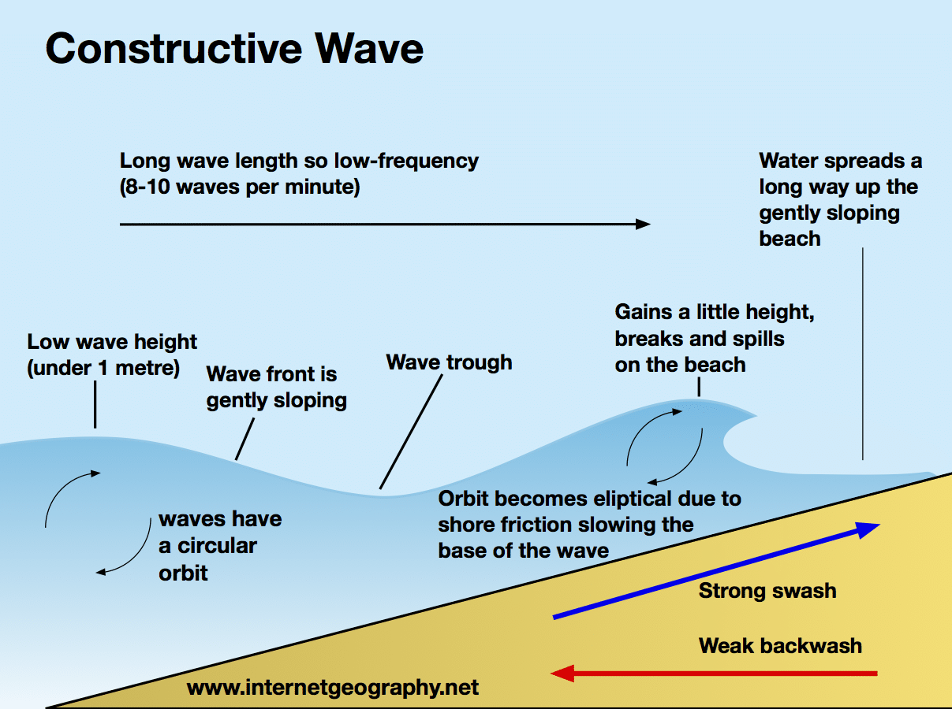
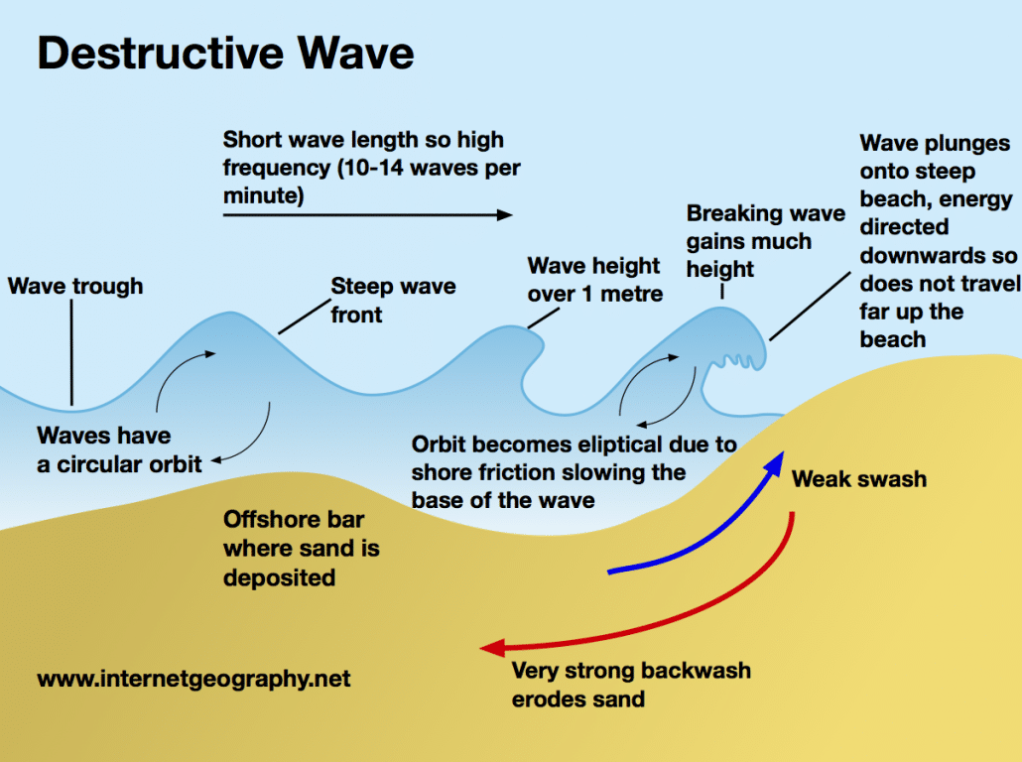
Using the images on the previous page, complete the table below to show the main characteristics of constructive and destructive waves.

Wave Characteristics | Constructive waves | Destructive waves
Wave frequency
Wave height
Wave length
Type of wave (plunging or spilling)
Strength of swash
Strength of backwash
Beach sediment – gain or loss

Check your learning
Head over to www.internetgeography.net/wb26 and complete the key word quiz. Add your score for quiz 2 on the recording sheet.

Dual coding
Use dual coding to summarise what you have studied in this section. Take a look at https://www.internetgeography.net/dual-coding/

Weathering

What is weathering?

_______________________________________________________________________________________

_______________________________________________________________________________________

_______________________________________________________________________________________

What is mechanical weathering?

_______________________________________________________________________________________

_______________________________________________________________________________________

_______________________________________________________________________________________

_______________________________________________________________________________________

Draw an annotated diagram to show the process of freeze-thaw weathering.

Explain the process of salt weathering.

_______________________________________________________________________________________

_______________________________________________________________________________________

_______________________________________________________________________________________

_______________________________________________________________________________________

What is chemical weathering?

_______________________________________________________________________________________

_______________________________________________________________________________________

_______________________________________________________________________________________

_______________________________________________________________________________________

Provide an outline of carbonation weathering, hydrolysis and oxidation.

_______________________________________________________________________________________

_______________________________________________________________________________________

_______________________________________________________________________________________

_______________________________________________________________________________________

_______________________________________________________________________________________

_______________________________________________________________________________________

Check your learning
Head over to www.internetgeography.net/wb27 and complete the key word quiz. Add your score for quiz 3 on the recording sheet.

Dual coding
Use dual coding to summarise what you have studied in this section. Take a look at https://www.internetgeography.net/dual-coding/

Mass Movement

What is mass movement?

_______________________________________________________________________________________

_______________________________________________________________________________________

_______________________________________________________________________________________

Draw an annotated diagram to explain each type of mass movement.
Rockfall | Landslide
Mud slide | Slumping

Check your learning
Head over to www.internetgeography.net/wb28 and complete the key word quiz. Add your score for quiz 4 on the recording sheet.

Dual coding
Use dual coding to summarise what you have studied in this section. Take a look at https://www.internetgeography.net/dual-coding/

Coastal Processes

Complete the table below to describe the four main processes of coastal erosion.

Hydraulic action | Abrasion
Attrition | Solution

Describe the 4 ways material can be transported by the sea.
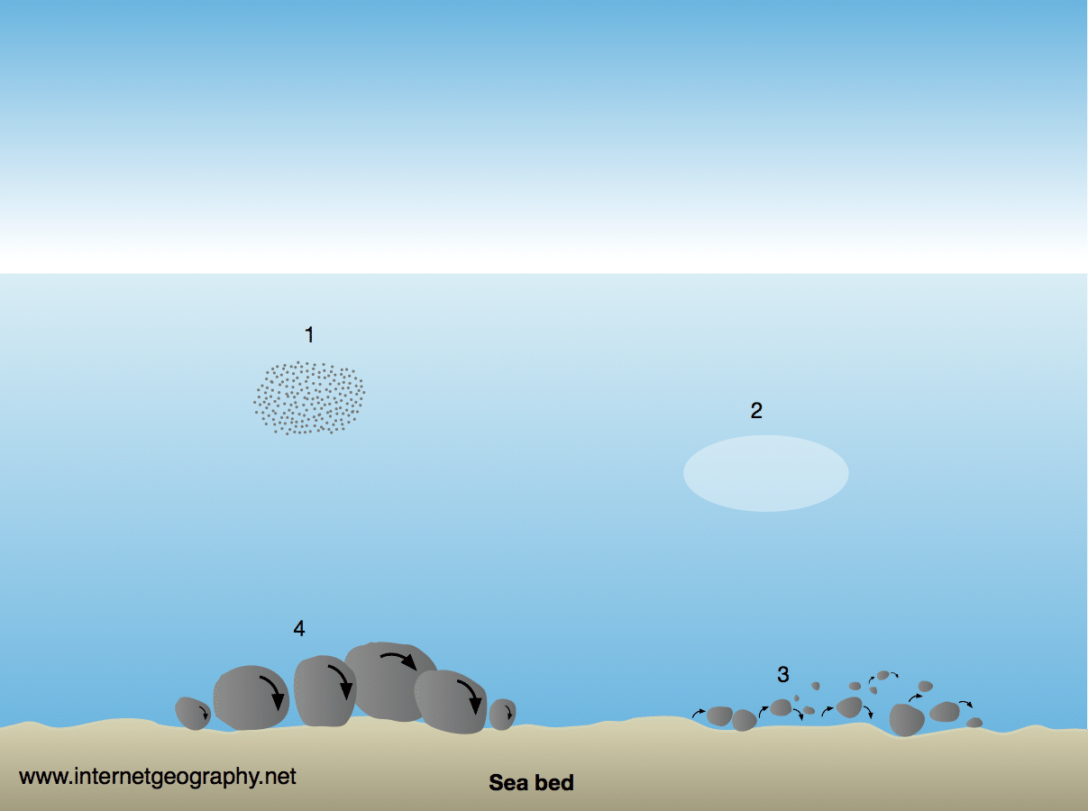

1.
_______________________________________________________________________________________

_______________________________________________________________________________________

_______________________________________________________________________________________

_______________________________________________________________________________________

2.
_______________________________________________________________________________________

_______________________________________________________________________________________

_______________________________________________________________________________________

_______________________________________________________________________________________

3.
_______________________________________________________________________________________

_______________________________________________________________________________________

_______________________________________________________________________________________

_______________________________________________________________________________________

4.
_______________________________________________________________________________________

_______________________________________________________________________________________

_______________________________________________________________________________________

_______________________________________________________________________________________
What is longshore drift?

_______________________________________________________________________________________

_______________________________________________________________________________________

_______________________________________________________________________________________

Using an annotated diagram explain the process of longshore (littoral) drift

What is coastal deposition?

_______________________________________________________________________________________

_______________________________________________________________________________________

_______________________________________________________________________________________

Give three reasons why coastal deposition can occur.

_______________________________________________________________________________________

_______________________________________________________________________________________

_______________________________________________________________________________________

_______________________________________________________________________________________

_______________________________________________________________________________________

_______________________________________________________________________________________

_______________________________________________________________________________________

_______________________________________________________________________________________

_______________________________________________________________________________________

Check your learning
Head over to www.internetgeography.net/wb29 and complete the key word quiz. Add your score for quiz 5 on the recording sheet.

Dual coding
Use dual coding to summarise what you have studied in this section. Take a look at https://www.internetgeography.net/dual-coding/

Coastal landforms of erosion
How do rock type and geological structure affect coastal landscapes and landforms?

_______________________________________________________________________________________

_______________________________________________________________________________________

_______________________________________________________________________________________

_______________________________________________________________________________________

_______________________________________________________________________________________

_______________________________________________________________________________________

_______________________________________________________________________________________

_______________________________________________________________________________________

_______________________________________________________________________________________

What is the difference between a discordant and concordant coastline?

_______________________________________________________________________________________

_______________________________________________________________________________________

_______________________________________________________________________________________

_______________________________________________________________________________________

_______________________________________________________________________________________

_______________________________________________________________________________________

_______________________________________________________________________________________

_______________________________________________________________________________________

_______________________________________________________________________________________

In the space provided produce an annotated diagram to show what is likely to happen to this stretch of discordant coastline in the future.

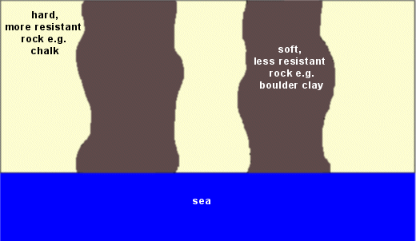

What is wave refraction and what is its impact on bays and headlands?

_______________________________________________________________________________________

_______________________________________________________________________________________

_______________________________________________________________________________________

_______________________________________________________________________________________

_______________________________________________________________________________________

_______________________________________________________________________________________

_______________________________________________________________________________________

Using a diagram, explain the formation of a cliff and wave-cut platform.

Complete the diagram below to explain the erosion of a headland.

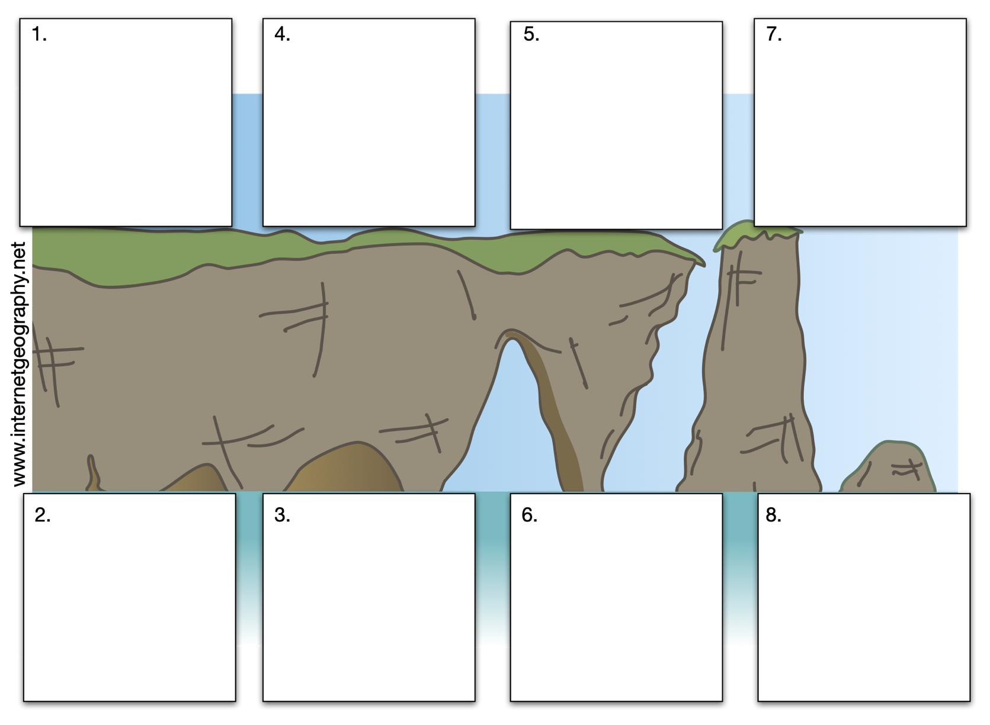

Check your learning
Head over to www.internetgeography.net/wb30 and complete the key word quiz. Add your score for quiz 6 on the recording sheet.

Dual coding
Use dual coding to summarise what you have studied in this section. Take a look at https://www.internetgeography.net/dual-coding/

Coastal landforms of deposition
What is a beach?

_______________________________________________________________________________________

_______________________________________________________________________________________

_______________________________________________________________________________________

Describe and explain the characteristics of a sandy beach.

_______________________________________________________________________________________

_______________________________________________________________________________________

_______________________________________________________________________________________

_______________________________________________________________________________________

Describe and explain the characteristics of a pebble beach.

_______________________________________________________________________________________

_______________________________________________________________________________________

_______________________________________________________________________________________

_______________________________________________________________________________________

Annotate the diagram below to show the main features of a beach.
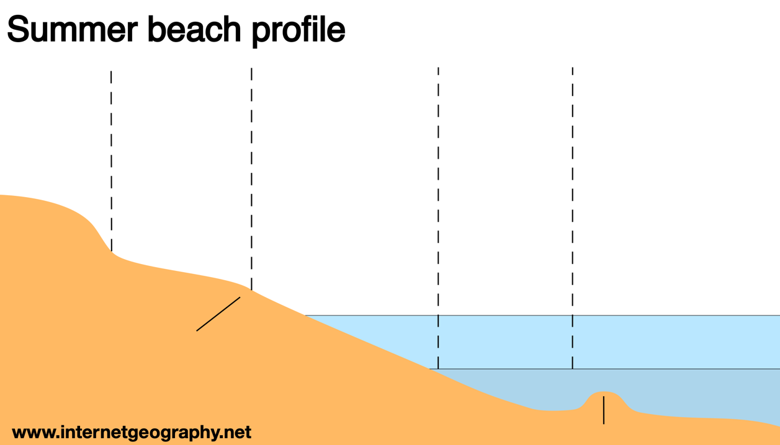
What is a sand dune?

_______________________________________________________________________________________

_______________________________________________________________________________________

_______________________________________________________________________________________

Explain the formation of sand dunes.

_______________________________________________________________________________________

_______________________________________________________________________________________

_______________________________________________________________________________________

_______________________________________________________________________________________

_______________________________________________________________________________________

_______________________________________________________________________________________

_______________________________________________________________________________________

_______________________________________________________________________________________

_______________________________________________________________________________________

Label the diagram below to show how sand dunes change inland. 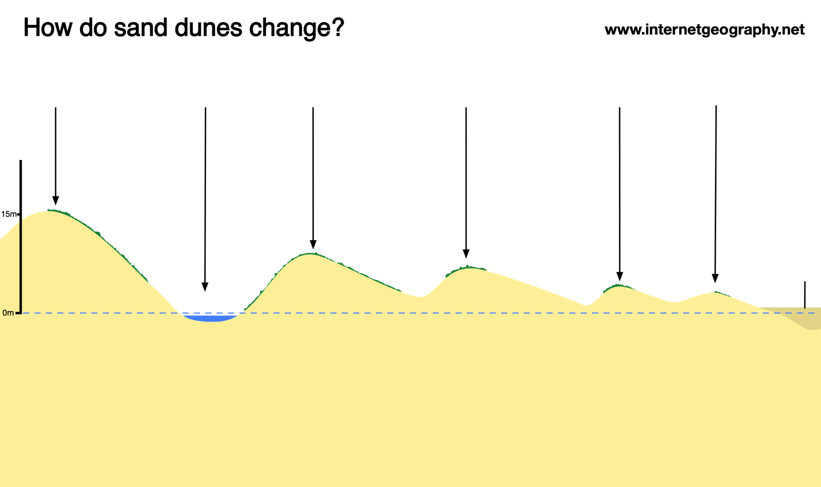
What is a coastal spit?

_______________________________________________________________________________________

_______________________________________________________________________________________

_______________________________________________________________________________________

Annotate the diagram below to explain the formation of a spit.

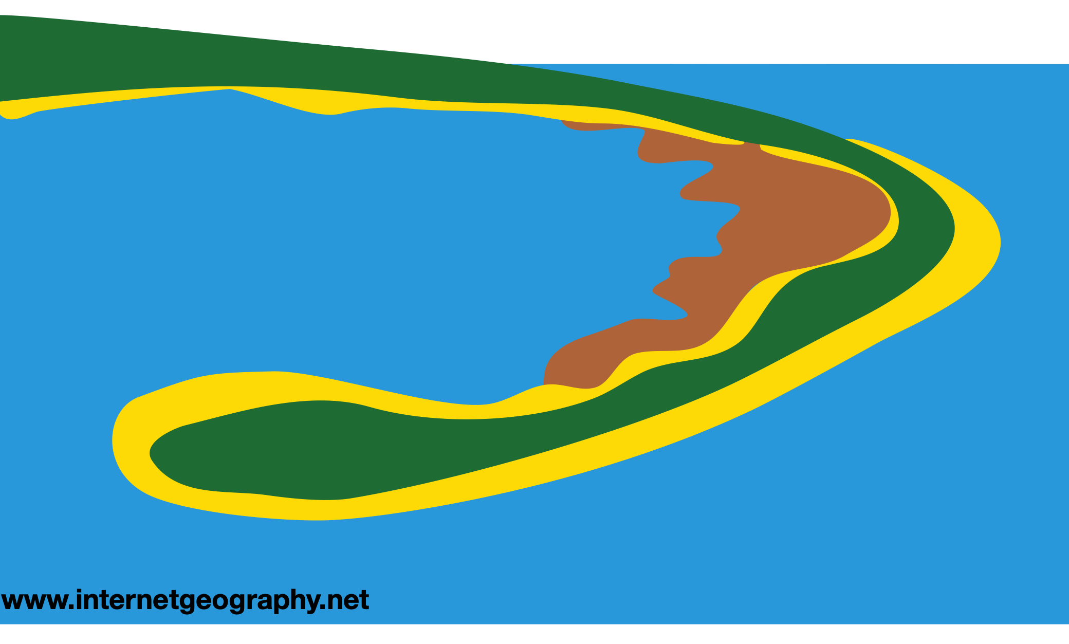

What is a coastal bar?

_______________________________________________________________________________________

_______________________________________________________________________________________

_______________________________________________________________________________________

Draw a diagram to show the formation of a bar.

Check your learning
Head over to www.internetgeography.net/wb31 and complete the key word quiz. Add your score for quiz 7 on the recording sheet.

Dual coding
Use dual coding to summarise what you have studied in this section. Take a look at https://www.internetgeography.net/dual-coding/

An example of a section of coastline in the UK to identify its major landforms of erosion and deposition.
The Holderness Coast

Describe the geology of the Holderness Coast

_______________________________________________________________________________________

_______________________________________________________________________________________

_______________________________________________________________________________________

_______________________________________________________________________________________

_______________________________________________________________________________________

_______________________________________________________________________________________

_______________________________________________________________________________________

Describe the features found along the Holderness Coast from Flamborough Head in the north to Spurn Point in the south.

Location | Landforms of erosion/deposition
Flamborough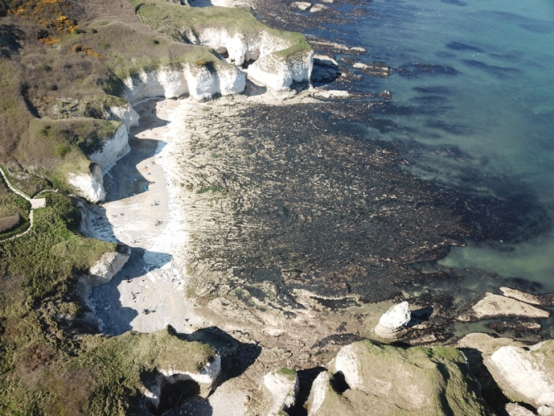
Hornsea 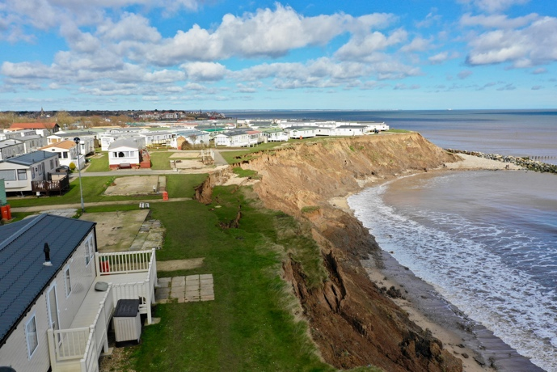
Spurn Point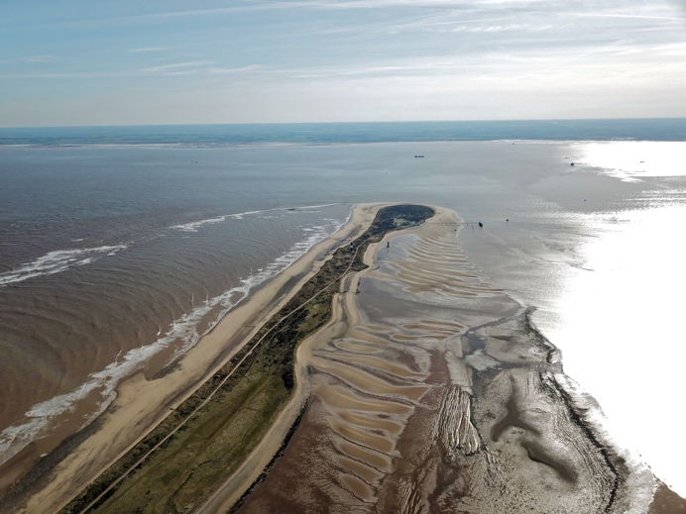

Check your learning
Head over to www.internetgeography.net/wb32 and complete the key word quiz. Add your score for quiz 8 on the recording sheet.

Dual coding
Use dual coding to summarise what you have studied in this section. Take a look at https://www.internetgeography.net/dual-coding/

Coastal management strategies
Give a brief outline of each of the four coastal management options are.

Do nothing:

Hold the line:

Advance the line:

Managed retreat:

Complete the table below about the main hard engineering strategies.
Strategy | Sketch | Costs | Advantages
Sea wall
Rock armour
Gabions
Groynes

Complete the table below about the main soft engineering strategies.
Strategy | Sketch | Costs | Advantages
Beach nourishment and reprofiling
Dune regeneration

What is managed retreat?

_______________________________________________________________________________________

_______________________________________________________________________________________

_______________________________________________________________________________________

What are the costs and benefits of managed retreat?
Costs | Benefits

Check your learning
Head over to www.internetgeography.net/wb33 and complete the key word quiz. Add your score for quiz 9 on the recording sheet.

Dual coding
Use dual coding to summarise what you have studied in this section. Take a look at https://www.internetgeography.net/dual-coding/

An example of a coastal management scheme in the UK
Case study location:________________________________________________________

Reasons for management

_______________________________________________________________________________________

_______________________________________________________________________________________

_______________________________________________________________________________________

_______________________________________________________________________________________

_______________________________________________________________________________________

_______________________________________________________________________________________

Management strategies

_______________________________________________________________________________________

_______________________________________________________________________________________

_______________________________________________________________________________________

_______________________________________________________________________________________

_______________________________________________________________________________________

_______________________________________________________________________________________

Effects of management strategies

_______________________________________________________________________________________

_______________________________________________________________________________________

_______________________________________________________________________________________

_______________________________________________________________________________________

_______________________________________________________________________________________

_______________________________________________________________________________________

_______________________________________________________________________________________

Conflicts

_______________________________________________________________________________________

_______________________________________________________________________________________

_______________________________________________________________________________________

_______________________________________________________________________________________

_______________________________________________________________________________________

_______________________________________________________________________________________

_______________________________________________________________________________________

_______________________________________________________________________________________

_______________________________________________________________________________________

Dual coding
Use dual coding to summarise what you have studied in this section. Take a look at https://www.internetgeography.net/dual-coding/

Check your learning recording table

 | Attempt 1 | Attempt 2 | Attempt 3
Quiz 1  www.internetgeography.net/wb25/ | /7 | /7 | /7
Quiz 2  www.internetgeography.net/wb26/ | /10 | /10 | /10
Quiz 3  www.internetgeography.net/wb27/ | /8 | /8 | /8
Quiz 4  www.internetgeography.net/wb28/ | /8 | /8 | /8
Quiz 5  www.internetgeography.net/wb29/ | /13 | /13 | /13
Quiz 6  www.internetgeography.net/wb30/ | /10 | /10 | /10
Quiz 7  www.internetgeography.net/wb31/ | /10 | /10 | /10
Quiz 8  www.internetgeography.net/wb32/ | /9 | /9 | /9
Quiz 9  www.internetgeography.net/wb33/ | /10 | /10 | /10

