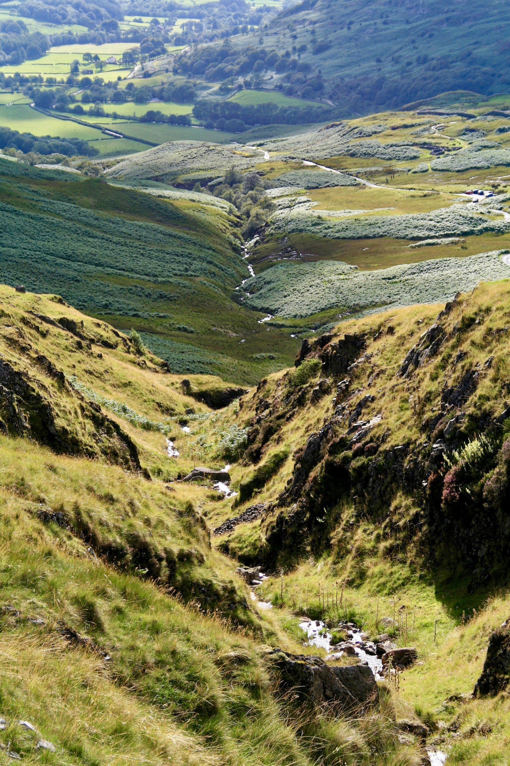
GEOGREVISE
by internet geography

Step 1 – Review your learning
Before you start your revision, you need to be clear about what it is you need to revise. This means going over everything covered in the unit you have studied then deciding how much you understand. This will give you an idea of what areas you need to focus your revision on. Complete the coastal environments personal learning check list (PLC) to check what you feel confident about and what you need to work on.

Step 2 – Revision
Technique 1 - Revision Cards
1. Make notes on an area of study. This could involve highlighting information in a revision book or writing information out. Grade C+ students avoid copying huge chunks of text. They read the information - then summarise it.
2. Once you have gathered notes summarise your notes on revision cards - blank postcards or post-it notes are good for this. You can then stick them all around your bedroom, toilet, bathroom etc! See an example here: https://www.internetgeography.net/revision-techniques/
3. Read your cards through regularly. Once you're confident about knowing the information write key words about the topic on a card. Then revise from these. As your knowledge base builds up you will need fewer prompts to remember information. BRAIN SCIENCE ALERT: By displaying this information and regularly reading it you will create stronger connections between the neurons in your brain which will help you retain information.

Technique 2 - Mind Maps A mind map is a spider diagram that contains information in the form of pictures and text. Mind maps can be used to plot information relevant to the different topics in geography. To find out more on mind mapping see this page: https://www.internetgeography.net/revision-techniques/

Technique 3 - Asking questions when taking notes This technique involves you asking questions when making notes. The example below considers the main features of earthquakes.
 | What | When | Why | Where | Who | So what?
Earthquakes
Question cues you can use are what?, when?, why?, where?, who? and how? There are more - can you think of any?

Technique 4 - Change the form of information
Your text books contain a lot of information. Some people can read this information and remember it! If you find it hard to retain information that you read, then do something with it. For example, take a piece of text and transform it into a diagram.

Technique 5 - Teach It!
Another useful method of learning information is to try and teach someone else what you have learnt.

A good method to use is to write down the key points of what has been learnt
over a set period e.g. 3 lessons and try to teach the other person, who questions
everything he or she cannot clearly understand.
Try also setting a test on what you have taught. The other person’s answers will
clarify your own thinking!

Technique 6 - What would you tell your brother?
Simplify some text about the topic you are revising and write down what you would tell someone younger than you.

Technique 7 - Condense it
Read a paragraph of text and condense it into one sentence.

Technique 8 - Condense it with a friend
Complete technique 5 and/or 6 with a friend. Compare your answers and discuss your choices.

Resources to support revision for this unit are available here: www.internetgeography.net/topics/rivers/

Step 3 – Retrieval Practice
Improve learning by reducing forgetting using retrieval practice
Retrieval practice involves retrieving and using knowledge. Through thinking about and using what we know we strengthen learning. Low stakes quizzes, flashcards and quick writing can be used to improve learning. This booklet contains questions for retrieval practice from p5. Ask a friend or parent to quiz you using the questions.

Step 4 – Exam Questions
Once you’re feeling confident have a go at completing some past exam papers. Your teacher will be able to provide you with these.

Geogrevise – AQA Fluvial Environments
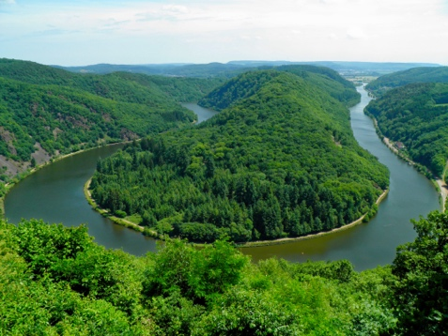
Fluvial Environments PLC
Homework Tips Checklist for Parents

Red = Not confident at all
Amber = Some confidence
Green = Very confident

 | Red | Amber | Green
The shape of river valleys changes as rivers flow downstream
I know what the long profile of a river is
I know how and why the long profile of a river changes from source to mouth
I know the characteristics of the cross profile of a river in the upper, middle and low course
I know how and why the characteristics of the cross profile of a river in the upper, middle and low course change
I know the characteristics of the cross profile of a river valley in the upper, middle and low course
I know how and why the characteristics of the cross profile of a river valley in the upper, middle and low course change
I can describe and explain the 4 main processes of fluvial erosion
I can describe and explain the 4 main processes of fluvial transportation
I know why rivers deposit sediment
I know where and why rivers deposit sediment
Distinctive fluvial landforms result from different physical processes.
I know the characteristics and formation of landforms resulting from erosion:
- interlocking spurs
- waterfalls
- gorges
I know the characteristics and formation of landforms resulting from erosion and deposition:
- meanders
- ox-bow lakes
I know the characteristics and formation of landforms resulting from deposition:
- levées
- flood plains
- estuaries
I know an example of a river valley in the UK to identify its major landforms of erosion and deposition.

Different management strategies can be used to protect river landscapes from the effects of flooding.
I know how physical factors affect the flood risk:
- precipitation
- geology
- relief
I know how human factors affect the flood risk:
- landuse
I know how to use hydrographs to show the relationship between precipitation and discharge.
I can describe and explain the costs and benefits of hard engineering strategies:
- dams and reservoirs
- straightening
- embankments
- flood relief channels
I can describe and explain the costs and benefits of soft engineering strategies:
- flood warnings and preparation
- flood plain zoning
- planting trees
- river restoration
I know an example of a flood management scheme in the UK to show:
- why the scheme was required
- the management strategy
- the social, economic and environmental issues

GEOGREVISE FLUVIAL ENVIRONMENTS

Homework Tips Checklist for Parents
Retrieval Practice
Homework Tips Checklist for Parents

THE LONG PROFILE
- What is the long profile of the river?
- Where is the steepest gradient in the long profile of a river?
- Why does the long profile of a river become concave in the middle course?
- Why in the upper course is the cross profile of a river valley narrow and steep sided?
- Why does the river channel become wider and deeper with distance downstream?
- In the middle course of the river valley floor becomes wider why is this?
- Why do discharge and velocity increase downstream?

Fluvial Processes – Erosion
- What is vertical erosion?
- What is lateral erosion?
- Identify the four Processes of erosion that occur within a river.
- What is hydraulic action?
- What is abrasion?
- What is attrition?
- What is the solution?
- What happens to the shape and size of bed load as you move down the river?
- What is the main process of erosion in the upper course of a river?

Fluvial Processes – Transportation
- Identify the four main processes of transportation in a river?
- What is traction?
- What is saltation?
- What is suspension?
- What is solution?

Fluvial Processes – Deposition
- What is deposition?
- Why do rivers deposit sediment?
- Give three examples of where a river may deposit sediment.

THE cross profiles OF A RIVER
- What is a cross profile?
- What is a channel cross profile?
- What is a valley cross profile?
- How does a channel cross-section change downstream?
- Why does the channel cross-section change downstream?
- How does the valley cross-section change downstream?
- Why does the valley cross-section change downstream?

Interlocking spurs and rapids
- What are interlocking spurs?
- Give three characteristics of interlocking spurs.
- What are rapids?
- how are rapids formed?
- Give three characteristics of rapids.

Waterfalls and gorges
- Where are waterfalls and gorges typically found along the long profile of a river?
- What is a waterfall?
- Draw a diagram to illustrate the formation of a waterfall.
- What is a gorge?
- Give three characteristics of a gorge.
- How does a waterfall create a gorge?

Meanders and oxbow lakes
- Draw a simple diagram to show the main features of a meander.
- How is a meander formed?
- What is an oxbow lake?
- Draw a simple diagram to show the formation of an oxbow lake.
- Explain the formation of an oxbow lake.

Levees and floodplains
- What is a levee?
- What are the characteristics of levees?
- How are levees formed?
- What is a flood plain?
- What are the characteristics of a flood plain?
- How is a flood plain formed?
- Why are flood plains often very fertile?

Example of a river valey in the UK
- Give an example of a river valley in the UK that you have studied
- Identify the landforms of erosion in the river valley you have studied
- Identify the major landforms of deposition in the river valley you have studied

Physical casuses of flooding
- What does the drainage basin hydrological cycle show?
- Draw a simple diagram to show the main features of the drainage basin hydrological cycle.
- What is precipitation?
- What is interception?
- What is surface run-off?
- What is evaporation?
- what is transpiration?
- Give three natural ways flood risk can be increased.
- How can geology increase flood risk?
- How can relief increase flood risk?

Human causes of flooding
- Identify three ways humans can increase the risk of flooding In urban areas.
- Identify three ways humans can increase the risk of flooding in rural areas.
- How does a change from pastoral to arable farming increase the risk of flooding?
- How does building a new housing estate on the floodplain increase the risk of flooding?

Hydrographs
- What is a hydrograph?
- What is shown on the vertical axis of a hydrograph?
- What is shown on the horizontal axis of a hydrograph?
- What is peak rainfall?
- What is peak discharge?
- What is like time?
- What does a rising limb show on the hydrograph?
- What does a falling limb on a hydrograph show?
- What is base flow?
- What is bankfull discharge?
- What are the characteristics of a flashy or storm hydrograph?

River management: hard engineering
- What is hard engineering?
- Give three examples of hard engineering
- Identify one social cost of dams and reservoirs
- Identify one economic benefit of dams and reservoirs
- List the social economic and environmental benefits of embankments

River management: soft engineering
- What is soft engineering?
- Give three examples of soft engineering.
- Identify two benefits of floodplain zoning
- Identify two costs of floodplain zoning
- Give two benefits of planting trees
- Identify one cost of planting trees

Example of a flood management scheme in the UK
- Identify the flood management scheme you have studied
- Why was the scheme required?
- What management strategy was used?
- Identify a social, economic and environmental benefit of the flood management scheme.
- Identify a social, economic and environmental cost of the flood management scheme.

Answers

THE LONG PROFILE
- A Long profile shows the gradient of the river from its source to mouth.
- The steepest gradient in the long profile of a river is found in the upper course near to the source.
- The gradient of the long profile becomes more concave as vertical erosion reduces.
- It becomes narrow and steep sided in the upper course due to vertical erosion.
- The river channel becomes deeper due to the increase in discharge and wider due to lateral erosion.
- The increase in lateral erosion.
- Discharge increases downstream because of additional water from tributaries. Velocity increases due to the additional water from tributaries and less water is in contact with the bed and banks so there is less friction.

Fluvial Processes – Erosion
- Vertical erosion involves the deepening of the river bed. This is mostly by hydraulic action. It is most common in the upper course of the river.
- Lateral erosion erodes the banks of the river. This is more common in the middle and lower courses of a river.
- Abrasion or corrasion, attrition, hydraulic action and solution or corrosion
- Hydraulic action is when the force of fast-flowing water hits the bed and banks and forces water and air into cracks in the bedrock. The repeated changes in air pressure cause the river bed to weaken.
- Abrasion, also known as corrasion, is when boulders and stones wear away the river banks and bed. Angular rocks that have entered the channel recently are useful tools of abrasion because they are more angular. Abrasion is responsible for both lateral and vertical erosion of the river channel
- Attrition is when sediment particles knock against the bed or each other and break, becoming more rounded and smaller as you move down the river.
- Solution (or corrosion) is when acidic water dissolves rocks such as chalk or limestone.
- It becomes more rounded and smaller.
- Hydraulic action.

Fluvial Processes – Transportation
- Solution, suspension, saltation and traction.
- Large boulders and rocks are rolled along the river bed.
- Small pebbles and stones are bounced along the river bed.
- Fine, light material is carried along in the water.
- Minerals are dissolved in the water and carried along in solution.

Fluvial Processes – Deposition
- Deposition is the processes by which a river drops its load.
- Deposition occurs whenever a river loses energy and velocity falls.
- Deposition occurs:
- a river enters a shallow area (this could be when it floods and comes into contact with the flood plain)
- at the base of a waterfall
- on the inside bend of a meander
- towards its mouth where it meets another body of water.

THE cross profiles OF A RIVER
- River cross profiles show you a cross-section, taken sideways, of a river’s channel and/or valley at certain points in the river’s course.
- A channel cross-profile is a cross section of only the river channel.
- A valley cross-profile includes the channel, the valley floor and the sides of the valley.
- In the upper course the channel is very narrow and very shallow. By the middle course the channel becomes wider and deeper usually over 1 m. By the lower course the channel becomes wider still and the channel is much deeper.
- In the upper course, the river erodes its bed by hydraulic action and abrasion. As the river flows downstream it is joined by tributaries, increasing the volume of water, velocity and therefore its erosive power. This enables it to cut a deeper channel as it flows downstream.
Downstream, the channel becomes wider as the gradient becomes more gentle leading to less vertical erosion. By the middle course of the river lateral erosion becomes the dominant type of erosion. The channel becomes wide because of lateral erosion.
- In the upper course, the valley cross-profile is narrow and steep-sided. The river takes up most of the valley floor. In the middle course, the valley becomes wider due to lateral erosion. By the lower course, the valley is almost flat, consisting of a wide flood plain.
- A steep, V-shaped cross-profile is typical in the upper course. This is because of vertical erosion by the river combined with weathering and mass movement of the valley slopes.
In the middle course, the river is flowing through lower lying land. The gradient is gentler, so the river begins to meander (bend). As it does this the dominant type of erosion becomes lateral, eroding the valley sides. The makes the valley broader. Also, the rate of weathering increases on the softer rocks of the valley sides.
In the lower course, the river is passing through the low-lying country. Flooding results in deposition building up the flood plain and this, along with migrating meanders builds up and widens the valley further.

Interlocking spurs and rapids
- Interlocking spurs are fingers of land that jut out into the river valley that streams and rivers are forced to flow around in the upper course.
- Steep gradient, convex slopes, project from alternate sides of the family, separated by a narrow valley floor which is mainly taken up by the river channel, sometimes covered in Woodland and may have scree slopes.
- Rapids are fast flowing, turbulent sections of the river where the bed has a relatively steep gradient. They are found in the upper course of the river.
- Rapids form when there is a vertical bedding which is when alternate bands of hard and soft rock cross the channel. Differential erosion will occur as soft rock is more easily eroded than hard rock. This makes the riverbed uneven and river’s flow becomes turbulant leading to white water sections typical of rapids.
- The characteristics of rapids include:
- turbulent flow of water
- white water
- uneven river bed
- steep gradients.

Waterfalls and gorges
- Waterfalls and gorges are typically found in the upper course of the river.
- A waterfall is a step in the long profile of the valley. It is where water falls down the vertical drop in the channel usually from a considerable height.
- 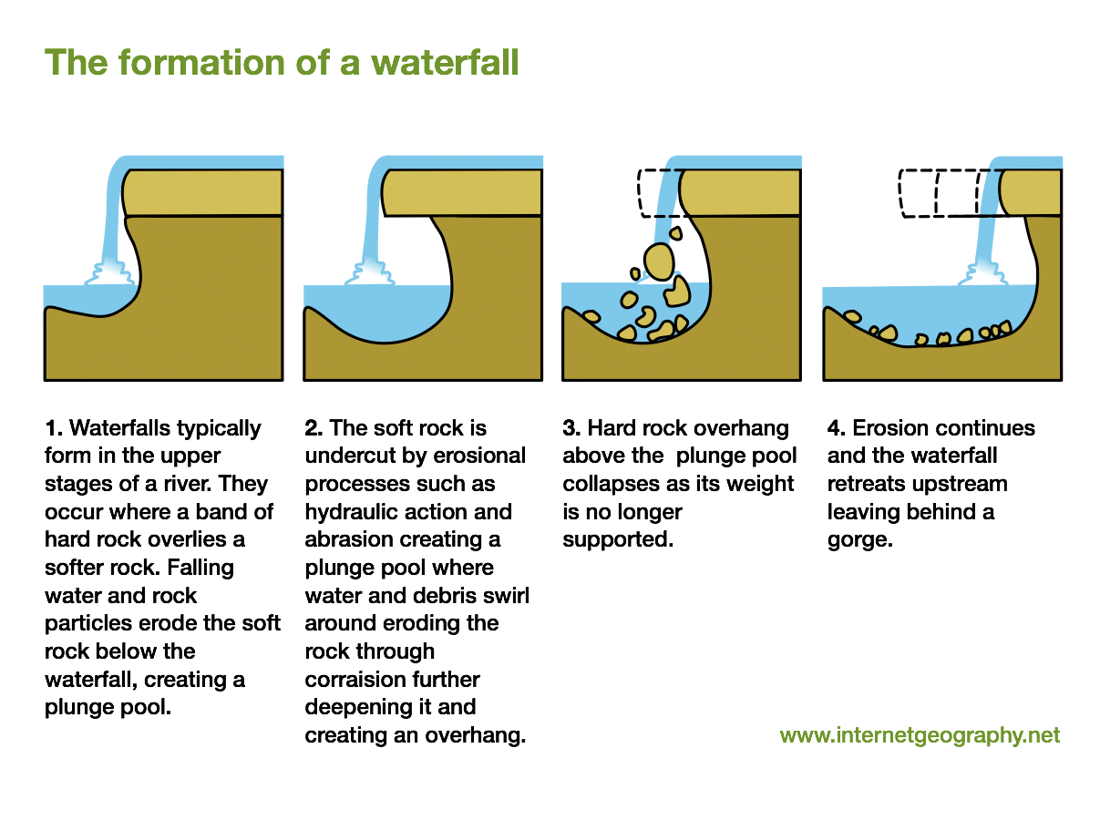
- A gorge is a narrow, steep sided valley, with bare, rocky walls
- Characteristics of gorge include:
- very narrow valley
- very steep, high valley sides is
- located immediately downstream of a waterfall
- river channel takes up most, if not all, of the valley floor
- boulders litter the river bed
- turbulent, fast flowing whitewater
- As a waterfall it needs behind the steep sided valley which is called gorge. Every time the overhanging Rock breaks off the gorge retreats and grows longer.

Meanders and oxbow lakes
- 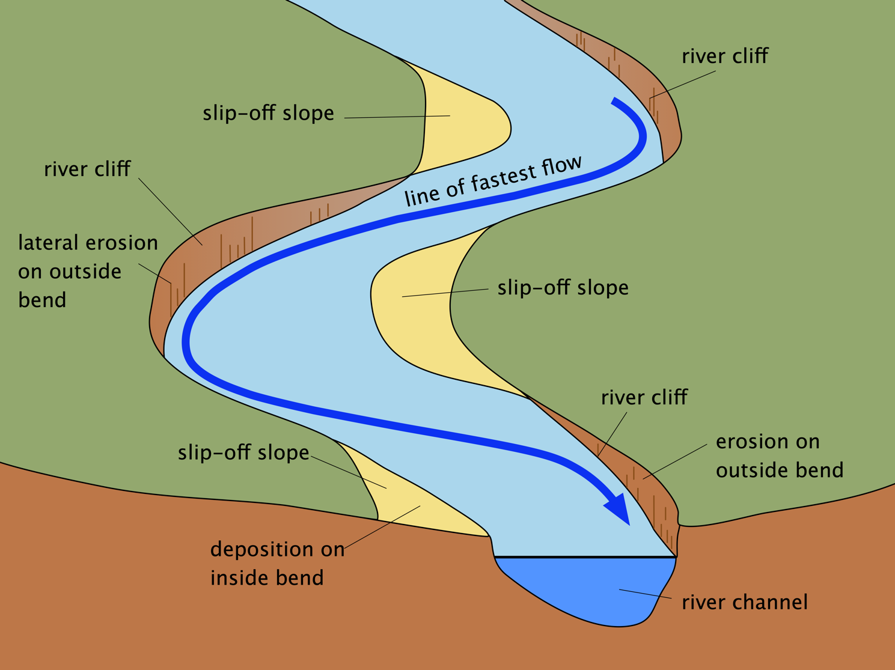
- Water flows slowly over shallow areas (riffles) in the riverbed and faster through pools, deeper sections of the river. This leads to helicoidal flow that cork screws from one bank to another. Fast flowing water on the outside bank causes lateral erosion through hydraulic action and abrasion which under cuts the bank, creating a river cliff. Eroded material is then deposited on the inside of the next meander where friction slows the flow, creating a slip-off slope.
- An oxbow lake is a small, horseshoe shaped lake that is located several meters from a straight stretch of river.
- 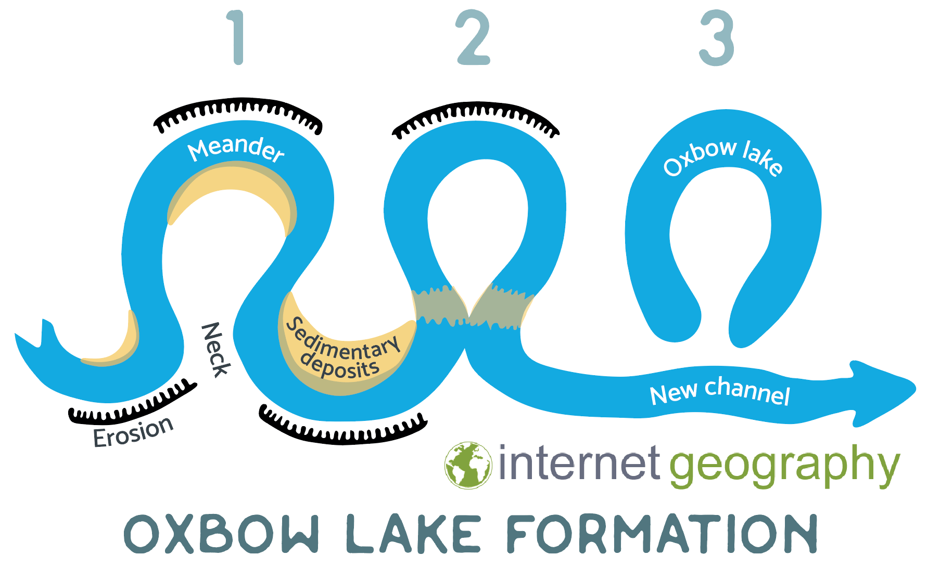
- Due to erosion on the outside of a bend and deposition on the inside, the shape of a meander will change over a period of time. Erosion narrows the neck of the land within the meander and as the process continues, the meanders move closer together. When there is a very high discharge (usually during a flood), the river cuts across the neck, taking a new, straighter and shorter route. Deposition will occur to cut off the original meander, leaving a horseshoe-shaped oxbow lake.

Levees and floodplains
- Levees are naturally raised riverbanks found along the sides of the river channel that has experienced flooding.
- The main characteristics of levees are:
- raised river banks
- consist of gravel, stones and small sediment
- steep on the channel side, gentle sloping on the land side
- relatively flat top covered in grass
- When a river floods friction with the floodplain leads to a rapid decrease in the velocity of the river and therefore its capacity to transport material. Larger material is deposited closest to the river bank. This often leads to large, raised mounds being formed. Smaller material is deposited further away and leads to the formation of gently sloping sides of the levees.
- A flood plain is a large area of flat land either side of the river that experiences or has experienced flooding.
- Characteristics of a flood plain include:
- A large area of flat land either side of a river
- layers of alluvium cover the flood plain
- a river bluff along the edge of a flood plain
- meander scars
- levees
- rich, fertile soil
- reeds and marsh plants
- Floodplains form due to erosion and deposition. Erosion removes any interlocking spurs, creating a wide, flat area on either side of the river. During a flood, material being carried by the river is deposited (as the river loses its speed and energy to transport material). Over time, the height of the floodplain increases as material is deposited on either side of the river. The floodplain is often a wide, flat area caused by meanders shifting along the valley.
- It’s made up of alluvium (deposited silt from a river flood).

Example of a river valey in the UK
- Examples will vary depending on which river valley has been studied but could include the River Tees, River Tyne, River Severn etc.
- Landforms of erosion will be identified and could include waterfalls, rapids, interlocking spurs, gorges and meanders
- Landforms of deposition will be identified and could include meanders, levees and floodplains.

Physical casuses of flooding
- The drainage basin hydrological cycle shows how precipitation, falling on a catchment areas, reaches a river. It also shows how water leaves the catchment area.
- 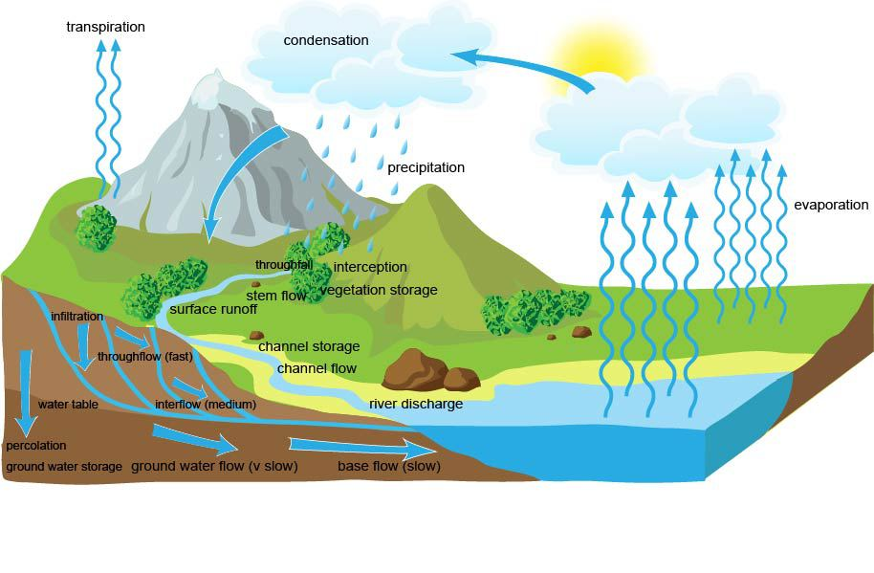
- Precipitation is any form of moisture reaching the ground.
- Interception is when precipitation is prevented from reaching the ground. This could be by vegetation or buildings.
- Surface run-off is when water flows over the surface of the ground.
- Evaporation is when water is lost from the ground as it turns from liquid to vapor due to an increase in temperature or pressure.
- Transpiration is the loss of water from vegetation through pores.
- Natural ways flood risk can be increased include:
- heavy rainfall caused by depressions causing heavy, continuous rain which saturates the soil. The land can no longer absorb water as it is saturated increasing surface run-off, higher river discharge and flooding.
- sudden downpours occurring following a very dry period can lead to flooding because the surface is baked hard. Surface run-off occurs as water cannot infiltrate leading to higher river discharge and flooding.
- sudden snow melt releases stored water that flows over the land as surface run-off
- the loss of vegetation cover through drought or disease can lead to flooding as less interception occurs so more precipitation reaches the surface leading to increased surface run-off.
- Geology can increase the risk of flooding when:
- The upland bedrock is impermeable, such as slate, which means there is more surface run-off
- Soil in low lying areas is made up of clay. Because it is so compact it is difficult for infiltration to occur.
- Areas of permeable rock, such as limestone, become inundated with water leading to increased surface run-off
- Relief can increase flood risk because:
- Steep sided slopes mean that it is hard for infiltration to occur which leads to greater surface run-off
- Low lying flood plains are at risk of flooding because they do not have enough gradient to move the water on quick enough. This risk increases when the soils have a high clay content.
- Upland areas are more likely to experience rain due to relief rainfall. This increases the likelihood of high levels of precipitation and therefore surface run-off.

Human causes of flooding
- Three ways humans can increase the risk of flooding in urban areas are:
- Building new infrastructure
- Building new houses
- Disappearing gardens
- Three ways humans can increase the risk of flooding in rural areas are:
- Deforestation
- Intensive farming, leaving fields bare in the winter
- Over grazing
- Increased use of polytunnels
- A change from pastoral to arable farming increases the risk of flooding because one crops have been harvested the soil is sometimes left bare in the winter. This reduces interception because there is no vegetation.
- Building a new housing estate on the floodplain increases the risk of flooding because the surface becomes impermeable due to the construction of houses, tarmac roads and concrete pavements. Surface run-off increases leading to a rapid increase in a river’s discharge.

Hydrographs
- A hydrograph is a way of showing how a river’s discharge changes in response to a precipitation event.
- Precipitation and discharge
- Time
- The highest amount of rainfall per time units (the highest bar).
- The highest discharge following a rainfall event.
- The time between the peak rainfall and the peak discharge.
- How quickly the discharge increases after a storm event.
- Shows the reduce in discharge over time after the peak.
- The normal discharge of a river when its level is being sustained by groundwater flow.
- The maximum discharge level before flooding will occur.
- A flashy or storm hydrograph will have a steep rising limb and a short lag time.

River management: hard engineering
- Hard engineering involves the use of heavy machinery to build artificial structures which work against nature to reduce a flood risk.
- Examples of hard engineering include:
- Dams and reservoirs
- Channel straightening
- Embankments
- Flood-relief channels
- A social cost of constructing dams and reservoirs is the displacement of people due to flooding.
- One economic benefit of constructing dams and reservoirs is that it boosts tourism. For example, the local economy of Kielder has been boosted by £6 million thanks to the construction of Kielder Dam.
- Benefits of embankments:
Social:
- Safer from flooding due to the increased carrying capacity of the river so the risk of flooding to nearby settlements is reduced.
- Embankments are often used for walking routes which makes the embankment a more attractive walkway for local people.
Economic:
- Cheap compared to other methods of hard engineering
Environmental:
- Habitats are provided for riverbank animals such as otters, voles and kingfishers

River management: soft engineering
- Soft engineering involves working with nature and adapting to a river and learning to live with it.
- Flood warnings, flood plain zoning, planting trees and river restoration.
- Low cost solution, reduces additional impermeable surface coverage of the floodplain, protects and conserves water meadows for wildlife and recreation and reduces insurance costs when property has been flooded
- Restricts economic development as certain land uses are prohibited, if land cannot be used for building the current housing shortage will continue, through building elsewhere habitats may be lost, and it is very difficult to implement retrospectively where urban development has already taken place on the floodplain.
- Benefits wildlife by creating habitats, natural method of intercepting precipitation and slowing water transfer in a river basin, absorbs and stores carbon reduce the amount of carbon dioxide in the atmosphere and it is relatively inexpensive.
- Can reduce habitat diversity when hillsides are covered in trees, can lead to acidity in soil and the loss of farm land.

Example of a flood management scheme in the UK
The answers to this section will vary by case study.
- Appropriate flood management scheme identified.
- Social, economic and environmental reasons will be given.
- Clear identification of a management strategy used.
- One social, economic and environmental benefit of the flood management scheme will be identified.
- One social, economic and environmental cost of the flood management scheme will be identified.

