[](https://www.google.co.uk/imgres?imgurl=https://png.pngtree.com/element_origin_min_pic/17/07/23/34f2df6af79bdf4ddbcecdb50622171a.jpg&imgrefurl=https://pngtree.com/freepng/hand-painted-cartoon-statistics_3277535.html&docid=Xd-Ig4vWIkB9yM&tbnid=3aX2eJAynK8mQM:&vet=10ahUKEwjKyaSo24XcAhWEbMAKHShSD08QMwjOAigvMC8..i&w=650&h=452&safe=strict&bih=619&biw=1024&q=statistics%20cartoon&ved=0ahUKEwjKyaSo24XcAhWEbMAKHShSD08QMwjOAigvMC8&iact=mrc&uact=8)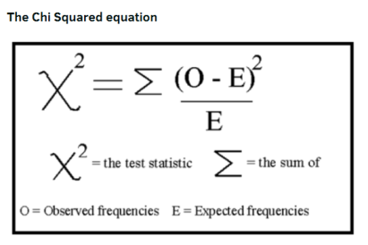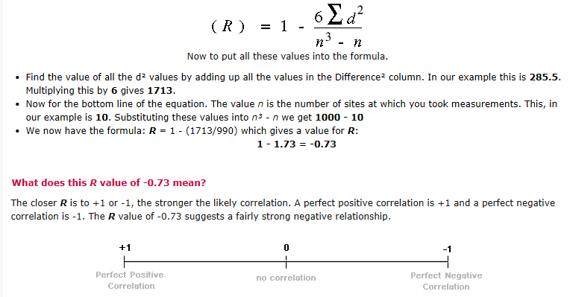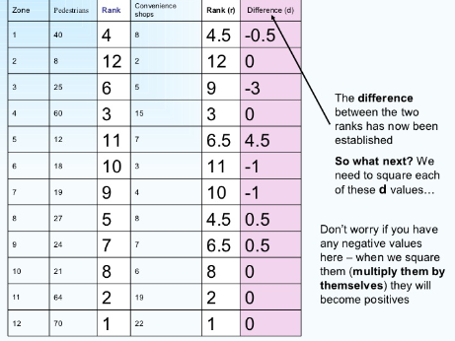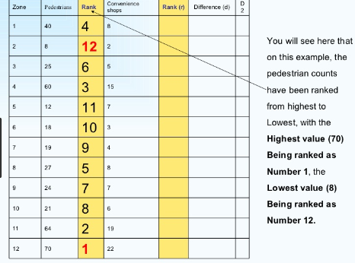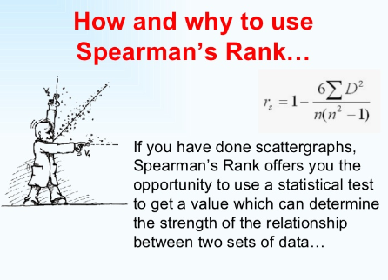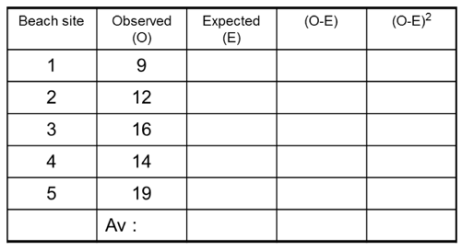

Geography – Statistics

**Figure it out**

* **Percentage of a number**. E.g. To find 20% of 30, convert 20% to a decimal and multiply by 30. 20% = 0.2, 0.2 x 30= 6
* **Area in km2** – the land size of a place. E.g the UK is 243,610 km2
* **Map scale** – 1cm = a given size of the map. E.g. 1:100000 = 1cm = 1km on the map

Chi squared – to help us

test a hypothesis

Hypothesis: Beach material gets larger as you move south along the beach

Null hypothesis: there is NO significant variation in pebble size along the stretch of beach

1.Step 1: put in the figures recorded in the Observed column (O)

2.Step 2: work out the average (mean) figure for O (add up the column & divide by number of data sets)

3.Step 3: put the ‘average’ into the ‘Expected’ column (E)

4.Step 4: work out O-E and put into the next column

5.Step 5: work out O-E squared and put into the next column and total up the column

6.Step 6: that is the top part of the formula – now divide by the ‘E’ figure to get your chi-squared number

Range = the difference between the highest and lowest values. It gives us a good measure of the spread of the values in a data set and provides another means of description for an ‘average’.

Example:

Data: 11, 15, 17, 22, 24, 26, 34, 35

Range = 35-11 = 24

Quartiles and inter-quartile range

The median is the middle value in a ranked data set (in order). It splits the data set into two halves, an upper half and a lower half. These two halves can be split again into quarters. We call them quartiles.

For example if we have 20 values in a data set, the median would be halfway between the 10th and 11th value. The upper quartile would then lie between the 5th and 16th value, and the lower quartile between the 5th and 6th value. So over all, there are 4 groups with 5 numbers in.

SO… the interquartile range = the difference between the upper quartile and the lower quartile. Look at the example below:

Data = 3, 3, 3, 4, 6, 7, 7, 8, 8, 10, 14, 14, 16, 20, 21, 21, 22

1. Median = 10+14 = 24/2 = 12
2. Lower quartile = 6+7 = 13/2 = 6.2
3. Upper quartile = 21 +21 = 42/2 = 21
4. Interquartile range = 21-6.5 = 14.5

Mean = calculated by adding up all the values in a data set and then dividing by the number of values.

Example: 10 14 8 16 14 9 12 18 10 9

Mean is 120 divided by 10 = 12

Median = this is the central or middle value in a ranked data set. This means once all the numbers are put in order of size, the middle value is then identified. If there is an even number of values, the median lies mid-way between the two central values.

Example:

Odd number of values   
13, 13, 13, 13, 14, 14, 16, 18, 21  
Median is the 5th value = 14

Even number of values:

8, 9, 11, 13, 14, 16, 16, 18, 21, 24

Median = 14+16 = 30/2 = 15

Mode = this is the most common value in a data set. If there are no repeated values then there is no mode in the data set.

Example:

13, 13, 13, 13, 14, 14, 16, 18, 21

Mode = 13