Example of a river valley in the UK to identify its major landforms of erosion and deposition = River Tees
Where?
The River Tees is located in the north east of England.
The source lies high up in the Pennines close to Cross Fell (893 metres above sea level). The river flows east to its mouth in the North Sea. Along its way there are many tributaries. They join the river at a confluence and so the river gets wider and deeper downstream.

Upper course
- In the upper course the river flows over hard, impermeable rocks. The valley has steep sides forming a V-shape. The river channel is shallow and rocky and the river is turbulent and clear.
- In the upper course there is the famous High Force waterfall and gorge as well as rapids and potholes. Erosion downwards is the main work of the river in the upper course. At High Force, the waterfall and its gorge of recession have been formed over millions of years.

Middle course

- As the River Tees flows downstream the gradient becomes less steep. The river begins to erode sideways (lateral erosion) rather than downwards and the river begins to deposit sand and gravel. The lateral erosion means the river gets wider, the river valley gets wider and meanders begin to form.
- A meander is a bend in the river. On the outside bend of the river the water is deeper and flows more quickly. The force of the water (hydraulic power) and abrasion erode the outside bend to form a river cliff. On the inside bend the water is shallower and flows more slowly. Here there is deposition of sand and gravel forming a slip-off slope.

Lower course
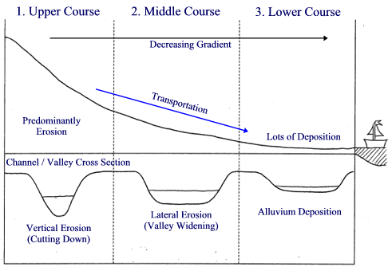
- Close to Yarm the River Tees has formed very large meanders in the lower course. Some of these meanders have led to the formation of ox-bow lakes.
- Flooding has caused levées to form. Levées are high banks of silt along the banks of a river. They are formed where a river flows slowly, carries a large load of silt and floods on occasions. When the river floods the coarser material is deposited first close to the river channel. The finer material is deposited further away. Over many years this coarse material builds up to form the levées on the river bank.
- The lateral erosion by the meanders and the occasional floods build up a wide, flat flood plain on either side of the river.

Mouth

- The mouth of the River Tees is an estuary. An estuary is a river valley in a lowland area that has been flooded. The River Tees has a very wide estuary with mudflats and sandbanks. The estuary has been a magnet for industry with iron and steel, engineering and chemical works all along its length. However, parts of the estuary are very important sites for wildlife, such as seals and birds.

