Geography Summer Work booklet

Name - ____________________
Class - ____________________
Teacher - __________________

Checking My Knowledge

Read each statement carefully and consider if you think you are red, amber or green in that area.
Red = I think I have no knowledge in this area
Amber = I think I have some knowledge in this area
Green = I am confident in my knowledge in this area
Knowledge and Skills
I can recall terms associated with globalisation with ease.
I can identify the 4 different types of employment
I can give advantages and disadvantages of the 4 different types of employment.
I can identify the positives and negatives of TNCs operating in different countries.
I can read an article and answer questions based on the article demonstrating comprehension.
I can create an accurate pie chart.
I can demonstrate an understanding of the information from the pie chart.
I can recall terms associated with world issues with ease.
I can break down a piece of text into relevant information.
I can categorise effects into social, environmental, and economic effects.
I can describe a location using a map.
I can interpret effects and transform these into a diagram.
I can plot relevant information onto a map.
I can make a decision for a solution based on evidence given.
I can recall terms associated with extreme weather with ease.
I can interpret information from a map to answer questions
I know how a climate graph should look
I can calculate the mean temperature and total rainfall
I can weigh up different effects based on the severity of these
I can recall effects of the wildfires in Australia.
I can recall terms associated with development with ease.
I can use the internet to research different topics for work and put this into my own words.
I can recall terms associated with conservation with ease.
I can categorise information into pros and cons for different types of conservation
I know why poaching is committed
I can recall effects of poaching
I can use the terms of the Antarctic treaty to suggest why some activities should take place

Section1: Globalisation
Task 1: Glossary, find the definitions for these key terms
Fair Trade
Globalisation
HIC
LIC
Manufactured Goods
MNC
NIC
Primary Employment
Primary Goods
Quaternary Employment
Secondary Employment
Sustainable
Tertiary Employment
Trade
Trade Deficit
Trade Surplus
Trading Bloc
WTO

Task 2: Employment Types
In the table below you need to give an example of each type of employment as well as advantages and disadvantages of these employment types.
Primary Employment  Examples:  Advantages:  Disadvantages: | Secondary Employment:  Examples;  Advantages:  Disadvantages:
Tertiary Employment:  Examples;  Advantages:  Disadvantages: | Quarternary Employment:  Examples;  Advantages:  Disadvantages:

Task 3: TNCs
The positive and negative impacts of TNCs in LEDCs
1) highlight the positive and negative impacts of TNCs in LEDCs.
2) write your own impact in the blank box (positive or negative)
KEY:
They bring jobs to LICs. | TNCs can move profits from one country to another to avoid paying tax.
TNCs bring new technology to LICs. | TNCs give people a variety of goods to choose from.
TNCs often pay their workers a low wage. | Conditions in TNC factories are often better than those in other factories in LICs.
TNCs connect different countries together. | The money TNCs make goes back to their headquarters in HICs, rather than helping the country the goods are made in.
TNCs often pollute the air or water with toxic chemicals from their factories. They would not do this in their own country. | TNCs are richer and more powerful than many governments so they do what they want in LICs.
The people living in these LICs find it difficult to develop their own industry with all the competition from TNCs. | TNCs move whenever they see a better deal elsewhere, closing down factories as they go.
 | The wages from the TNCs help the economy of the LICs.
TASK: Rank them in order of best impact – worst impact (1= best – 14 = worst)

Read the following article and answer the questions at the bottom

‘Beyonce's new Topshop sportswear range 'is made by workers earning just 44p an HOUR who'd have to work for a month to buy a £100 pair of leggings'

Beyonce's new Topshop collection is reportedly made by Sri Lankan factory workers earning just £4.30 a day.
Seamstresses making Beyonce's activewear clothing line Ivy Park is made to work more than 60 hours per week, for less than half the average Chinese wage, it has been revealed.
The singer's 228-piece range has previously been criticised for being overpriced - with a pair of leggings costing as much as £100 - and excluding, as it only available up to a UK size 14. Now the brand has come under fire over the conditions of workers in a factory in Henan, China where a part of the collection is made.
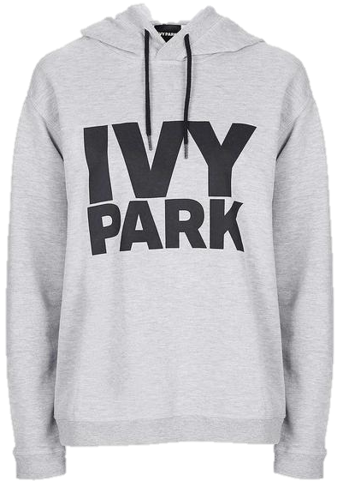
The workers make 18,500 yuan (£87.26) a month - a sum which would not even cover a pair of Ivy Park leggings at Topshop. The female seamstresses pay 4,000 yuan (£19) a month to stay in a boarding house near the factory. 'All we do is work, sleep, work, sleep,' a 22-year-old sewing machine operator told the newspaper. 'We don't have our own kitchen or shower, it's just a small bedroom.
'My goal with Ivy Park is to push the boundaries of athletic wear and to support and inspire women who understand that beauty is more than your physical appearance.'
She went on to say: 'True beauty is in the health of our minds, hearts and bodies.
This is not the first time Beyonce has come under fire for collaborating with a high-street clothing brand embroiled in a 'sweatshop scandal'.
In 2013, the singer was criticised for staying on as the face of H&M despite revelations of the conditions at its factories in Bangladesh.
Two factories in Bangladesh which produces clothes for H&M reportedly employed children and withheld wages.
Task:
Read the newspaper article and answer the following questions on the next page:
- Why are clothes manufactured in China and not the UK or USA?
- What are the working conditions like for workers in the Chinese factories? (use evidence from the text to support this)
- If you could advise Beyonce on improving working conditions for workers in China what would you suggest she do and why?
_____________________________________________________________________________________________________________________________________________________________________________________________________________________________________________________________________________________________________________________________________________________________________________________________________________________________________________________________________________________________________________________________________________________________________________________________________________________________________________________________________________________________________________________________________________________________________________________________________________________________________________________________________________________________________________________________________________________________________________________________________________________________________________________________________________________________________________________________________________________________________________________________________________________________________________________________________________________________________________________________________________________________________________________________________________________________________________________________________________________________________________________________________________________________________________________________________________________________________________________________________________________________________________________________________________________________________________________________________________________________________________________________________________________________________________________________________________________________________________________________________________________________________________________________________________________________________________________________________________________________________________________________________________________________________________________________________________________________________________________________________________________________________________________________________________________________________________________________________________________________________

Task 4: Fair Trade

Using the figures below complete the pie chart to demonstrate where the money from each banana sale goes. Colour corresponding sections of the table to create a key.
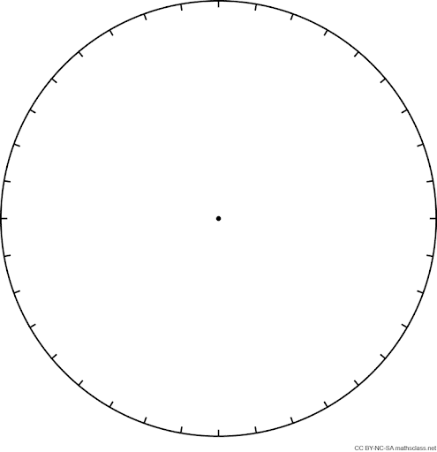
Plantation Worker | 1p
Plantation owner | 5p
Shipper | 15p
Importer | 35p
Supermarket | 44p

Explain why this method of splitting the costs is deemed unfair trade.

_____________________________________________________________________________________________________________________________________________________________________________________________________________________________________________________________________________________________________________________________________

Using the internet research what fair trade is and how it can benefit the banana farmers in Ghana.
_____________________________________________________________________________________________________________________________________________________________________________________________________________________________________________________________________________________________________________________________________

Section 2: World Issues
Task 1: Glossary, find the definitions for these key terms
Civil War
Evacuate
Insurance
Logging
Millennium Development Goal
Nuclear Reactor
Piracy
Radiation
Refugee
World Issue

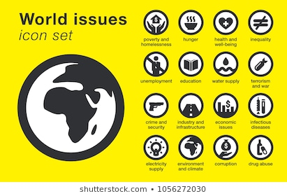

Task 2: Chernobyl
Break down the following paragraph of the Chernobyl disaster into three bullet points.
In the early morning of 26 April 1986, one of the four reactors at the Chernobyl nuclear power station ran out of control while engineers were running safety tests.
Within four seconds, a power surge of 100 times normal output led to a violent explosion and fire. The 1,000 tonne concrete top of the reactor building was blown off and huge chunks of blazing, radioactive material were blasted into the air like a volcanic explosion.
The reactor burned furiously and highly radioactive debris was scattered around and inside the reactor building.
- Gnfgnrfnrhn
- Cbdgndngn
- gnfnfnfhnhn
Colour code these effects of the Chernobyl disaster in social, economic, and environmental effects.
31 people lost their lives in the explosion | An estimated $325 billion was lost because of the Chernobyl disaster | Over 300,000 people had to be resettled after the disaster
5000 people have developed thyroid cancer (the thyroid controls metabolism) | 600,000 people have been exposed to the radiation over a 30 year period | A large area of pine forest was killed due to the radiation
Farm animals were contaminated | The city has been quarantined due to safety concerns | The indigenous Sami people of Norway went hungry as food supplies were contaminated
Tourism is now a growing economy in Ukraine around the Chernobyl site | Fish stocks in Sweden and Norway were banned for sale | Social  Economic  Environmental

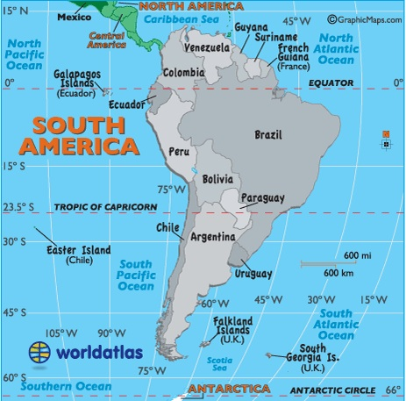
Task 3: Illegal Logging
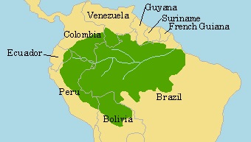

Task 4: Piracy

Include:
Continent
Countries is covers
Between which latitudes N+S of 0⁰ (the equator)

Describe the location of the Amazon Rainforest
_____________________________________________________________________________________________________________________________________________________________________________________________________________________________________________________________________________________________________________________________________
Turn these effects of rainforest deforestation into images to represent these.

The World Bank states that the annual global market loses US$10 billion annually from illegal logging. | Increased demand for forests products has brought some financial benefits for poor people living in or near forests. | Conflict causes indigenous tribes to relocate.

Task 4: Piracy
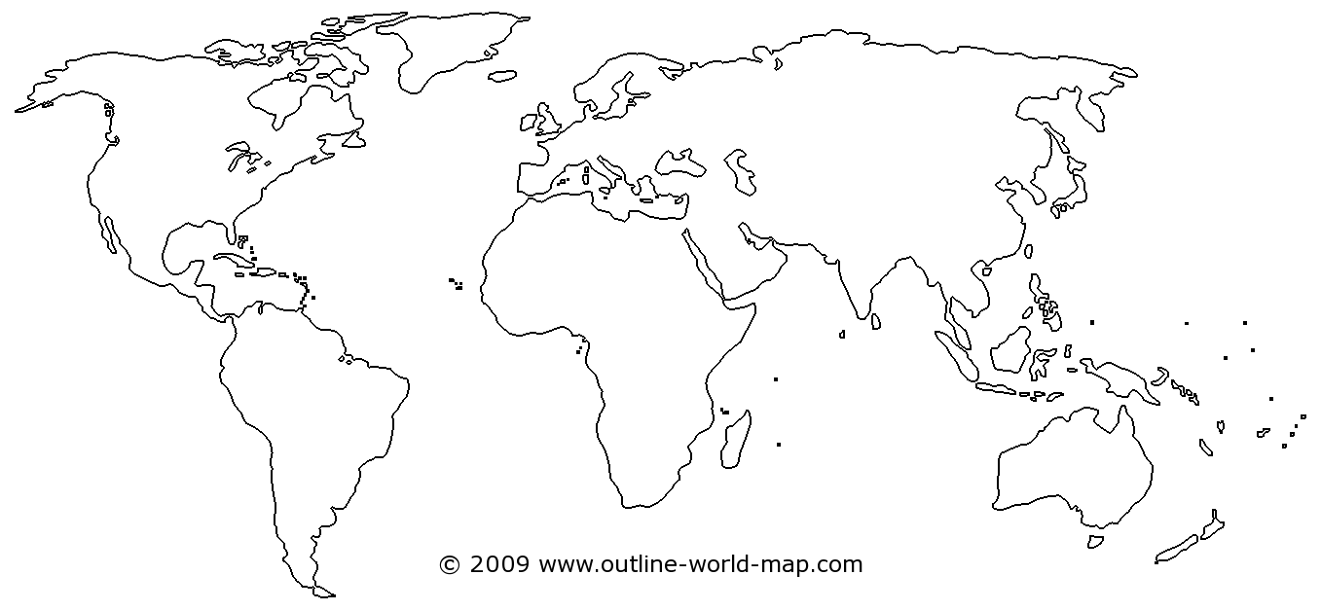
Three areas where the most Piracy are committed are, Indonesia, Central America and the Horn of Africa. Plot these onto the map above.

From the four solutions to Piracy below choose which one you think is best to combat the issues of Piracy. Remember to be balanced and say what is good and bad about your option. As well as why you did not pick the others.
Arm cargo ships – giving sailors guns will allow them to defend themselves and the cargo and deter pirates – shipping companies don’t want to deal with the added security risks, costs and legal liability – what if they fire at an innocent vessel?
Do nothing – the cost of ransom (usually $30-$40 million) is next to nothing for those countries pay it – if the country always pays up the ransom, the ransom will increase, surely?
Back the Somalia government – support them in the creation and upholding of on-shore law enforcement – the government has been weak for the past 19 years.
Naval patrols and conveys – This is the current policy, nations join forces and patrol the waters, this will deter piracy – they’re not always close enough to the large cargo ships to intercept pirates and so pirates take the risk still.

_____________________________________________________________________________________________________________________________________________________________________________________________________________________________________________________________________________________________________________________________________________________________________________________________________________________________________________________________________________________________________________________________________________________________________________________________________________________________________________________________________________________________________________________________________________________________________________________________________________________________________________________________________________________________________________________________________________________________________________________________________________________________________________________________________________________________________________________________________________________________________________________________________________________________________________________________________________________________________________________________________________________________________________________________________________________________________________________________________________________________________________________________________________________________________________________________________________________________________________________________________________________________________________________________________________________________________________________________________________________________________________________________________________________________________________________________________________________________________________________________________________________________________________________________________________________________________________________________________________________________________________________________________________________________________________________________________________________________________________________________________________________________________________________________________________________________________________________________________________________________________

Section 3: Extreme Weather
Task 1: Glossary, find the definitions for these key terms
Air Pressure
Altitude
Atmosphere
Climate
Climate Graph
Drought
Latitude
Monsoon
Polar Vortex
Precipitation
Prevailing Winds
Sea Currants
Temperature
Tornado
Weather
Wildfire

Task 2: Climate
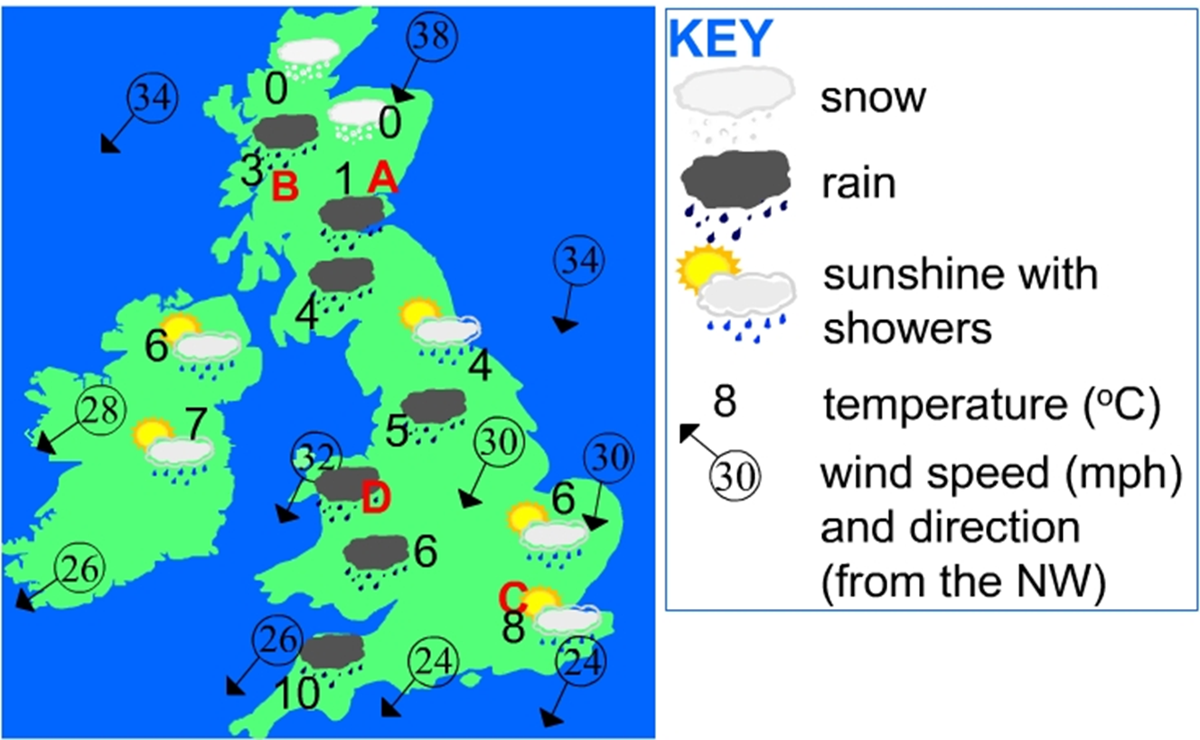
Look at the map above and then answer the following questions.
Why is point A cooler than point D?
__________________________________________________________________________________________________________________________________
What are the weather conditions like at A, B, C, D? Include information from the key.
____________________________________________________________________________________________________________________________________________________________________________________________________________________________________________________________________
Overall describe what the climate is like in the UK in the winter.
____________________________________________________________________________________________________________________________________________________________________________________________________________________________________________________________________
Complete the Climate Graph with the missing information. Temperature is missing for April, and July. Precipitation is missing for July and October.
Mangalore, India | JAN | FEB | MAR | APR | MAY | JUN | JUL | AUG | SEP | OCT | NOV | DEC
Temp | 27 | 27 | 28 | 29 | 29 | 27 | 26 | 26 | 26 | 27 | 28 | 28
Rain (mm) | 0 | 0 | 20 | 40 | 200 | 980 | 1000 | 600 | 300 | 200 | 100 | 30
Remember in a climate graph to take care looking at the correct axis and that temperature is drawn as a LINE and precipitation is drawn as a BAR CHART.
Then work out the following
The mean temperature for Mangalore:

Answer: ºC
The total rainfall over the year.

Answer: mm

Task 3: Polar Vortex
Summarise the following paragraph into three bullet points to explain how polar vortices form.
- A polar vortex is an area of low pressure—a wide expanse of swirling cold air—that is parked in polar regions. The one up north can cause some pretty wild weather and sub-zero temperatures in the United States. But it's not a new thing—this low-pressure system is almost always up there.
- Sometimes this low-pressure system, full of cold Arctic air, strays a little bit too far from home. Part of it can break off and migrate southward, bringing all of that cold air with it. Just like that, areas as far south as Florida get to experience their own little taste of life in the Arctic.

- Fvbbvfbvbr
- Vebefihbvebv
- Fjbvepib efbepib
Categorise the effects of the polar vortex from most severe at the top to least severe at the bottom.
- 8 people died in Chicago
- Many coastlines were also issued with flood warnings
- Hundreds of flights were cancelled along the east coast as planes were unable to take off.
- Thousands of schools were closed
- Hospitals cancelled all outpatient appointments while other hospitals asked staff who can walk to work to go in to cover shifts
- People were trapped in cars overnight as the traffic was too bad to move.
- The weather cost the USA millions. In just three days, with the insurance cost above $10m with car crashes. Two thirds of them due to snow and ice.
- Some supermarkets saw a rush of customers. There were reports of shelves being stripped of bread, milk and soup.
- There were worries the USA could run out of gas

Task 4: Wildfire
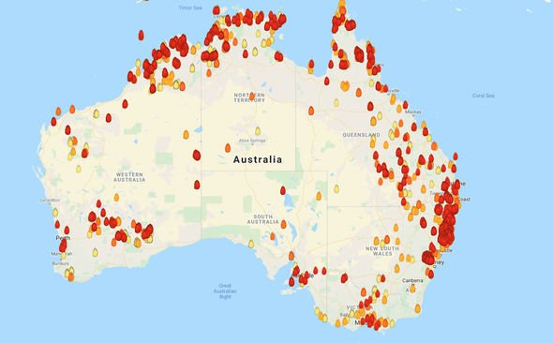
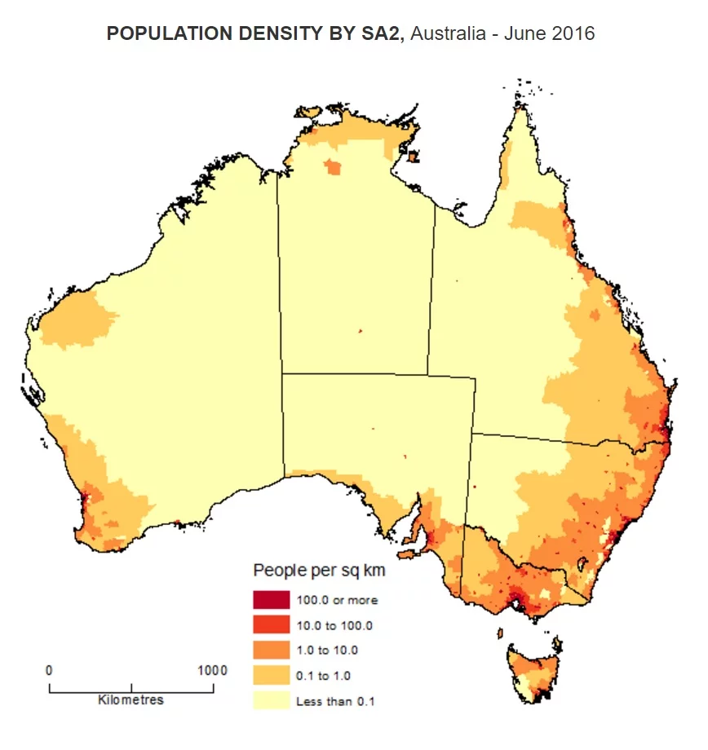
Task 4: Monsoon

Identify what the two maps are showing.
____________________________________________________________________________________________________________________________________________________________________________________________________________________________________________________________________
Describe how the two maps are linked.
____________________________________________________________________________________________________________________________________________________________________________________________________________________________________________________________________
Suggest why people in areas of higher population density will have a tougher time dealing with the fires.
____________________________________________________________________________________________________________________________________________________________________________________________________________________________________________________________________
Using the following effects write an article about the Australian wildfires. You may also want to do some research online.
- 12 people have died
- 2500 firefighters have been deployed
- In one 4 million hectares have been destroyed in New South Wales
- 900 homes have been destroyed in New South Wales
- Major roads in Sydney have had to be closed preventing access
- Some states have had to evacuate 30,000 people
- A state of emergency has had to be declared
- Total insurance claims have reached £126 million
- 1/3 of the population is facing health impacts
_____________________________________________________________________________________________________________________________________________________________________________________________________________________________________________________________________________________________________________________________________________________________________________________________________________________________________________________________________________________________________________________________________________________________________________________________________________________________________________________________________________________________________________________________________________________________________________________________________________________________________________________________________________________________________________________________________________________________________________________________________________________________________________________________________________________________________________________________________________________________________________________________________________________________________________________________________________________________________________________________________________________________________________________________________________________________________________________________________________________________________________________________________________________________________________________________________________________________________________________________________________________________________________________________________________________________________________________________________________________________________________________________________________________________________________________________________________________________________________________________________________________________________________________________________________________________________________________________________________________________________________________________________________________________________________________________________________________________________________________________________________________________________________________________________________________________________________________________________________________________________
Section 4: Development
Task 1: Glossary, find the definitions for these key terms
Birth Rate
Blood Diamond
Death Rate
Development
Developmental Aid
GDP
Governmental Aid
HDI
Humanitarian Aid
Infant Mortality
Life Expectancy
Literacy Rate
Non-governmental organisation
Poverty

Task 2: HDI- Human Development Index
In class we learnt about the Human Development Index, this is a way of looking at development, averaging the wealth, healthcare, and education of a country. The score is measured from 0 – 1, a country with a score closer to 1 is more developed than a country with a score closer to 0. The map below is a choropleth map showing the HDI scores across the globe. Use this to complete the following tasks.
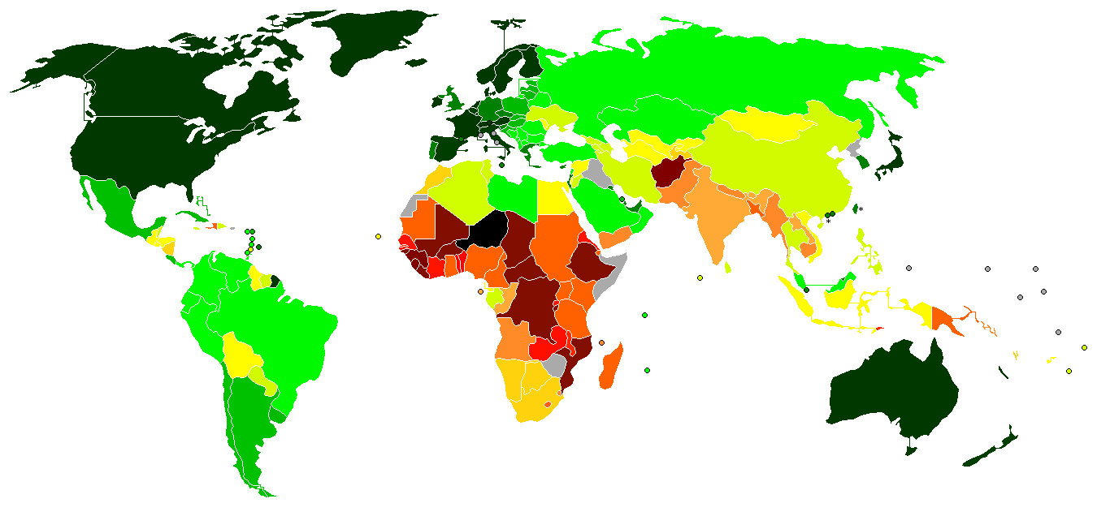

High HDI
Medium HDI
Low HDI
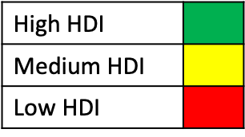
Define a choropleth map: ________________________________________________
________________________________________________
________________________________________________
167 | Sudan | 0.502
168 | Haiti | 0.498
169 | Afghanistan | 0.498
170 | Ivory Coast | 0.492
171 | Malawi | 0.477
Look at the two tables below showing the top 5 countries ranked by HDI and the bottom 5. For reference the UK is 14th in the world with a score of 0.922. Using this information compare how life would be in the top 5 countries to those in the bottom 5 countries.
1 | Norway | 0.953
2 | Switzerland | 0.944
3 | Australia | 0.939
4 | Ireland | 0.938
5 | Germany | 0.936

___________________________________________________________________________________________________________________________________________________________________________________________________________________________________________________________________________________________________________________________________________________________________________________________________________________________________________________________________________________________________________________________________________________________________________________________________________________________________________________________________________________________________________________________________________

Task 3: Barriers to Development
As we learnt in class the aim of all countries is to develop over time to provide a better life for its citizens. Countries however have to deal with an array of challenges ranging from types of diseases in their country to the climate they receive. In this task you need to complete the table to explain how the barriers prevent a country from developing further. Use your own knowledge and research to complete this task.
Barrier to Development | Information about the barrier
Disease
Political Problems
Economic Problems

Trade & Transport

Task 4: Types of Aid
Match the following definitions to the different types of aid. Match this as a code underneath e.g. 1A
1:
2:
3:
4:

 | Type of Aid |  | Definition
1 | Humanitarian Aid | A | This is designed to fund longer-term projects that aim to help people improve their quality of life, for example, building schools, building a fresh water pump.
2 | Developmental Aid | B | This type of aid is given by the government of one country directly to another, for example, the UK Government giving money to the Indian Government and the Government there chooses how to spend it.
3 | Governmental Aid | C | This is Aid that is sent quickly in response to an emergency in order to save lives. For example, food, water, and shelter.
4 | Aid from non-governenmental organisations | D | This type of Aid is given by charities such as Oxfam or Save the Children. It is normally spent by those charities in community projects. The NGO workers go to the place, decide what is needed and then spend the money on that.

3) In the table below suggest some positives and negatives of the different types of aid. You may want to do some research for this.

Type of Aid | Advantages | Disadvantages
Humanitarian Aid
Governmental Aid
Developmental Aid
Non-Governmental Aid

Section 5: Conservation
Task 1: Glossary, find the definitions for these key terms
Antarctic Treaty
Biodiversity
Conflict
Conservation
Ecosystem
Ex-situ conservation
Honeypot Site
Hunting
In Situ conservation
National Park
Poaching
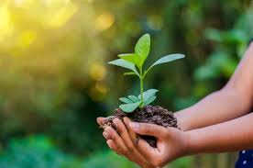

Task 2: Conservation In-situ and ex-situ
In lessons we learnt that Conservation in-situ is conservation that occurs in the organisms’ own habitat such as in a national park or conservation reserve. We also learnt that conservation ex-situ was conservation that took place outside organisms’ natural habitat, this can be in the form of zoos or botanical gardens. The table below has pros and cons of both in situ and ex situ conservation which you need to organise.

Organism is protected from poaching and predation | The correct environmental conditions may be hard to achieve | Animals are kept in their correct habitats | Animals are able to evolve to adapt to new conditions e.g. drought
Money is generated through the selling of tickets and souvenirs | Nutritional issues can be difficult to provide for | The animals can be exposed to diseases | Often these sites are understaffed so can’t be protected everywhere
Conservation in the natural habitat is cheaper | The land can sometimes still be used for other purposes e.g. logging | Money is required from the government | Allows scientific research to happen where the animals live
Animals may not survive re-introduction to the wild | Culturally significant sites are protected | Health of individuals can be monitored | Some animals such as the great white shark cant survive in captivity
Selective breeding can be carried out / IVF can be used | The organisms are living outside their natural environments | Animals are kept wild and therefore use their instincts | Poachers are still able to access the area
Animals can cause trouble when coming into contact with people | Endangered species can be bred to increase numbers | Biodiversity permanently protected | It may be expensive to achieve the right environmental conditions

Task 3: Poaching
Look at the image to the left and answer the following questions:
Identify why animals are poached.
________________________
________________________
________________________
________________________
________________________
________________________

Describe what uses horns and tusks have.
_________________________________________________________________
_________________________________________________________________
_________________________________________________________________
_________________________________________________________________
_________________________________________________________________
_________________________________________________________________
Suggest why poaching is difficult to stop.
_________________________________________________________________
_________________________________________________________________
_________________________________________________________________
_________________________________________________________________
_________________________________________________________________
_________________________________________________________________
Complete the diamond 9 with the effect you think is the most severe through to the effect you think is least severe.
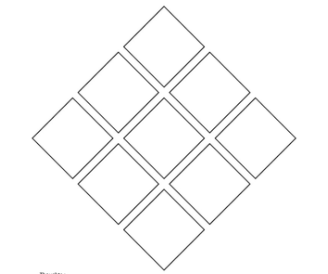
- Experts believe that elephants will go extinct within the next decade if the killing continues at this rate
- Tourism will decrease if there are no animals to see
- The ecosystem can be damaged if animals are endangered or threatened
- Food chains may break down with less animals to eat or hunt
- Many animals will be left orphaned and will struggle
- Government money is spent trying to protect animals rather than helping those in need in the country
- Local tribes who view these animals as sacred lose part of their culture
- Members of the local community can be hurt or killed in the conflict with animals and poachers
- Natural resources available to humans may be depleted if there are less animals

Task 4: Antarctic Treaty
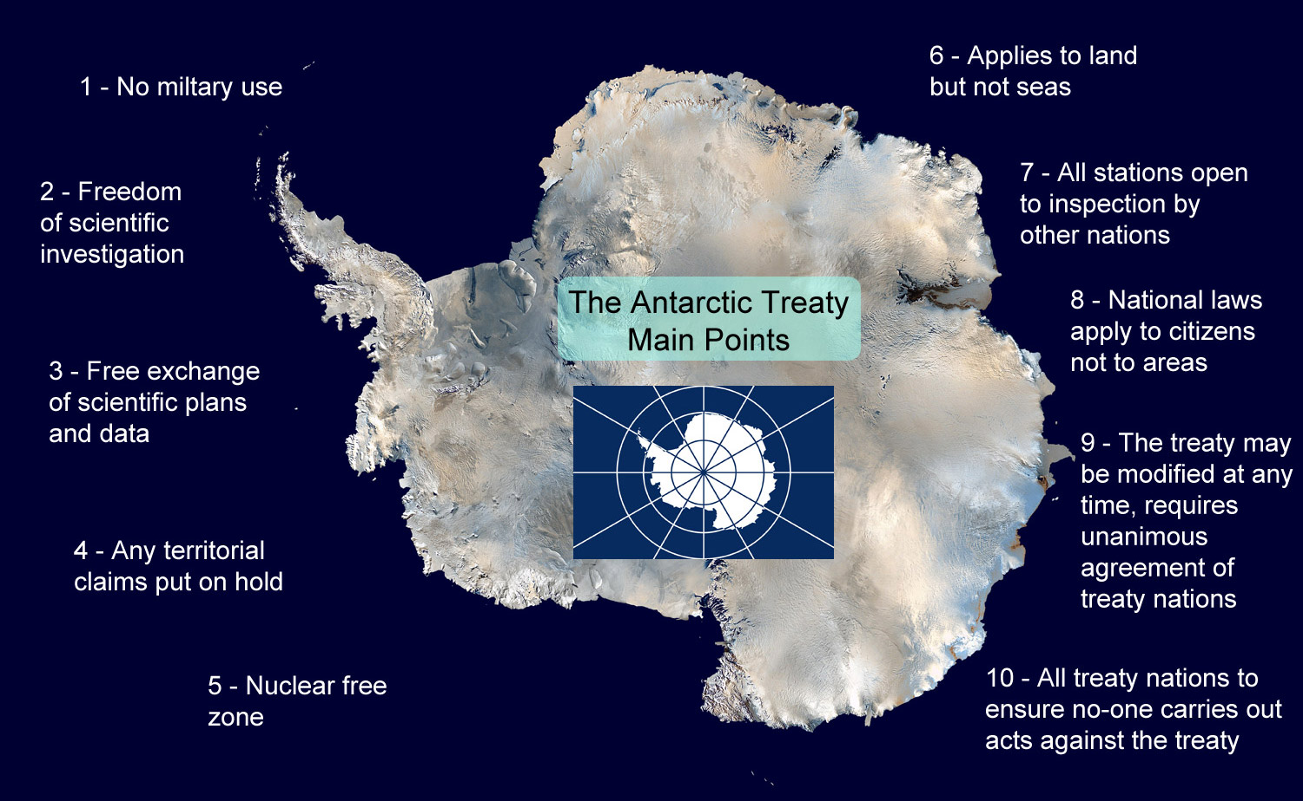
Using the terms of the Antarctic Treaty to the left complete the table below to decide if they would be permitted on Antarctica or not and then justify this with a reason.

The 1961 Antarctic Treaty System: Applications
Application | Allowed or rejected? | Your reasons?
Scientists from different nations want to share your data and information about climate change.
Your scientists want to catch up to 600 Minke whales a year in Antarctic waters for scientific research.
A big clothing company wants to start a fashion craze for seal fur coats, and have submitted a proposal to catch a hundred fur seals a year.
Scientists want to build an airstrip at one of your research stations in order to bring in supplies and people by plane.
Argentina submits a proposal to transport pregnant women to Antarctica in the hopes that they will give birth in Antarctica and have the first “Antarctic Citizen” on the planet. Hoping to give it claim to some resources.
A proposal to use military satellite data to spot fishing boats in Antarctic waters that are fishing illegally has been submitted.
A section of your countries fishing industry wants to do more fishing in Antarctic waters as your own fish have all run out.
A medical research unit wants to harvest some microscopic plants along the coasts of the Southern Ocean with the hope of developing a new way of treating people with third degree skin burns.
China wishes to establish a research base in a remote part of Antarctica but does not want to be visited by other countries or their scientists.
Donald Trump wants to change the treaty so that nuclear testing may be allowed for his “Nuke the Hurricane” project

