Petrochemicals infographic: Global polyethylene trade flows
Platts petrochemical analysis team have joined forces with our design & production department to produce what we think is a beautifully crafted infographic on global trade flows for polyethylene. It also details surplus and deficit totals and includes key trend points, statistics and forecasts going out all the way to 2023. Remember: we’d love to read your thoughts on the impact of shale on both petrochemical and oil markets, so join in on the comments section below.
Click the image to see a full size version.
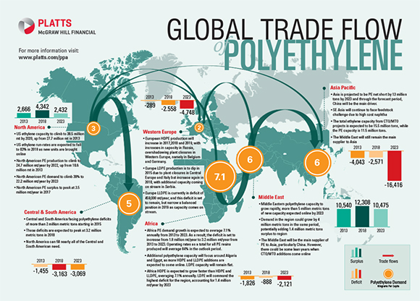
Polyethylene analysis
- If China’s development of Coal-to-Olefins technology continues as planned for the next five years, the global polyethylene market is likely to be saturated with material through 2019, according to a new analysis by Platts.
- New plants are expected to add more than 10 million metric tons of ethylene to the Chinese market.
- According to the latest edition of Platts Shale to Polyethylene report, the amount of ethylene produced from coal-to-olefins in China is expected to match the amount of ethylene produced from new steam cracker projects in North America, tied to shale gas developments.
- China is also adding more than 14 million metric tons of additional polyethylene capacity between 2014 and 2021, much of which is being feed by the CTO-produced ethylene.
- The largest capacity gains in the Americas are expected in 2017 and 2020, when new shale-based production comes on-stream. And each of those two years will only see increases of about two-million metric tons. In 2015 and 2016 alone, Asian PE capacity could climb more than 7 million metric tons.
- This influx of Asian material is expected to increase global polyethylene surpluses by more than 50% between 2013 and 2015. Global surpluses of the plastic would climb above 7 million metric tons between 2016 and 2018. During that period, Asian polyethylene deficits could almost disappear, leaving polyethylene producers scrambling to sell excess material before they are forced to cut production rates.
- Based on the Platts analysis, global polyethylene run rates would need to be cut by 7% to balance the markets globally during the period of peak surplus.
- Middle Eastern producers, who globally have the most price-advantaged feedstock for ethylene production, would likely compete with Asian producers in South Korea, Singapore and Thailand during these periods of global polyethylene oversupply.
- This period of global oversupply also coincides with the largest potential polyethylene surpluses in North America, according to the Platts analysis. From 2018 to 2020, North America is expected to be long 4 million metric tons of material or more.
- The first outlet for that excess is going to be Latin America, and for the most part, Latin America will be happy to have it. North American polyethylene producers will need to find buyers in Europe and Asia to keep the market balanced, because Central and South America will not be able to absorb all of the surpluses.
- By 2020, though, the global markets are expected to be more balanced as demand growth continues. And if no new projects are announced, there would be a global polyethylene deficit by 2022.

