River landscapes
in the UK
Contents
Using this booklet 3
Introduction to river landscapes 4
Check your learning 4
Rivers and river valleys 5
Check your learning 6
Dual coding 7
What are fluvial processes? 8
Check your learning 8
Check your learning 10
Check your learning 10
Dual coding 11
River landforms of erosion 12
Check your learning 15
Dual coding 16
River landforms of deposition 17
Check your learning 19
Dual coding 20
River management strategies 21
Check your learning 24
Dual coding 25
River management strategies 26
Check your learning 26
Check your learning 28
Dual coding 29
An example of a flood management scheme in the UK 30
Dual coding 32
Check your learning recording table 33

Using this booklet
Welcome to the Internet Geography Work Booklet for the River Landscapes in the UK. There are a range of resources on Internet Geography to support you studying this unit. Head over to https://www.internetgeography.net/aqa-gcse-geography/physical-landscapes-in-the-uk/ to access them.

As well as the resources in this booklet, there are a number of online quizzes to check your learning as you work your way through this booklet.
This icon lets you know when you should attempt the online quizzes developed to support your learning and check your knowledge. Your scores should be recorded on the tracking table at the back of this booklet. It is useful to revisit the quizzes to help your learning stick.

QR codes are included throughout the booklet to support you in researching the information you need to complete the activities. You will need to download a free QR code scanner to your mobile phone or tablet. Just go to your app store and search for “QR Code scanner” and download a free one.

After each section in this booklet there is a summary page for you to record the main points for each sub-topic. We recommend you use dual coding for this. Dual coding sounds a bit complicated, however, it’s not. It simply involves combining text and images when you are studying. There are many ways you can present text and images, such as with infographics, timelines, cartoon strips, diagrams, and graphic organisers. We’ve pulled together a guide to help you do this with examples on Internet Geography. Either go to https://www.internetgeography.net/dual-coding/ or scan the QR code below.

Introduction to river landscapes
There are a number of key words you need to know about river landscapes.
Complete the key terms list below by adding the correct definitions.

Long profile
Cross profile
Fluvial processes
Erosion
Deposition
Transportation
River landforms
Depositional landforms
Hydrographs
Hard engineering
Soft engineering

Check your learning
Head over to www.internetgeography.net/wb40 and complete the key word quiz. Add your score for quiz 1 on the recording sheet.

Rivers and river valleys

What is the long profile of a river?

_______________________________________________________________________________________

_______________________________________________________________________________________

_______________________________________________________________________________________

Produce a sketch to show the long profile of a river. Identify the upper, middle and lower course. Add a step, or waterfall to the diagram.

What is the cross profile of a river?

_______________________________________________________________________________________

_______________________________________________________________________________________

_______________________________________________________________________________________

_______________________________________________________________________________________

Complete the table below to show and explain the characteristics of the cross profile of a river from upper to lower course.

Sketch of cross-profile | Physical characteristics | The reasons for this is…
Upper course
Middle course
Lower course

Check your learning
Head over to www.internetgeography.net/wb41 and complete the key word quiz. Add your score for quiz 2 on the recording sheet.

Dual coding
Use dual coding to summarise what you have studied in this section. Take a look at https://www.internetgeography.net/dual-coding/

What are fluvial processes?

What is erosion?

_______________________________________________________________________________________

_______________________________________________________________________________________

_______________________________________________________________________________________

Complete the table below to describe the processes of erosion.

Process | Description
Hydraulic action
Abrasion
Attrition
Solution
Vertical erosion
Lateral erosion

Check your learning
Head over to www.internetgeography.net/wb42 and complete the key word quiz. Add your score for quiz 3 on the recording sheet.

What is transportation?

_______________________________________________________________________________________

_______________________________________________________________________________________

_______________________________________________________________________________________

Complete the table below to describe the processes of transportation.

Process | Description
Traction
Saltation
Suspension
Solution

Draw a simple diagram to show the processes of transportation.

Check your learning
Head over to www.internetgeography.net/wb43 and complete the key word quiz. Add your score for quiz 4 on the recording sheet.
What is deposition?

_______________________________________________________________________________________

_______________________________________________________________________________________

_______________________________________________________________________________________

When does a river deposit sediment?

_______________________________________________________________________________________

_______________________________________________________________________________________

_______________________________________________________________________________________

_______________________________________________________________________________________

Annotate the diagram below to show where deposition can occur along a river.

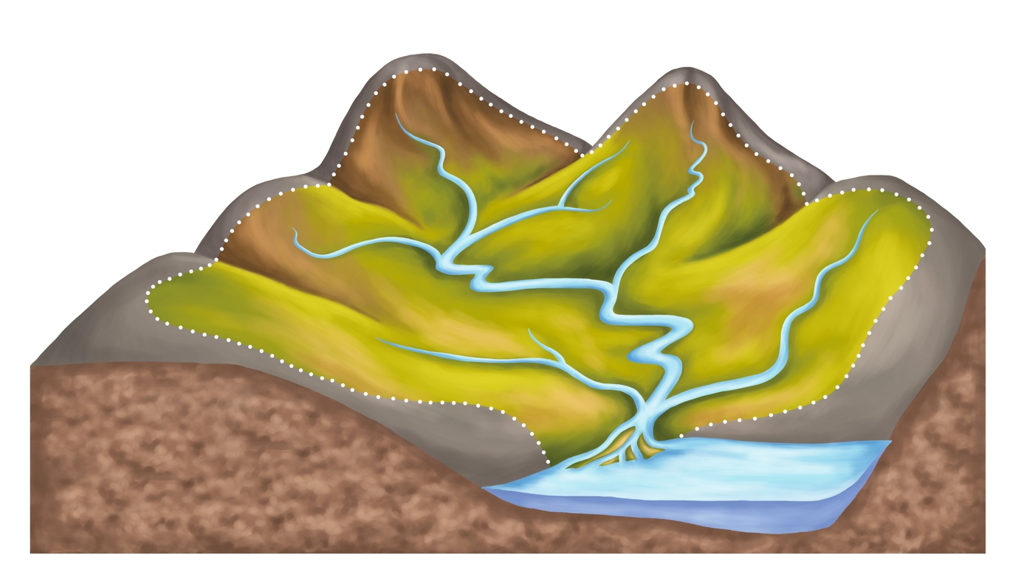

Check your learning
Head over to www.internetgeography.net/wb44 and complete the key word quiz. Add your score for quiz 5 on the recording sheet.

Dual coding
Use dual coding to summarise what you have studied in this section. Take a look at https://www.internetgeography.net/dual-coding/

River landforms of erosion
Complete the table below to describe the characteristics of each river landform and
explain their formation.
Interlocking Spurs
Diagram
Description (characteristics) | How are they formed? (explanation)
Waterfalls
Diagram
Description (characteristics) | How are they formed? (explanation)
Gorges
Diagram
Description (characteristics) | How are they formed? (explanation)
Meanders
Diagram
Description (characteristics) | How are they formed? (explanation)
Oxbow Lakes
Diagram
Description (characteristics) | How are they formed? (explanation)

Check your learning
Head over to www.internetgeography.net/wb45 and complete the key word quiz. Add your score for quiz 6 on the recording sheet.

Dual coding
Use dual coding to summarise what you have studied in this section. Take a look at https://www.internetgeography.net/dual-coding/

River landforms of deposition
Complete the table below to describe the characteristics of each depositional river landform
and explain their formation.
Levées
Diagram
Description (characteristics) | How are they formed? (explanation)
Floodplains
Diagram
Description (characteristics) | How are they formed? (explanation)
Estuaries
Diagram
Description (characteristics) | How are they formed? (explanation)

Check your learning
Head over to www.internetgeography.net/wb46 and complete the key word quiz. Add your score for quiz 7 on the recording sheet.

Dual coding
Use dual coding to summarise what you have studied in this section. Take a look at https://www.internetgeography.net/dual-coding/

River management strategies

A flood occurs when water can no longer be contained within a river channel.

The flood risk of a river can be increased by human and physical factors. Complete the diagrams below to identify and explain these human and physical factors.

human factors
physical factors
What is a hydrograph?

_______________________________________________________________________________________

_______________________________________________________________________________________

_______________________________________________________________________________________

Annotate the hydrograph below to show its main features.

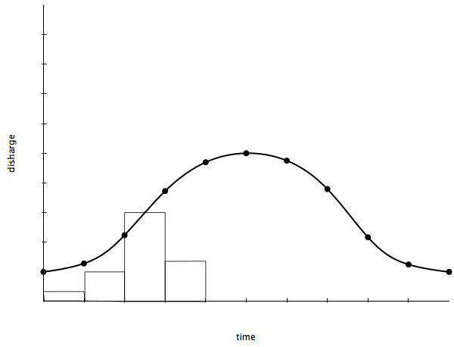

Describe the human/physical causes of a flashy rapid response hydrograph posing a high flood risk, as shown below.
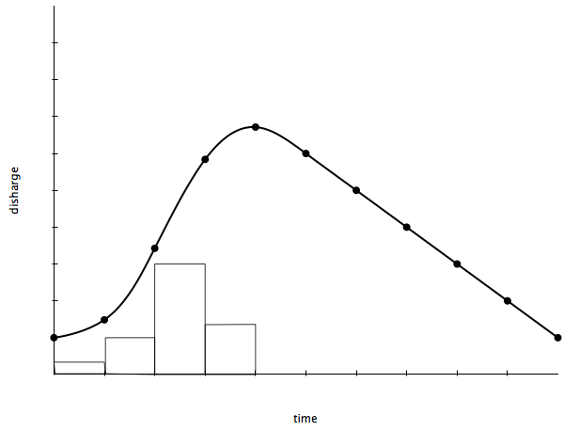

Physical ________________________________________________________________________________

_______________________________________________________________________________________

_______________________________________________________________________________________

_______________________________________________________________________________________

_______________________________________________________________________________________

Human_________________________________________________________________________________

_______________________________________________________________________________________

_______________________________________________________________________________________

_______________________________________________________________________________________

Check your learning
Head over to www.internetgeography.net/wb47 and complete the key word quiz. Add your score for quiz 8 on the recording sheet.

Dual coding
Use dual coding to summarise what you have studied in this section. Take a look at https://www.internetgeography.net/dual-coding/

River management strategies

Complete the table below about the main hard engineering strategies.

Strategy | Sketch | Costs | Advantages
Dams and reservoirs
Channel straightening
Embankments
Flood relief channels

Check your learning
Head over to www.internetgeography.net/wb48 and complete the key word quiz. Add your score for quiz 9 on the recording sheet.

Complete the table below about the main soft engineering strategies.
Strategy | Sketch | Costs | Advantages
Flood warnings
Floodplain zoning
Afforestation
River restoration

Check your learning
Head over to www.internetgeography.net/wb49 and complete the key word quiz. Add your score for quiz 10 on the recording sheet.

Dual coding
Use dual coding to summarise what you have studied in this section. Take a look at https://www.internetgeography.net/dual-coding/

An example of a flood management scheme in the UK
Case study location:________________________________________________________

Reasons for management

_______________________________________________________________________________________

_______________________________________________________________________________________

_______________________________________________________________________________________

_______________________________________________________________________________________

_______________________________________________________________________________________

_______________________________________________________________________________________

Management strategies

_______________________________________________________________________________________

_______________________________________________________________________________________

_______________________________________________________________________________________

_______________________________________________________________________________________

_______________________________________________________________________________________

_______________________________________________________________________________________

Social issues

_______________________________________________________________________________________

_______________________________________________________________________________________

_______________________________________________________________________________________

_______________________________________________________________________________________

_______________________________________________________________________________________

_______________________________________________________________________________________

_______________________________________________________________________________________

Economic issues

_______________________________________________________________________________________

_______________________________________________________________________________________

_______________________________________________________________________________________

_______________________________________________________________________________________

_______________________________________________________________________________________

_______________________________________________________________________________________

_______________________________________________________________________________________

Environmental issues

_______________________________________________________________________________________

_______________________________________________________________________________________

_______________________________________________________________________________________

_______________________________________________________________________________________

_______________________________________________________________________________________

_______________________________________________________________________________________

_______________________________________________________________________________________

Dual coding
Use dual coding to summarise what you have studied in this section. Take a look at https://www.internetgeography.net/dual-coding/

Check your learning recording table

 | Attempt 1 | Attempt 2 | Attempt 3
Quiz 1  www.internetgeography.net/wb40/ | /9 | /9 | /9
Quiz 2  www.internetgeography.net/wb41/ | /10 | /10 | /10
Quiz 3  www.internetgeography.net/wb42/ | /10 | /10 | /10
Quiz 4  www.internetgeography.net/wb43/ | /10 | /10 | /10
Quiz 5  www.internetgeography.net/wb44/ | /5 | /5 | /5
Quiz 6  www.internetgeography.net/wb45/ | /10 | /10 | /10
Quiz 7  www.internetgeography.net/wb46/ | /10 | /10 | /10
Quiz 8  www.internetgeography.net/wb47/ | /10 | /10 | /10
Quiz 9  www.internetgeography.net/wb48/ | /10 | /10 | /10
Quiz 10  www.internetgeography.net/wb49/ | /8 | /8 | /8

