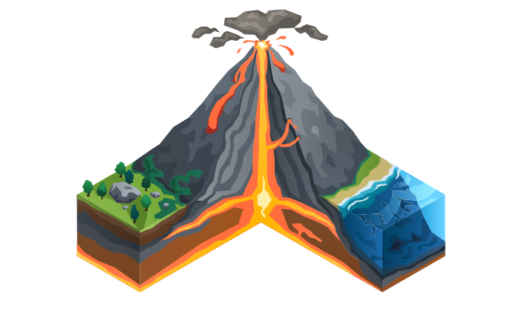
Tectonics

The challenge of
natural hazards

Contents
Using this booklet 3
Introduction to natural hazards 4
Check your learning 5
Natural hazards 6
Check your learning 7
Dual coding 8
Earthquakes and Volcanoes 9
Check your learning 10
Check your learning 12
Dual coding 13
Tectonic hazards 14
Check your learning 17
Dual coding 18
Comparing Earthquakes 19
Check your learning 21
Dual coding 22
Management of tectonic hazards 23
Check your learning 25
Dual coding 26
Check your learning recording table 27

Using this booklet
Welcome to the Internet Geography Work Booklet for the challenge of natural hazards. There are a range of resources on Internet Geography to support you studying this unit. Head over to https://www.internetgeography.net/aqa-gcse-geography/the-challenge-of-natural-hazards/ to access them.

As well as the resources in this booklet, there are a number of online quizzes to check your learning as you work your way through this booklet.
This icon lets you know when you should attempt the online quizzes developed to support your learning and check your knowledge. Your scores should be recorded on the tracking table at the back of this booklet. It is useful to revisit the quizzes to help your learning stick.

QR codes are included throughout the booklet to support you in researching the information you need to complete the activities. You will need to download a free QR code scanner to your mobile phone or tablet. Just go to your app store and search for “QR Code scanner” and download a free one.

After each section in this booklet there is a summary page for you to record the main points for each sub-topic. We recommend you use dual coding for this. Dual coding sounds a bit complicated, however, it’s not. It simply involves combining text and images when you are studying. There are many ways you can present text and images, such as with infographics, timelines, cartoon strips, diagrams, and graphic organisers. We’ve pulled together a guide to help you do this with examples on Internet Geography. Either go to https://www.internetgeography.net/dual-coding/ or scan the QR code below.

Introduction to natural hazards
There are a number of key words you need to know about natural hazards.
Complete the key terms list below by adding the correct definitions.

Natural hazard
Hazard risk
HIC
LIC
NEE
Tectonic hazards
Atmospheric hazards
Earthquake
Volcano
Subduction zone

Check your learning
Head over to www.internetgeography.net/wb60 and complete the key word quiz. Add your score for quiz 1 on the recording sheet.

Natural hazards

If humans did not live on Earth, would an earthquake be a natural hazard?
Explain your answer.

_______________________________________________________________________________________

_______________________________________________________________________________________

_______________________________________________________________________________________

_______________________________________________________________________________________

_______________________________________________________________________________________

_______________________________________________________________________________________

Examples of tectonic hazards
Examples of climatic hazards
Complete the table below to explain the factors that affect hazard risk.

Factors affecting hazard risk | Hazard risk is affected because…
Population increase
Urbanisation
Economic development
Geographical location
Increase in the frequency and magnitude of a natural hazard

Check your learning
Head over to www.internetgeography.net/wb61 and complete the quiz. Add your score for quiz 2 on the recording sheet.

Dual coding
Use dual coding to summarise what you have studied in this section. Take a look at https://www.internetgeography.net/dual-coding/

Earthquakes and Volcanoes

Annotate the diagram below to describe the structure of the Earth.

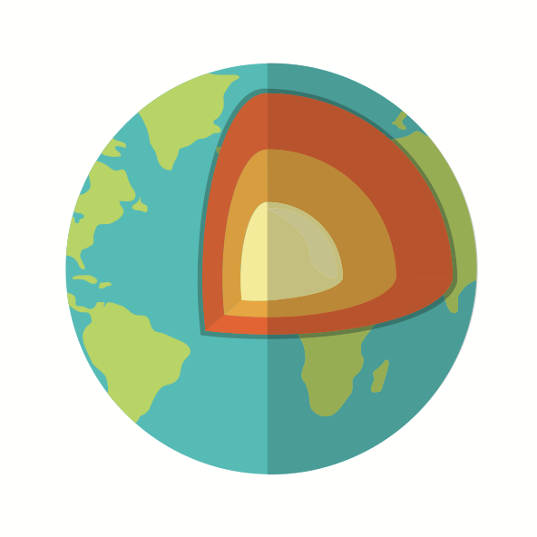
What is the lithosphere?

_______________________________________________________________________________________

_______________________________________________________________________________________

_______________________________________________________________________________________

Complete the table below to compare the characteristics of oceanic and continental plates.

Characteristics | Oceanic Plate | Continental Plate
Density
Thickness
Geology
Age

Check your learning
Head over to www.internetgeography.net/wb62 and complete the quiz. Add your score for quiz 3 on the recording sheet.

Annotate the diagram to explain the causes of tectonic plate movement (convection
currents, ridge push and slab pull).

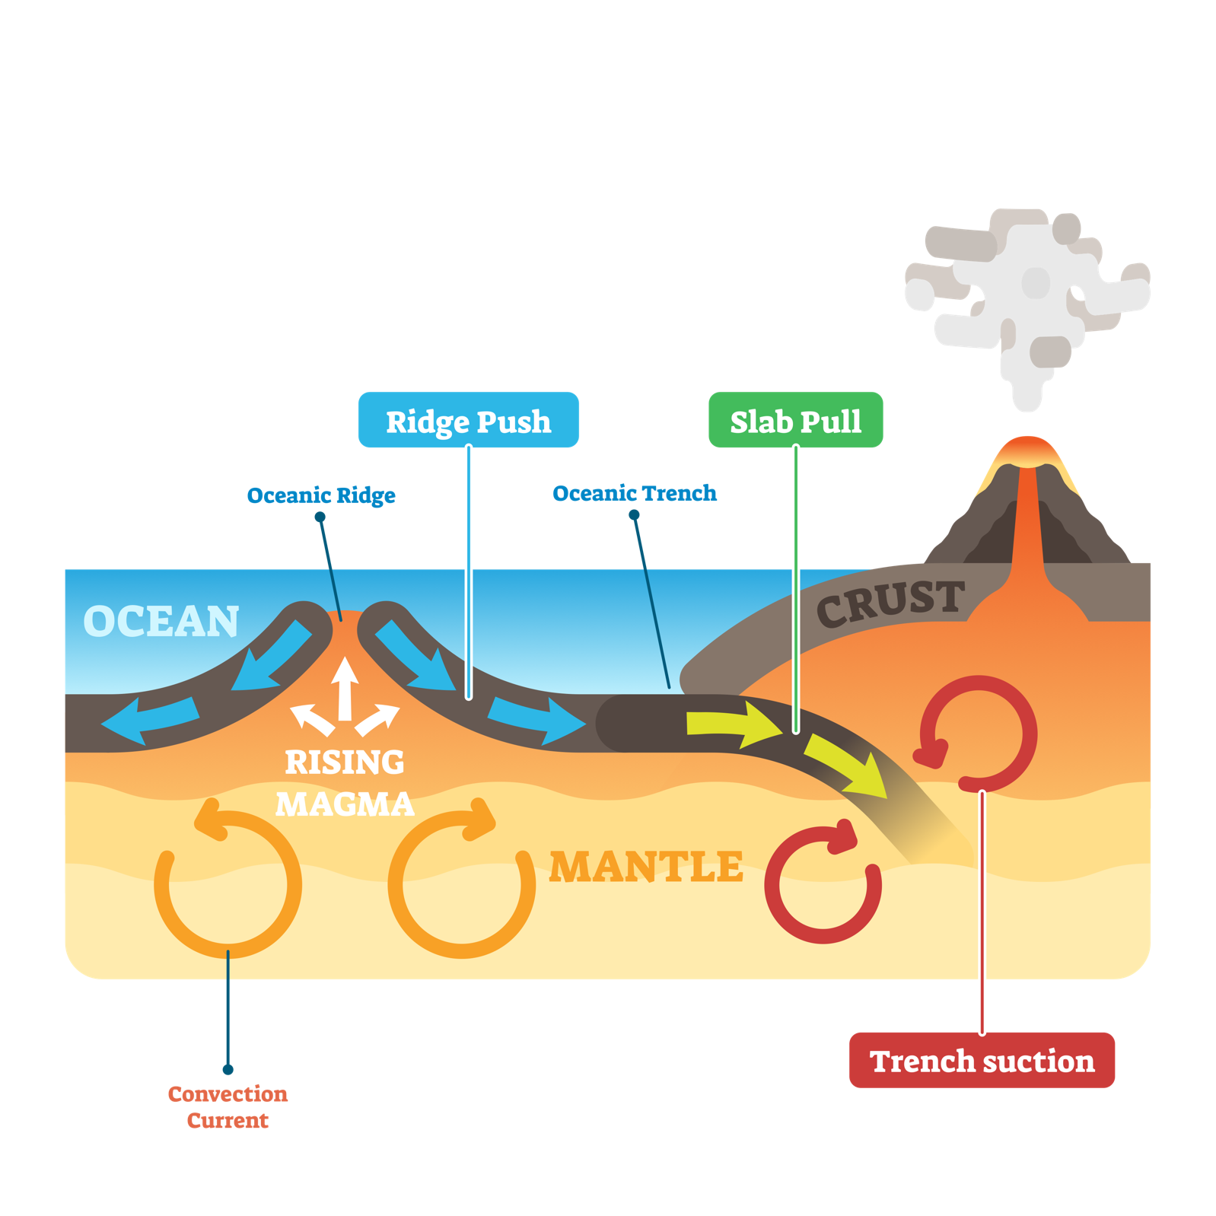

Describe the global distribution of earthquakes and volcanoes.

_______________________________________________________________________________________

_______________________________________________________________________________________

_______________________________________________________________________________________

_______________________________________________________________________________________

_______________________________________________________________________________________

_______________________________________________________________________________________

_______________________________________________________________________________________

_______________________________________________________________________________________

_______________________________________________________________________________________

_______________________________________________________________________________________

_______________________________________________________________________________________

Complete the table below to show the physical processes that occur at each plate margin.

Plate margin (sketch) | Direction of plate movement | Physical processes | Earthquakes | Volcanic eruptions
Constructive
Destructive
Conservative

Check your learning
Head over to www.internetgeography.net/wb63 and complete the quiz. Add your score for quiz 4 on the recording sheet.

Dual coding
Use dual coding to summarise what you have studied in this section. Take a look at https://www.internetgeography.net/dual-coding/

Tectonic hazards
What is the difference between a primary and secondary effects of an earthquake?

_______________________________________________________________________________________

_______________________________________________________________________________________

_______________________________________________________________________________________

_______________________________________________________________________________________

_______________________________________________________________________________________

Identify the primary and secondary effects of an earthquake.

Primary effects of an earthquake | Secondary effects of an earthquake

Annotate the photograph below to show the primary and secondary effects of the earthquake (make sure you draw arrows that touch the exact point you are referring to in the image).

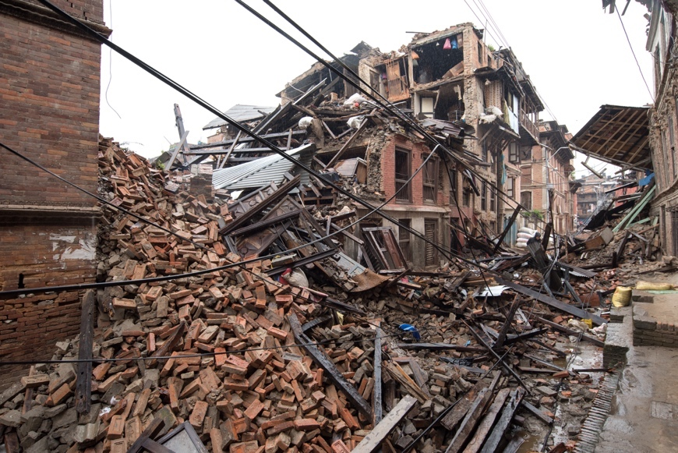

Identify the primary and secondary effects of a volcanic eruption.

Primary effects of an earthquake | Secondary effects of an earthquake

What is the difference between an immediate and long-term response to a tectonic hazard?

_______________________________________________________________________________________

_______________________________________________________________________________________

_______________________________________________________________________________________

_______________________________________________________________________________________

Give four examples of immediate responses to tectonic hazards.

_______________________________________________________________________________________

_______________________________________________________________________________________

_______________________________________________________________________________________

_______________________________________________________________________________________

_______________________________________________________________________________________

_______________________________________________________________________________________

_______________________________________________________________________________________

_______________________________________________________________________________________

Give four examples of long-term responses to tectonic hazards.

_______________________________________________________________________________________

_______________________________________________________________________________________

_______________________________________________________________________________________

_______________________________________________________________________________________

_______________________________________________________________________________________

_______________________________________________________________________________________

_______________________________________________________________________________________

_______________________________________________________________________________________

Check your learning
Head over to www.internetgeography.net/wb64 and complete the key word quiz. Add your score for quiz 5 on the recording sheet.

Dual coding
Use dual coding to summarise what you have studied in this section. Take a look at https://www.internetgeography.net/dual-coding/

Comparing Earthquakes

You need to study named examples of two tectonic hazards to show how the effects
and responses vary depending on their contracting levels of wealth. If you study either
the earthquake in Haiti or Nepal as your LIC example and either the Christchurch or L’Aquila as your example of an HIC there are quizzes to check learning.

Earthquake in a LIC/NEE: | Earthquake in a HIC:
Primary effects: | Primary effects:
Secondary effects: | Secondary effects:
Immediate response: | Immediate response:
Long-term response: | Long-term response:

Complete the table below using a ✔ to show the reasons for variations between the two earthquakes you have studied.

 | Causes differences in: |  | Influence by wealth
Reasons for variations | Effects | Responses
Building density
Construction standards
Corruption
Hazard-prone area
Magnitude or scale
Monitoring/prediction
Medical facilities
Population density
Resources/finance
Secondary effects (e.g. tsunamis
Time of day/year
Trained emergency services
Transport infrastructure
Type of plate margin

Check your learning
Earthquake in an LIC (you only need to complete one of these)
Haiti: www.internetgeography.net/wb65
Nepal: www.internetgeography.net/wb66
Add your score to quiz 6.

Earthquake in an HIC (you only need to complete one of these)
L’Aquila: www.internetgeography.net/wb67
Christchurch: www.internetgeography.net/wb68
Add your score to quiz 7.

Dual coding
Use dual coding to summarise what you have studied in this section. Take a look at https://www.internetgeography.net/dual-coding/

Management of tectonic hazards

A considerable number of people live in tectonically active areas of the world. Complete
the table below to identify economic and social reasons for this.

Economic reasons for living in risk in tectonically active locations | Social reasons for living at risk in tectonically active locations

Complete the spider diagram below to show how the risks from tectonic hazards can be reduced. Use a different coloured pen for earthquakes and volcanic eruptions.

Prediction
Monitoring
Reducing the risks of tectonic hazards
Planning
Protection

Check your learning
Head over to www.internetgeography.net/wb69 and complete the key word quiz. Add your score for quiz 8 on the recording sheet.

Dual coding
Use dual coding to summarise what you have studied in this section. Take a look at https://www.internetgeography.net/dual-coding/

Check your learning recording table

 | Attempt 1 | Attempt 2 | Attempt 3
Quiz 1  www.internetgeography.net/wb60/ | /10 | /10 | /10
Quiz 2  www.internetgeography.net/wb61/ | /10 | /10 | /10
Quiz 3  www.internetgeography.net/wb62/ | /10 | /10 | /10
Quiz 4  www.internetgeography.net/wb63/ | /10 | /10 | /10
Quiz 5  www.internetgeography.net/wb64/ | /10 | /10 | /10
Quiz 6
Earthquake in an LIC (you only need to complete one of these)
Haiti: www.internetgeography.net/wb65
Nepal: www.internetgeography.net/wb66
Quiz 7
Earthquake in an HIC (you only need to complete one of these)
L’Aquila: www.internetgeography.net/wb67
Christchurch: www.internetgeography.net/wb68
Quiz 8  www.internetgeography.net/wb69/ | /15 | /15 | /15

