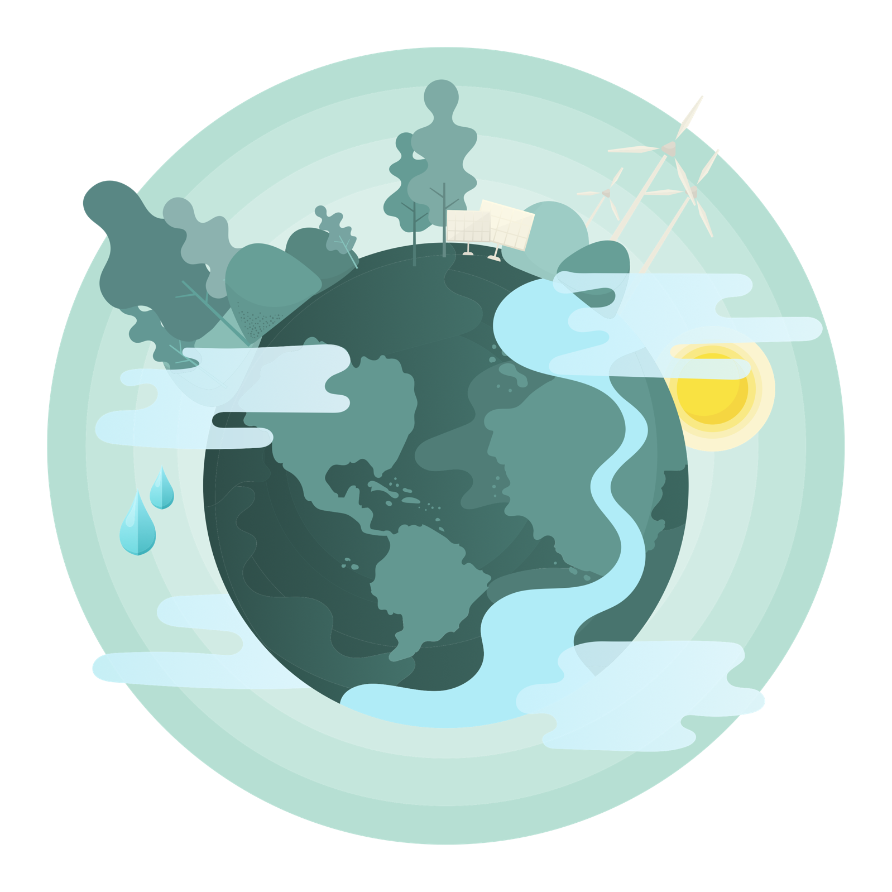
The Challenge of Resource Management
Contents
Using this booklet 3
Introduction to The Challenge of Resource Management 4
The global distribution of food, energy and water 5
Check your learning 8
Dual coding 8
Changing food demand in the UK 9
Check your learning 13
Dual coding 13
Changing water demand in the UK 14
Check your learning 16
Dual coding 17
The UK’s changing energy mix 18
Check your learning 20
Dual coding 21
Check your learning recording table 22

Using this booklet
Welcome to the Internet Geography Work Booklet for The Challenge of Resource Management. There are a range of resources on Internet Geography to support you studying this unit. Head over to https://www.internetgeography.net/aqa-resource-management/ to access them.

As well as the resources in this booklet, there are a number of online quizzes to check your learning as you work your way through this booklet.

This icon lets you know when you should attempt the online quizzes developed to support your learning and check your knowledge. Your scores should be recorded on the tracking table at the back of this booklet. It is useful to revisit the quizzes to help your learning stick.

QR codes are included throughout the booklet to support you in researching the information you need to complete the activities. You will need to download a free QR code scanner to your mobile phone or tablet. Just go to your app store and search for “QR Code scanner” and download a free one.

After each section in this booklet there is a summary page for you to record the main points for each sub-topic. We recommend you use dual coding for this. Dual coding sounds a bit complicated, however, it’s not. It simply involves combining text and images when you are studying. There are many ways you can present text and images, such as with infographics, timelines, cartoon strips, diagrams, and graphic organisers. We’ve pulled together a guide to help you do this with examples on Internet Geography. Either go to https://www.internetgeography.net/dual-coding/ or scan the QR code below.

Introduction to The Challenge of Resource Management
There are a number of key words you need to know about the changing economic world.
Complete the key terms list below by adding the correct definitions.

Renewable energy
Non-renewable energy
Fossil fuel
Water surplus
Water deficit
Energy mix
Seasonal food
Organic produce
Carbon footprint
Agribusiness

The global distribution of food, energy and water

Why is food, water and energy important to economic and social well-being?

How are global resources distributed?
Use the maps below to show the global distribution of resources. You should use colour to
indicate the distribution of each resource and annotations to describe and explain the pattern.

Food

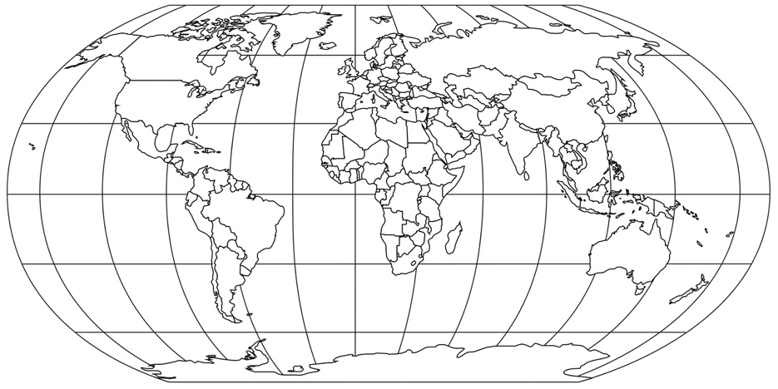

Water

Energy

How well off is the UK in terms of resources? Annotate the map to explain your answer
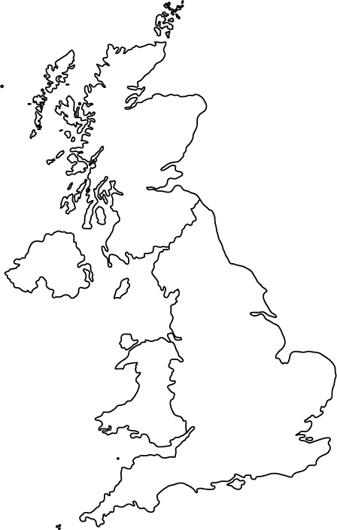

Check your learning
Head over to www.internetgeography.net/wb131 and complete the quiz. Add your score for quiz 1 on the recording sheet.

Dual coding
Use dual coding to summarise what you have studied in this section. Take a look at https://www.internetgeography.net/dual-coding/

Changing food demand in the UK

Despite the increased food miles why is some food grown in low income countries (LICs) and
transported to the UK?
_______________________________________________________________________________________

_______________________________________________________________________________________

_______________________________________________________________________________________

What is seasonal food?

_____________________________________________________________________________

_____________________________________________________________________________
How and why has demand for seasonal food changed?
_______________________________________________________________________________________

_______________________________________________________________________________________

_______________________________________________________________________________________

What is organic food?
_______________________________________________________________________________________

_______________________________________________________________________________________

Complete the hexagon below to describe the characteristics of organic farming.

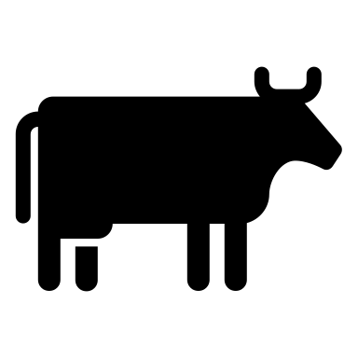
Organic farming techniques

Why is there demand for organic produce?

_____________________________________________________________________________

_____________________________________________________________________________

_____________________________________________________________________________

_____________________________________________________________________________

Summarise the impact of food on the UK’s carbon footprint.

CO²

CO²

How does local sourcing reduce carbon emissions?
_______________________________________________________________________________________

_______________________________________________________________________________________

_______________________________________________________________________________________
_______________________________________________________________________________________

_______________________________________________________________________________________

_______________________________________________________________________________________

What is agribusiness?
_______________________________________________________________________________________

_______________________________________________________________________________________

_______________________________________________________________________________________

What are the negative impacts of agribusiness?
_______________________________________________________________________________________

_______________________________________________________________________________________

_______________________________________________________________________________________

Check your learning
Head over to www.internetgeography.net/wb132 and complete the quiz. Add your score for quiz 2 on the recording sheet.

Dual coding
Use dual coding to summarise what you have studied in this section. Take a look at https://www.internetgeography.net/dual-coding/

Changing water demand in the UK

How is demand for water in the UK changing?

_______________________________________________________________________________________

_______________________________________________________________________________________

_______________________________________________________________________________________

Why is demand for water in the UK increasing?

UK population growth

Shade the map below to show areas of water deficit and surplus in the UK? Describe the geographical distribution of areas of water surplus and deficit.

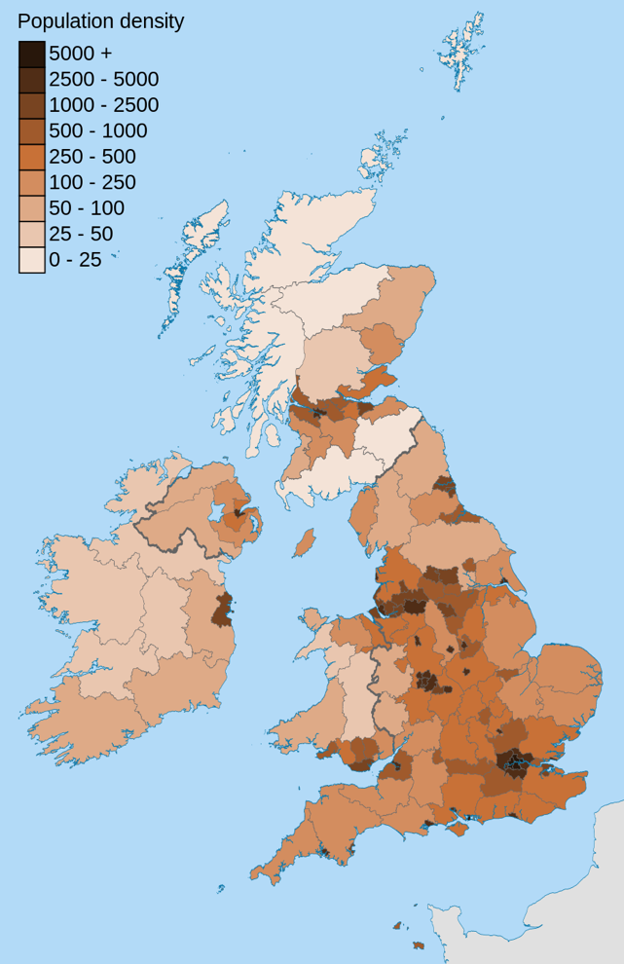
Using the map on the previous page and the map below, explain why there is a need for water transfer to maintain supplies?
______________________________________________________________________________________

_______________________________________________________________________________________

_______________________________________________________________________________________
_______________________________________________________________________________________

_______________________________________________________________________________________

_______________________________________________________________________________________
_______________________________________________________________________________________

_______________________________________________________________________________________

_______________________________________________________________________________________
_______________________________________________________________________________________

_______________________________________________________________________________________

_______________________________________________________________________________________
How good is the UK’s water quality?
_______________________________________________________________________________________

_______________________________________________________________________________________

_______________________________________________________________________________________
Causes of water pollution in the UK
Effects of water pollution in the UK
How are water quality and pollution levels managed in the UK?
_______________________________________________________________________________________

_______________________________________________________________________________________

_______________________________________________________________________________________
_______________________________________________________________________________________

_______________________________________________________________________________________

_______________________________________________________________________________________

Check your learning
Head over to www.internetgeography.net/wb133 and complete the quiz. Add your score for quiz 3 on the recording sheet.

Dual coding
Use dual coding to summarise what you have studied in this section. Take a look at https://www.internetgeography.net/dual-coding/

The UK’s changing energy mix

How is the UK’s energy demand changing? Describe changes in energy consumption in the UK since the 1970s.
_______________________________________________________________________________________

_______________________________________________________________________________________

_______________________________________________________________________________________
_______________________________________________________________________________________

Using the data below produce a pie chart to show the UK’s energy mix in 2015.

Electric production | %
Coal | 23%
Oil | 0.6%
Natural gas | 30%
Nuclear | 21.2%
Hydroelectric | 2%
Other renewables | 23.2%

How has the UK’s energy mix changed over time?
_______________________________________________________________________________________

_______________________________________________________________________________________

_______________________________________________________________________________________
_______________________________________________________________________________________
_______________________________________________________________________________________

_______________________________________________________________________________________

_______________________________________________________________________________________
_______________________________________________________________________________________

Using the diagram below describe and explain how the UK’s reliance on fossil fuels has changed.

Describe the growing significance of renewables.
_______________________________________________________________________________________

_______________________________________________________________________________________

_______________________________________________________________________________________
_______________________________________________________________________________________

Complete the diagram below to show the economic and environmental issues associated with non-renewable energy sources.

 | Economic Issues | Environmental Issues
Fossil fuels
Nuclear

Complete the diagram below to show the economic and environmental issues associated with renewable energy sources.

 | Economic Issues | Environmental Issues
Renewable energy sources

Check your learning
Head over to www.internetgeography.net/wb134 and complete the quiz. Add your score for quiz 4 on the recording sheet.

Dual coding
Use dual coding to summarise what you have studied in this section. Take a look at https://www.internetgeography.net/dual-coding/

Check your learning recording table

 | Attempt 1 | Attempt 2 | Attempt 3
Quiz 1  www.internetgeography.net/wb131 | /20 | /20 | /20
Quiz 2  www.internetgeography.net/wb132 | /11 | /11 | /11
Quiz 3  www.internetgeography.net/wb133 | /12 | /12 | /12
Quiz 4  www.internetgeography.net/wb134 | /10 | /10 | /10

