The Changing Economic World
Contents
Using this booklet 4
Introduction to The Changing Economic World 5
Measuring Development 7
Check your learning 9
Dual coding 10
The Demographic Transition Model 11
Check your learning 12
Dual coding 13
Uneven Development 14
Check your learning 18
Dual coding 18
Reducing the Development Gap 19
Check your learning 20
Dual coding 21
Economic Development in Nigeria – Introduction 22
Check your learning 26
Dual coding 27
Economic Development in Nigeria – The Economy 28
Check your learning 30
Dual coding 31
Economic Development in Nigeria – Political and trading relationships and aid 32
Check your learning 34
Dual coding 35
Economic Development in Nigeria – The impact of economic development (environmental and human) 36
Check your learning 37
Dual coding 38
Economic Change in the UK 39
Check your learning 41
Dual coding 42
The UK’s post-industrial economy 43
Check your learning 45
Dual coding 46
What are the impacts of industry on the physical environment? 47
Check your learning 47
Dual coding 48
Changes in the rural landscape 49
Check your learning 50
Dual coding 51
Developments in infrastructure 52
Check your learning 53
Dual coding 54
The north-south divide 55
Check your learning 56
Dual coding 57
The UK in the wider world 58
Check your learning 60
Dual coding 61
Check your learning recording table 62

Using this booklet
Welcome to the Internet Geography Work Booklet for The Changing Economic World. There are a range of resources on Internet Geography to support you studying this unit. Head over to https://www.internetgeography.net/topics/the-changing-economic-world/ to access them.

As well as the resources in this booklet, there are a number of online quizzes to check your learning as you work your way through this booklet.

This icon lets you know when you should attempt the online quizzes developed to support your learning and check your knowledge. Your scores should be recorded on the tracking table at the back of this booklet. It is useful to revisit the quizzes to help your learning stick.

QR codes are included throughout the booklet to support you in researching the information you need to complete the activities. You will need to download a free QR code scanner to your mobile phone or tablet. Just go to your app store and search for “QR Code scanner” and download a free one.

After each section in this booklet there is a summary page for you to record the main points for each sub-topic. We recommend you use dual coding for this. Dual coding sounds a bit complicated, however, it’s not. It simply involves combining text and images when you are studying. There are many ways you can present text and images, such as with infographics, timelines, cartoon strips, diagrams, and graphic organisers. We’ve pulled together a guide to help you do this with examples on Internet Geography. Either go to https://www.internetgeography.net/dual-coding/ or scan the QR code below.

Introduction to The Changing Economic World
There are a number of key words you need to know about the changing economic world.
Complete the key terms list below by adding the correct definitions.

Development
Low income countries
Newly emerging economies
High income countries
Social measures of development
Economic measures of development
Demographic transition model
Development gap
Industrial structure
Transnational Corporations
International aid
Quality of life
Globalisation
Deindustrialisation
Post-industrial economy
Infrastructure

Measuring Development
What is meant by the term development in geography?

_______________________________________________________________________________________

_______________________________________________________________________________________

_______________________________________________________________________________________

Complete the diagram below to show how development is measured across the world.

There are a number of economic and social measures of development. However, some
indicators are more reliable than others. Complete the table below to provide an outline
of each measure of development.

Measure of development – what is it? | Global Variations | Limitations of this measure of development.
Gross National Income

Measure of development – what is it? | Global Variations | Limitations of this measure of development.
Birth rate
Death rate
Infant mortality
Life expectancy
People per doctor
Literacy rates
Access to safe water
Human development index

Economic and social measures of development are averages for the whole country. What are the limitations of this?

_______________________________________________________________________________________

_______________________________________________________________________________________

_______________________________________________________________________________________

_______________________________________________________________________________________

_______________________________________________________________________________________

_______________________________________________________________________________________

Check your learning
Head over to www.internetgeography.net/wb101 and complete the quiz. Add your score for quiz 1 on the recording sheet.

Dual coding
Use dual coding to summarise what you have studied in this section. Take a look at https://www.internetgeography.net/dual-coding/

The Demographic Transition Model

What is the demographic transition model?
_______________________________________________________________________________________

_______________________________________________________________________________________

_______________________________________________________________________________________

Produce a labelled sketch of the demographic transition model.

Births and deaths per 1,000 people per year
High
Low
Time

Complete the table below to provide an outline of each stage of the demographic transition model.

Stage | Description | Links to development | Example countries
1. High fluctuating
2. Early expanding
3. Late expanding
4. Low fluctuating
5. Natural decrease

Check your learning
Head over to www.internetgeography.net/wb102 and complete the quiz. Add your score for quiz 2 on the recording sheet.

Dual coding
Use dual coding to summarise what you have studied in this section. Take a look at https://www.internetgeography.net/dual-coding/

Uneven Development

There are significant variations in levels of development across the world. There are
physical, economic and historical causes of this. Explain these causes on the diagrams below.

Physical causes of uneven development

Economic causes of uneven development

There are a number of consequences of uneven development including disparities in wealth, health and international migration. Complete the diagram below to summarise these consequences.

Annotate the map below to describe disparities in wealth as the result of uneven
development.

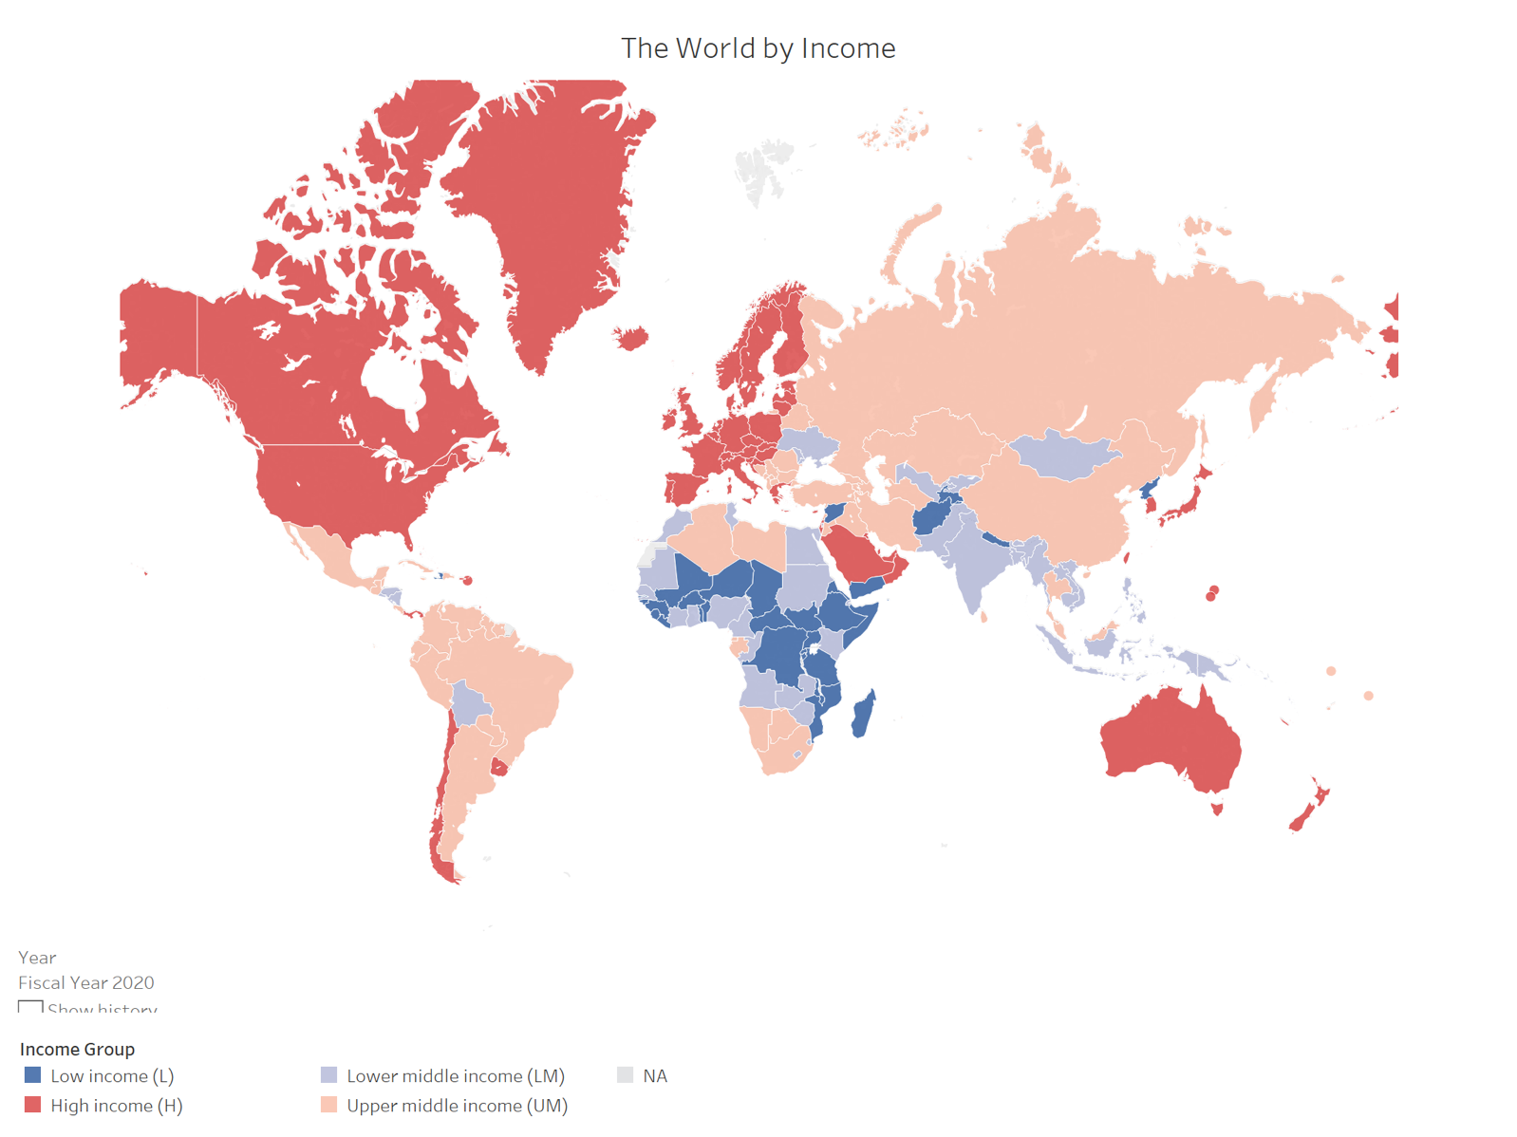

Compare the disparities in health resulting from uneven development and explain the impact.

_______________________________________________________________________________________

_______________________________________________________________________________________

_______________________________________________________________________________________

_______________________________________________________________________________________

_______________________________________________________________________________________

_______________________________________________________________________________________

_______________________________________________________________________________________

_______________________________________________________________________________________

_______________________________________________________________________________________

_______________________________________________________________________________________

_______________________________________________________________________________________

_______________________________________________________________________________________

Annotate the map below to describe and explain how international migration has occurred as the result of uneven development. You should also show recent patterns of international migration.

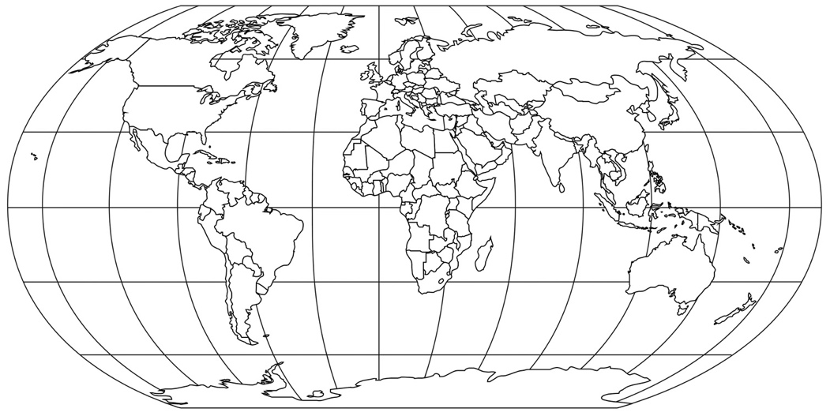

Check your learning
Head over to www.internetgeography.net/wb103 and complete the quiz. Add your score for quiz 3 on the recording sheet.

Dual coding
Use dual coding to summarise what you have studied in this section. Take a look at https://www.internetgeography.net/dual-coding/

Reducing the Development Gap

There are a number of strategies for reducing the development gap. Many of these
strategies support local development projects which generate employment opportunities
and increase incomes which in turn create ore wealth and reduce the development gap.

Complete the mind map to explain how each strategy can reduce the development gap.

microfinance loans
investment
intermediate technology
fair trade
debt relief
industrial development
aid
You need to know a case-study of how tourism can reduce the development gap. Complete
create a fact-file for your chosen country and explain how tourism has helped reduce the
development gap.

Case study
Physical attractions

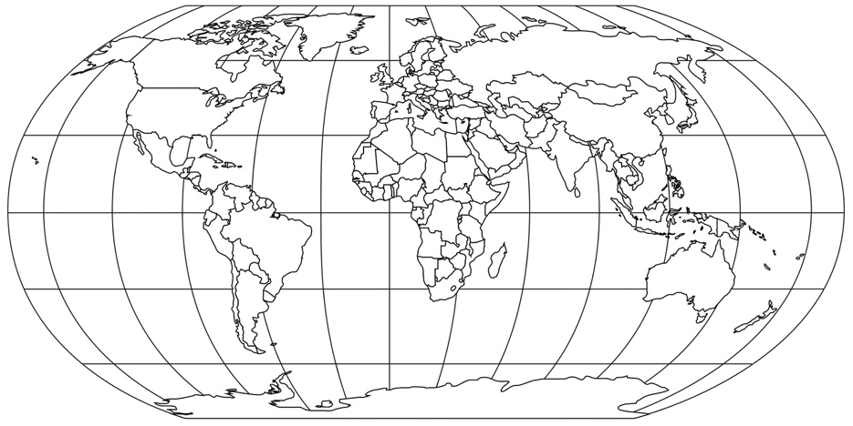
Human attractions

How has tourism reduced the development gap?

Check your learning
Head over to www.internetgeography.net/wb104 and complete the quiz. Add your score for quiz 4 on the recording sheet.

Dual coding
Use dual coding to summarise what you have studied in this section. Take a look at https://www.internetgeography.net/dual-coding/

Economic Development in Nigeria – Introduction

Annotate the map of Africa to show:
- Nigeria’s location
- Nigeria’s neighbouring countries
- Bodies of water

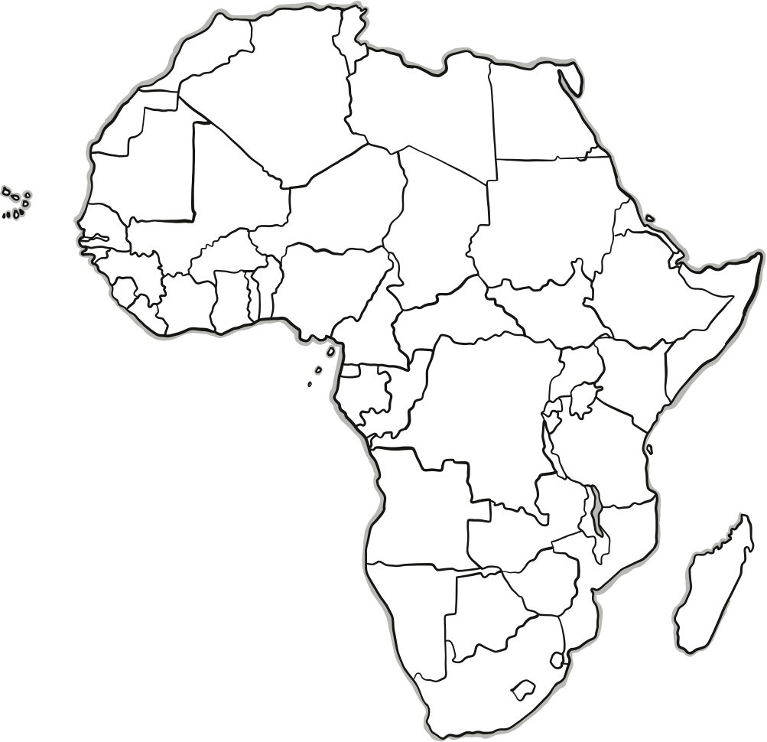

How is Nigeria economically classified?

_______________________________________________________________________________________

Describe Nigeria’s location. Use CLOCC to help:
- Continent
- Lines of latitude
- Oceans and seas
- Country
- Compass rose

_______________________________________________________________________________________

_______________________________________________________________________________________

_______________________________________________________________________________________

_______________________________________________________________________________________

_______________________________________________________________________________________

_______________________________________________________________________________________

_______________________________________________________________________________________

_______________________________________________________________________________________

_______________________________________________________________________________________

_______________________________________________________________________________________

_______________________________________________________________________________________

_______________________________________________________________________________________

_______________________________________________________________________________________

_______________________________________________________________________________________

_______________________________________________________________________________________

_______________________________________________________________________________________

_______________________________________________________________________________________

_______________________________________________________________________________________

_______________________________________________________________________________________
Complete the diagrams below to provide an overview of Nigeria’s global and regional importance.

What is Nigeria’s wider context? Complete the diagram below to provide an overview of
Nigeria’s political, social, cultural and environmental context.

Check your learning
Head over to www.internetgeography.net/wb105 and complete the quiz. Add your score for quiz 5 on the recording sheet.

Dual coding
Use dual coding to summarise what you have studied in this section. Take a look at https://www.internetgeography.net/dual-coding/

Economic Development in Nigeria – The Economy

Describe how Nigeria’s economic structure has changed.

_______________________________________________________________________________________

_______________________________________________________________________________________

_______________________________________________________________________________________

_______________________________________________________________________________________

_______________________________________________________________________________________

_______________________________________________________________________________________

_______________________________________________________________________________________

_______________________________________________________________________________________

_______________________________________________________________________________________

_______________________________________________________________________________________

Complete the pie chart below to show Nigeria’s GDP by economic structure

Give three ways manufacturing industry can stimulate economic growth.

_______________________________________________________________________________________

_______________________________________________________________________________________

_______________________________________________________________________________________

_______________________________________________________________________________________

_______________________________________________________________________________________

_______________________________________________________________________________________

_______________________________________________________________________________________

_______________________________________________________________________________________

_______________________________________________________________________________________

How important are TNCs in Nigeria’s economic development?

_______________________________________________________________________________________

_______________________________________________________________________________________

_______________________________________________________________________________________

_______________________________________________________________________________________

_______________________________________________________________________________________

_______________________________________________________________________________________

Give the advantages and disadvantages of TNCs.

Check your learning
Head over to www.internetgeography.net/wb106 and complete the quiz. Add your score for quiz 6 on the recording sheet.

Dual coding
Use dual coding to summarise what you have studied in this section. Take a look at https://www.internetgeography.net/dual-coding/

Economic Development in Nigeria – Political and
trading relationships and aid

You need to know how Nigeria’s political and trading relationship with the rest of the world is changing. Label the map below to show Nigeria’s political and trading relationships. Use separate colours to distinguish between political and trading relationships. Annotate the links to show how these are changing.

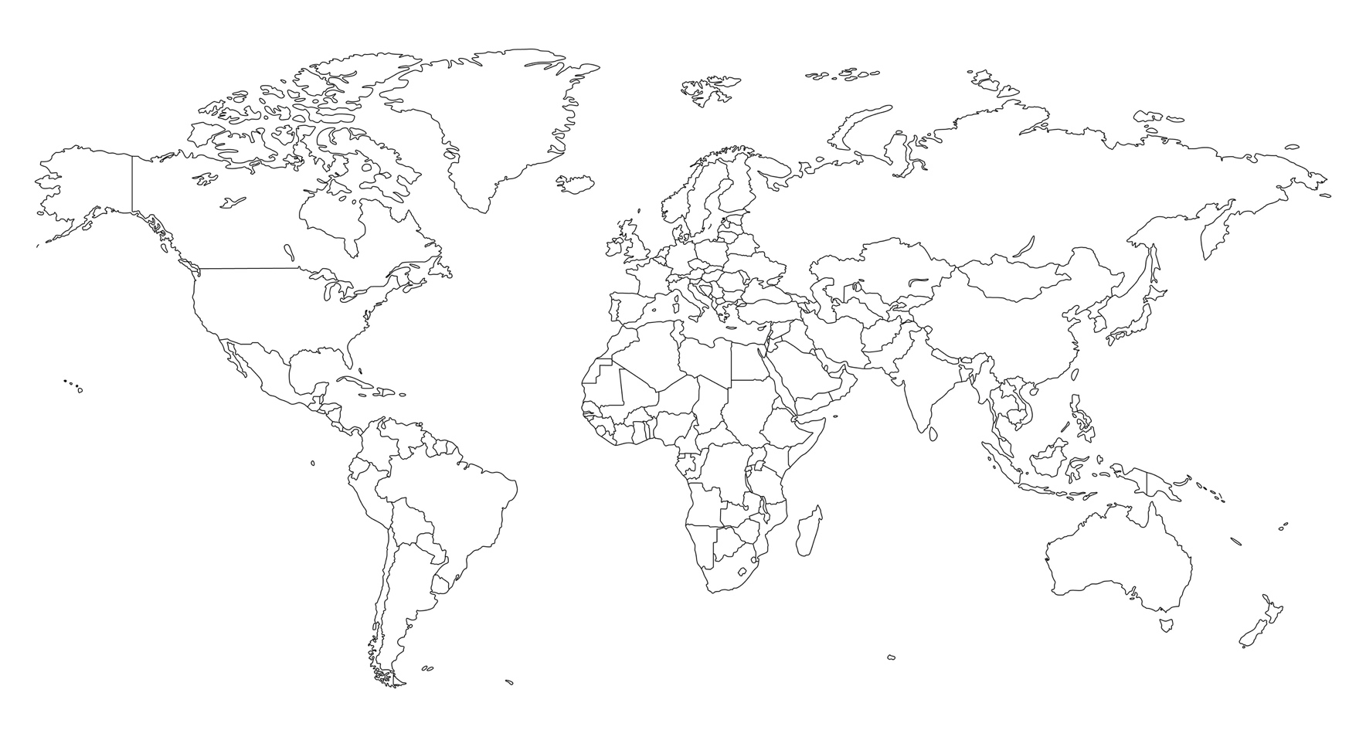

Aid involves the provision of support for people. It can take the form of emergency aid following a natural disaster or it can be long-term, designed to improve quality of life.

Annotate the diagram below to provide an overview of the main types of aid.

Despite Nigeria’s rapid economic growth poverty remains common in the country. Identify development data that supports this statement.

_______________________________________________________________________________________

_______________________________________________________________________________________

_______________________________________________________________________________________

_______________________________________________________________________________________

_______________________________________________________________________________________

Identify the sources of aid received by Nigeria.

_______________________________________________________________________________________

_______________________________________________________________________________________

_______________________________________________________________________________________

_______________________________________________________________________________________

_______________________________________________________________________________________

_______________________________________________________________________________________

How has Nigeria benefitted from aid?

_______________________________________________________________________________________

_______________________________________________________________________________________

_______________________________________________________________________________________

_______________________________________________________________________________________

_______________________________________________________________________________________

_______________________________________________________________________________________

Check your learning
Head over to www.internetgeography.net/wb107 and complete the quiz. Add your score for quiz 7 on the recording sheet.

Dual coding
Use dual coding to summarise what you have studied in this section. Take a look at https://www.internetgeography.net/dual-coding/

Economic Development in Nigeria – The impact of economic development (environmental and human)
Economic development in Nigeria has had impacts on the environment and on quality of life.

Complete the diagram below to explain the environmental impacts of economic development in Nigeria.

What are the environmental impacts of economic development in Nigeria?

Urban
growth
Mining and oil extraction

Industrial
development

How does economic development affect people’s quality of life?

What have been the positive impacts of economic development on quality of life in Nigeria?

_______________________________________________________________________________________

_______________________________________________________________________________________

_______________________________________________________________________________________

_______________________________________________________________________________________

_______________________________________________________________________________________

_______________________________________________________________________________________

_______________________________________________________________________________________

_______________________________________________________________________________________

What are the challenges facing Nigeria to ensure economic developments benefits the wider population?

_______________________________________________________________________________________

_______________________________________________________________________________________

_______________________________________________________________________________________

_______________________________________________________________________________________

_______________________________________________________________________________________

_______________________________________________________________________________________

_______________________________________________________________________________________

_______________________________________________________________________________________

_______________________________________________________________________________________

Check your learning
Head over to www.internetgeography.net/wb108 and complete the quiz. Add your score for quiz 8 on the recording sheet.

Dual coding
Use dual coding to summarise what you have studied in this section. Take a look at https://www.internetgeography.net/dual-coding/

Economic Change in the UK

At the height of the industrial revolution in the min-nineteenth century, UK industry was
dominated by manufacturing. During the twentieth century the UK’s industrial structure changed.

Complete the diagram below to describe and explain economic change in the UK during the twentieth century.

The three main causes of economic change in the UK are deindustrialisation, globalisation and government policies. Explain how each of the these have led to economic change in the UK.
Deindustrialisation

Globalisation

Government Policies

Check your learning
Head over to www.internetgeography.net/wb109 and complete the quiz. Add your score for quiz 9 on the recording sheet.

Dual coding
Use dual coding to summarise what you have studied in this section. Take a look at https://www.internetgeography.net/dual-coding/

The UK’s post-industrial economy
Since the decline in the UK’s traditional heavy industry sector in the 1970’s the UK has moved
towards a post-industrial economy. This is characterised by the development of information
technologies, services, research and science and business parks.

What effect has information technology had on the economy?

How information technology has affected people’s lives and economic development

What effect have service industries had on the economy?

_______________________________________________________________________________________

_______________________________________________________________________________________

_______________________________________________________________________________________

_______________________________________________________________________________________

_______________________________________________________________________________________

_______________________________________________________________________________________

_______________________________________________________________________________________

_______________________________________________________________________________________

What effect have developments in research had on the economy?

Employs: Economy contribution: University links: Research completed by: Growth:

What is a science park?

_______________________________________________________________________________________

_______________________________________________________________________________________

_______________________________________________________________________________________

_______________________________________________________________________________________

Complete the case study fact file below for a science park of your choice.
Science Park case study:

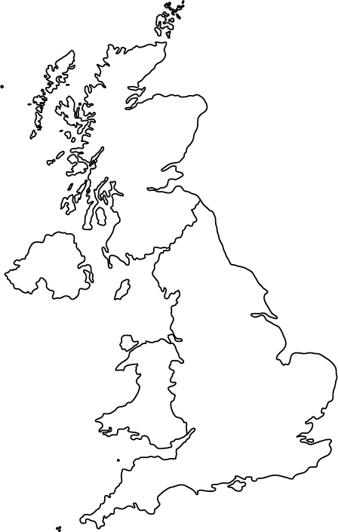
Fact file
Employs:
Companies:
Proximity to Uni:
Opened:
Environment:
Location

Sketch map of science park:

Benefits of science park:

What is a business park?

_______________________________________________________________________________________

_______________________________________________________________________________________

_______________________________________________________________________________________

_______________________________________________________________________________________

Provide an overview of the benefits of business parks.

_______________________________________________________________________________________

_______________________________________________________________________________________

_______________________________________________________________________________________

_______________________________________________________________________________________

_______________________________________________________________________________________

_______________________________________________________________________________________

_______________________________________________________________________________________

_______________________________________________________________________________________

Check your learning
Head over to www.internetgeography.net/wb110 and complete the quiz. Add your score for quiz 10 on the recording sheet.

Dual coding
Use dual coding to summarise what you have studied in this section. Take a look at https://www.internetgeography.net/dual-coding/

What are the impacts of industry on the physical environment?
What are the impacts of industry on the physical environment?

_______________________________________________________________________________________

_______________________________________________________________________________________

_______________________________________________________________________________________

_______________________________________________________________________________________

_______________________________________________________________________________________

_______________________________________________________________________________________

_______________________________________________________________________________________

Complete a case study of a modern industry that is environmentally sustainable.
Case study:

Facts about the industry

Location

Sketch map

How is the industry environmentally sustainable?

Check your learning
Head over to www.internetgeography.net/wb111 and complete the quiz. Add your score for quiz 11 on the recording sheet.

Dual coding
Use dual coding to summarise what you have studied in this section. Take a look at https://www.internetgeography.net/dual-coding/

Changes in the rural landscape
Rural landscapes in the UK are experiencing a range of changes. Some are experiencing
population growth, particularly those close to large urban areas, and others are experiencing
population decline as younger people move away. These changes have a range of social and
economic impacts. You need to know about the social and economic changes in an area of population growth and decline.

Check your learning
Head over to www.internetgeography.net/wb112 and complete the quiz. Add your score for quiz 12 on the recording sheet.

Dual coding
Use dual coding to summarise what you have studied in this section. Take a look at https://www.internetgeography.net/dual-coding/

Developments in infrastructure
The UK’s transport infrastructure is under considerable pressure as car ownership
increases and economic growth requires greater rail, port and airport capacity.

Complete the diagrams below to show how the UK’s transport infrastructure is being developed.

How are roads being developed?

How is the rail network being developed?

What have been the developments in ports?

What have been the developments in airports?

Check your learning
Head over to www.internetgeography.net/wb113 and complete the quiz. Add your score for quiz 13 on the recording sheet.

Dual coding
Use dual coding to summarise what you have studied in this section. Take a look at https://www.internetgeography.net/dual-coding/

The north-south divide

What is the north-south divide?

_______________________________________________________________________________________

_______________________________________________________________________________________

_______________________________________________________________________________________

_______________________________________________________________________________________

What has caused the north-south divide?

_______________________________________________________________________________________

_______________________________________________________________________________________

_______________________________________________________________________________________

_______________________________________________________________________________________

_______________________________________________________________________________________

_______________________________________________________________________________________

_______________________________________________________________________________________

What strategies are being used to address the north-south divide?

_______________________________________________________________________________________

_______________________________________________________________________________________

_______________________________________________________________________________________

_______________________________________________________________________________________

_______________________________________________________________________________________

_______________________________________________________________________________________

_______________________________________________________________________________________

_______________________________________________________________________________________

_______________________________________________________________________________________
Annotate the map below show the schemes that provide regional aid

Check your learning
Head over to www.internetgeography.net/wb114 and complete the quiz. Add your score for quiz 14 on the recording sheet.

Dual coding
Use dual coding to summarise what you have studied in this section. Take a look at https://www.internetgeography.net/dual-coding/

The UK in the wider world
Provide a brief overview of the place of the UK in the wider world.

_______________________________________________________________________________________

_______________________________________________________________________________________

_______________________________________________________________________________________

_______________________________________________________________________________________

_______________________________________________________________________________________

_______________________________________________________________________________________

_______________________________________________________________________________________

_______________________________________________________________________________________

What are the UK’s links with the wider world? Complete the diagram below to provide an overview.

trade
transport
What are the UK’s links with the wider world?

culture
electronic communications

What are the UK’s political and economic links with the EU?

_______________________________________________________________________________________

_______________________________________________________________________________________

_______________________________________________________________________________________

_______________________________________________________________________________________

_______________________________________________________________________________________

_______________________________________________________________________________________

_______________________________________________________________________________________

_______________________________________________________________________________________

_______________________________________________________________________________________

_______________________________________________________________________________________

_______________________________________________________________________________________

_______________________________________________________________________________________

_______________________________________________________________________________________

_______________________________________________________________________________________

_______________________________________________________________________________________

_______________________________________________________________________________________

_______________________________________________________________________________________

_______________________________________________________________________________________

_______________________________________________________________________________________

What are the UK’s political and economic links with the Commonwealth?

_______________________________________________________________________________________

_______________________________________________________________________________________

_______________________________________________________________________________________

_______________________________________________________________________________________

_______________________________________________________________________________________

_______________________________________________________________________________________

_______________________________________________________________________________________

_______________________________________________________________________________________

_______________________________________________________________________________________

_______________________________________________________________________________________

Check your learning
Head over to www.internetgeography.net/wb115 and complete the quiz. Add your score for quiz 15 on the recording sheet.

Dual coding
Use dual coding to summarise what you have studied in this section. Take a look at https://www.internetgeography.net/dual-coding/

Check your learning recording table

 | Attempt 1 | Attempt 2 | Attempt 3
Quiz 1  www.internetgeography.net/wb101 | / | / | /
Quiz 2  www.internetgeography.net/wb102 | / | / | /
Quiz 3  www.internetgeography.net/wb103 | / | / | /
Quiz 4  www.internetgeography.net/wb104 | / | / | /
Quiz 5  www.internetgeography.net/wb105 | / | / | /
Quiz 6  www.internetgeography.net/wb106 | / | / | /
Quiz 7  www.internetgeography.net/wb107 | / | / | /
Quiz 8  www.internetgeography.net/wb108 | / | / | /
Quiz 9  www.internetgeography.net/wb109 | / | / | /
Quiz 10  www.internetgeography.net/wb110 | / | / | /
Quiz 11  www.internetgeography.net/wb111 | / | / | /
Quiz 12  www.internetgeography.net/wb112 | / | / | /
Quiz 13  www.internetgeography.net/wb113 | / | / | /
Quiz 14  www.internetgeography.net/wb114 | / | / | /
Quiz 15  www.internetgeography.net/wb115 | / | / | /

