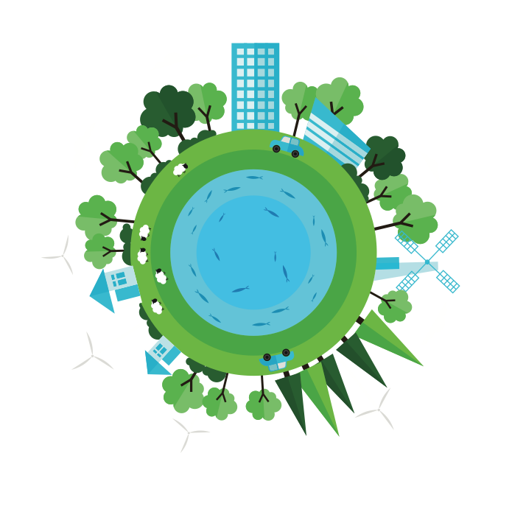
World
The Living
Contents
Using this booklet 3
Introduction to ecosystems 4
Check your learning 5
Food chains 5
Food webs Draw a food web to summarise the ecosystem below. 6
Check your learning 6
Dual coding 7
An example of a small-scale UK ecosystem 8
Dual coding 11
Ecosystem balance 12
Check your learning 13
Dual coding 14
Where are global ecosystems (biomes) located? 15
Check your learning 17
Dual coding 18
The physical characteristics of a tropical rainforest 19
Check your learning 21
Dual coding 22
Interdependence in the tropical rainforest 23
Check your learning 24
Dual coding 25
How do plants and animals adapt to physical conditions? 26
Check your learning 26
Dual coding 27
Issues related to biodiversity 28
Dual coding 30
Changing rates of deforestation 31
Check your learning 34
Dual coding 35
A case study of the causes and impacts of deforestation 36
Check your learning 38
Dual coding 39
The value of tropical rainforests 40
Check your learning 41
Dual coding 42
Sustainable management of tropical rainforests 43
Check your learning 45
Dual coding 46
Check your learning recording table 47

Using this booklet
Welcome to the Internet Geography Work Booklet for the Living World – Ecosystems and Tropical Rainforest. There are a range of resources on Internet Geography to support you studying this unit. Head over to www.internetgeography.net/aqa-gcse-geography/the-living-world/ to access them.

As well as the resources in this booklet, there are a number of online quizzes to check your learning as you work your way through this booklet.
This icon lets you know when you should attempt the online quizzes developed to support your learning and check your knowledge. Your scores should be recorded on the tracking table at the back of this booklet. It is useful to revisit the quizzes to help your learning stick.

QR codes are included throughout the booklet to support you in researching the information you need to complete the activities. You will need to download a free QR code scanner to your mobile phone or tablet. Just go to your app store and search for “QR Code scanner” and download a free one.

After each section in this booklet there is a summary page for you to record the main points for each sub-topic. We recommend you use dual coding for this. Dual coding sounds a bit complicated, however, it’s not. It simply involves combining text and images when you are studying. There are many ways you can present text and images, such as with infographics, timelines, cartoon strips, diagrams, and graphic organisers. We’ve pulled together a guide to help you do this with examples on Internet Geography. Either go to https://www.internetgeography.net/dual-coding/ or scan the QR code below.

Introduction to ecosystems
There are a number of key words you need to know about ecosystems.
Complete the key terms list below by adding the correct definitions.

Ecosystem
Biome
Biotic components
Abiotic components
Producers
Consumers
Decomposers
Food chain
Food web
Nutrient cycle
Carnivore
Herbivore
Omnivore

Check your learning
Head over to www.internetgeography.net/wb1 and complete the key word quiz. Add your score for quiz 1 on the recording sheet.

Food chains
Draw a simple food chain to show the flow of energy from a producer to a tertiary consumer.

Food webs
Draw a food web to summarise the ecosystem below.

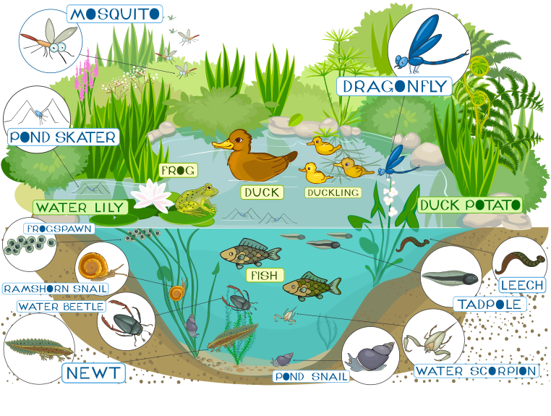

Check your learning
Head over to www.internetgeography.net/wb2 and complete the quiz. Add your score for quiz 2 on the recording sheet.

Dual coding
Use dual coding to summarise what you have studied in this section. Take a look at https://www.internetgeography.net/dual-coding/ if you need help with this.

An example of a small-scale UK ecosystem
You need to study an example of a small-scale ecosystem in the UK. Your case study could
be a pond or forest or any other small-scale ecosystem. If you need a case study take a look
at Epping Forest: www.internetgeography.net/topics/epping-forest-case-study/

Name of case study: ______________________________________________________________________

Brief description of the small-scale ecosystem including location:
_______________________________________________________________________________________

_______________________________________________________________________________________

Producers within the ecosystem
Primary consumers
Secondary consumers
Tertiary consumers

Draw a simple food chain to show the flow of energy from a producer to a tertiary consume within your small-scale ecosystem.

Draw a food web to summarise your small-scale ecosystem

Draw a diagram below to show how the ecosystem you have studied is interdependent.

Explain how the nutrient cycle works in your example.

_______________________________________________________________________________________

_______________________________________________________________________________________

_______________________________________________________________________________________

_______________________________________________________________________________________

_______________________________________________________________________________________

_______________________________________________________________________________________

_______________________________________________________________________________________

_______________________________________________________________________________________

How is your example of a small-scale ecosystem being managed sustainably?

_______________________________________________________________________________________

_______________________________________________________________________________________

_______________________________________________________________________________________

_______________________________________________________________________________________

_______________________________________________________________________________________

_______________________________________________________________________________________

_______________________________________________________________________________________

_______________________________________________________________________________________

Explain how changes to once component in your ecosystem can have an impact on the ecosystem.

_______________________________________________________________________________________

_______________________________________________________________________________________

_______________________________________________________________________________________

_______________________________________________________________________________________

_______________________________________________________________________________________

_______________________________________________________________________________________

_______________________________________________________________________________________

_______________________________________________________________________________________

Dual coding
Use dual coding to summarise what you have studied in this section. Take a look at https://www.internetgeography.net/dual-coding/

Ecosystem balance
Ecosystems are fragile environments and changes to one component can have a knock-on
effect on the rest of the ecosystem. The impacts can be both positive and negative. A classic
example of this is the re-introduction of wolves to Yellowstone National Park in the USA.
There is a good video summarising the impact here: https://youtu.be/ysa5OBhXz-Q

Complete the table below to identify natural changes that can affect an ecosystem along the changes due to human activities.
Natural causes of changes in ecosystems | Human causes of changes in ecosystems

How can changes affect ecosystems? Below are two scenarios for changes in ecosystems. Discuss the impact of the changes.

Change 1 – Deforestation occurs in a small woodland ecosystem. What will be the impact of this?

_______________________________________________________________________________________

_______________________________________________________________________________________

_______________________________________________________________________________________

_______________________________________________________________________________________

_______________________________________________________________________________________

Change 2 – More trout (predators) are added to a pond.
_______________________________________________________________________________________

_______________________________________________________________________________________

_______________________________________________________________________________________

_______________________________________________________________________________________

_______________________________________________________________________________________

Check your learning
Head over to www.internetgeography.net/wb3 and complete the quiz. Add your score for quiz 3 on the recording sheet.

Dual coding
Use dual coding to summarise what you have studied in this section. Take a look at https://www.internetgeography.net/dual-coding/

Where are global ecosystems (biomes) located?

The map below shows the location of the world’s major biomes.
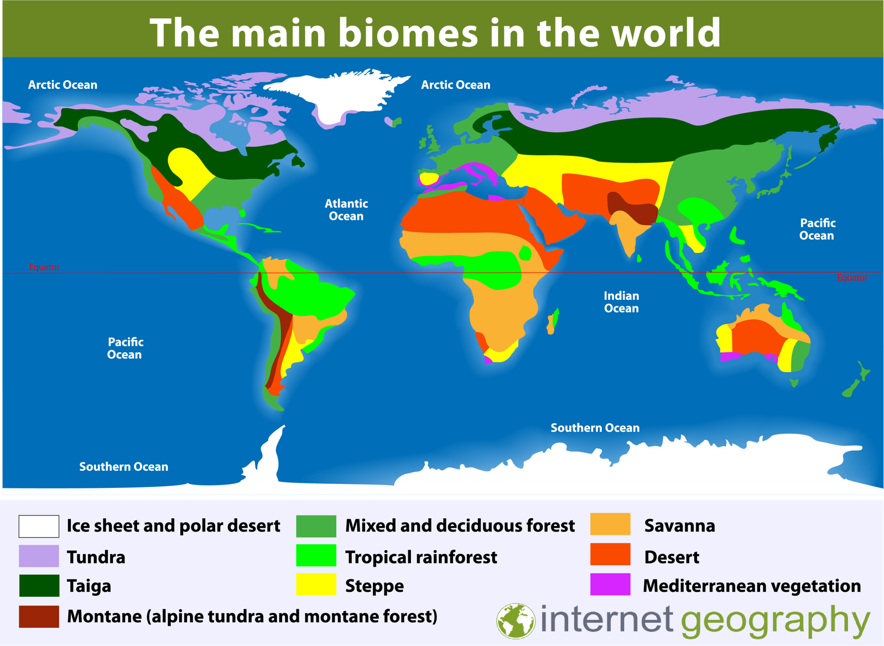

Describe the distribution of the tropical rainforest biome.

_______________________________________________________________________________________

_______________________________________________________________________________________

_______________________________________________________________________________________

_______________________________________________________________________________________

_______________________________________________________________________________________

_______________________________________________________________________________________

_______________________________________________________________________________________

_______________________________________________________________________________________

Complete the table below to provide an outline of the location and characteristics of each biome.
Biome | Location | Characteristics
Tundra
Tropical rainforest
Ice sheet and polar desert
Desert
Explain why ecosystems tend to be located in broad belts across the world, from east to west, almost parallel to lines of latitude.

_______________________________________________________________________________________

_______________________________________________________________________________________

_______________________________________________________________________________________

_______________________________________________________________________________________

_______________________________________________________________________________________

_______________________________________________________________________________________

_______________________________________________________________________________________

_______________________________________________________________________________________

_______________________________________________________________________________________

_______________________________________________________________________________________

_______________________________________________________________________________________

Check your learning
Head over to www.internetgeography.net/wb4 and complete the quiz. Add your score for quiz 4 on the recording sheet.

Dual coding
Use dual coding to summarise what you have studied in this section. Take a look at https://www.internetgeography.net/dual-coding/

The physical characteristics of a tropical rainforest

What is a tropical rainforest?

_______________________________________________________________________________________

_______________________________________________________________________________________

_______________________________________________________________________________________

Describe the location of the tropical rainforest biome.

_______________________________________________________________________________________

_______________________________________________________________________________________

_______________________________________________________________________________________

_______________________________________________________________________________________

_______________________________________________________________________________________

_______________________________________________________________________________________

_______________________________________________________________________________________

_______________________________________________________________________________________

Describe the climate of the tropical rainforest.

_______________________________________________________________________________________

_______________________________________________________________________________________

_______________________________________________________________________________________

_______________________________________________________________________________________

_______________________________________________________________________________________

_______________________________________________________________________________________

_______________________________________________________________________________________

_______________________________________________________________________________________

Explain why the tropical rainforest experiences high levels of rainfall.

_______________________________________________________________________________________

_______________________________________________________________________________________

_______________________________________________________________________________________

_______________________________________________________________________________________

_______________________________________________________________________________________

_______________________________________________________________________________________

_______________________________________________________________________________________

_______________________________________________________________________________________

Why is soil in the tropical rainforest infertile?

_______________________________________________________________________________________

_______________________________________________________________________________________

_______________________________________________________________________________________

_______________________________________________________________________________________

_______________________________________________________________________________________

_______________________________________________________________________________________

_______________________________________________________________________________________

_______________________________________________________________________________________

Annotate the diagram below to show the characteristics of vegetation in the rainforest.

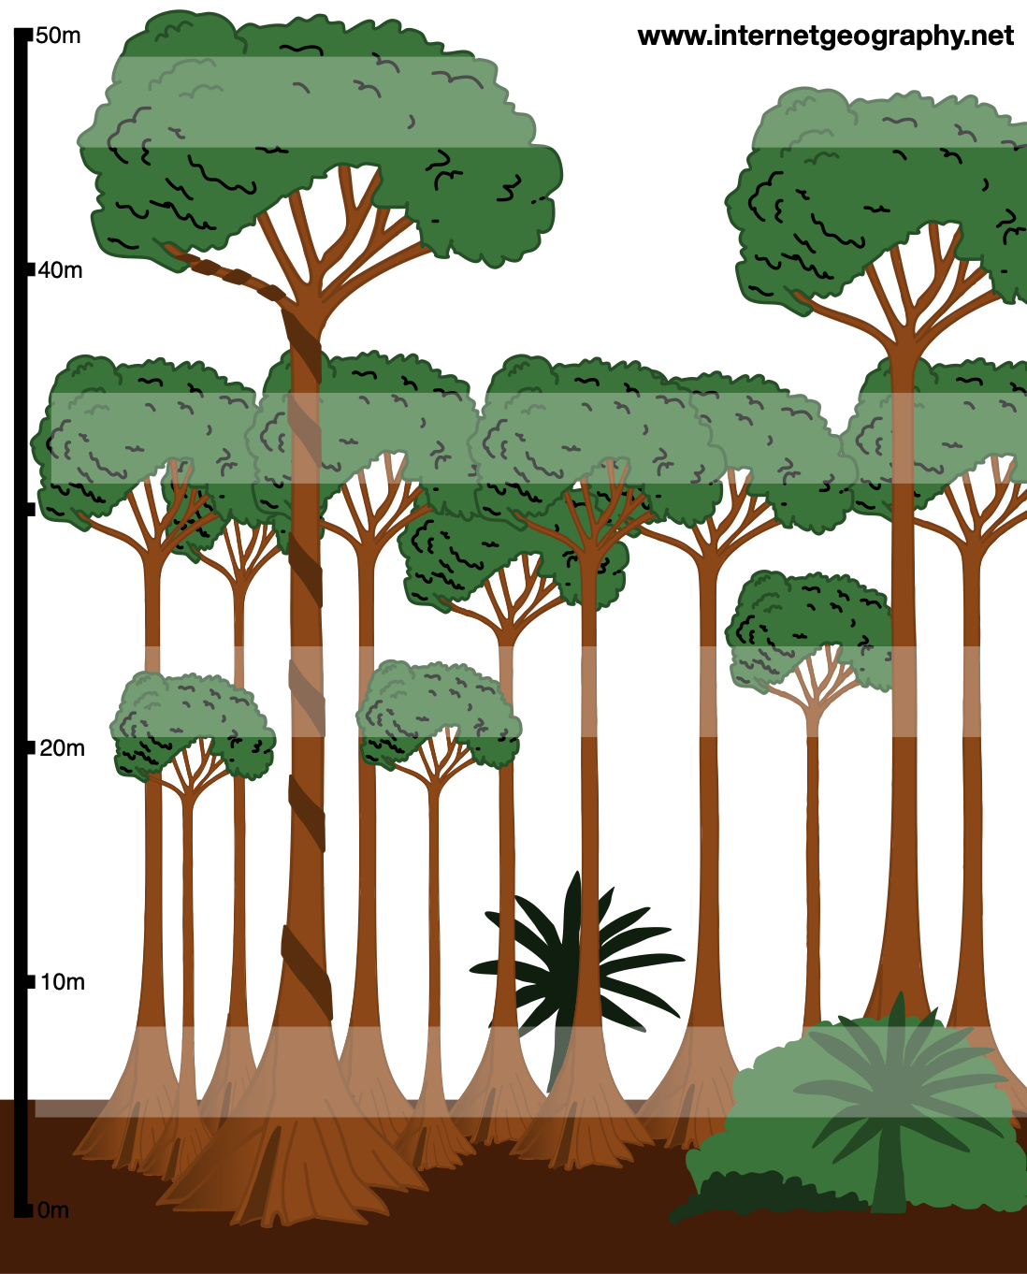

Check your learning
Head over to www.internetgeography.net/wb5 and complete the quiz. Add your score for quiz 5 on the recording sheet.

Dual coding
Use dual coding to summarise what you have studied in this section. Take a look at https://www.internetgeography.net/dual-coding/

Interdependence in the tropical rainforest
The nutrient cycle in the rainforest is an excellent example of interdependence.
Complete the diagram below to explain interdependence in the tropical rainforest.

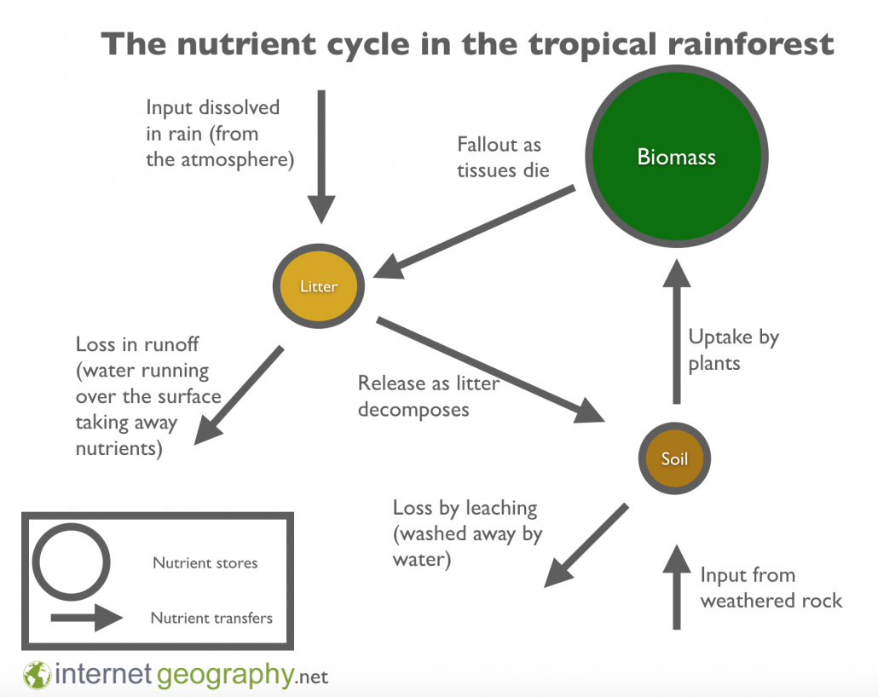

Give another example of interdependence within the tropical rainforest ecosystem

_______________________________________________________________________________________

_______________________________________________________________________________________

_______________________________________________________________________________________

Explain how in tropical rainforest ecosystems, climate, water, soils, plants, animals and people are interdependent.
_______________________________________________________________________________________

_______________________________________________________________________________________

_______________________________________________________________________________________

_______________________________________________________________________________________

_______________________________________________________________________________________

_______________________________________________________________________________________

_______________________________________________________________________________________

_______________________________________________________________________________________
_______________________________________________________________________________________

_______________________________________________________________________________________

_______________________________________________________________________________________

_______________________________________________________________________________________

_______________________________________________________________________________________

_______________________________________________________________________________________

_______________________________________________________________________________________

_______________________________________________________________________________________

Check your learning
Head over to www.internetgeography.net/wb6 and complete the quiz. Add your score for quiz 6 on the recording sheet.

Dual coding
Use dual coding to summarise what you have studied in this section. Take a look at https://www.internetgeography.net/dual-coding/

How do plants and animals adapt to physical conditions?
Annotate the image below to explain how vegetation has adapted to the rainforest environment.

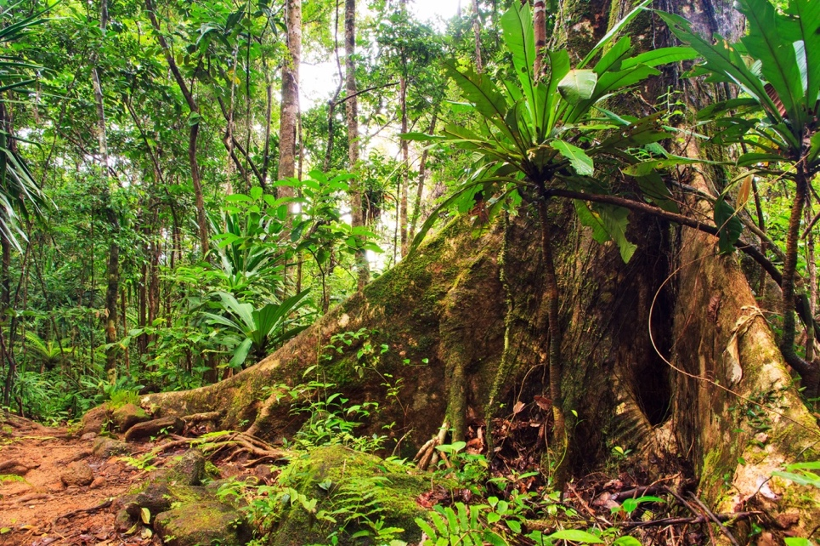

Explain three animal adaptations to the rainforest environment
_______________________________________________________________________________________

_______________________________________________________________________________________

_______________________________________________________________________________________

_______________________________________________________________________________________

_______________________________________________________________________________________

_______________________________________________________________________________________

_______________________________________________________________________________________

_______________________________________________________________________________________

Check your learning
Head over to www.internetgeography.net/wb7 and complete the quiz. Add your score for quiz 7 on the recording sheet.

Dual coding
Use dual coding to summarise what you have studied in this section. Take a look at https://www.internetgeography.net/dual-coding/

Issues related to biodiversity
Define biodiversity.
_______________________________________________________________________________________

_______________________________________________________________________________________

_______________________________________________________________________________________

_______________________________________________________________________________________

Tropical rainforests are the most biodiverse ecosystems in the world. Give three pieces of evidence to support this statement.

_______________________________________________________________________________________

_______________________________________________________________________________________

_______________________________________________________________________________________

_______________________________________________________________________________________

_______________________________________________________________________________________

_______________________________________________________________________________________

_______________________________________________________________________________________

_______________________________________________________________________________________

Why are there high levels of biodiversity in tropical rainforests?

_______________________________________________________________________________________

_______________________________________________________________________________________

_______________________________________________________________________________________

_______________________________________________________________________________________

_______________________________________________________________________________________

_______________________________________________________________________________________

_______________________________________________________________________________________

_______________________________________________________________________________________

What are the main threats to biodiversity in the tropical rainforests?

_______________________________________________________________________________________

_______________________________________________________________________________________

_______________________________________________________________________________________

_______________________________________________________________________________________

_______________________________________________________________________________________

_______________________________________________________________________________________

_______________________________________________________________________________________

_______________________________________________________________________________________

Give three impacts of biodiversity decline in the tropical rainforest.

_______________________________________________________________________________________

_______________________________________________________________________________________

_______________________________________________________________________________________

_______________________________________________________________________________________

_______________________________________________________________________________________

_______________________________________________________________________________________

_______________________________________________________________________________________

_______________________________________________________________________________________

Dual coding
Use dual coding to summarise what you have studied in this section. Take a look at https://www.internetgeography.net/dual-coding/

Changing rates of deforestation

The graph below shows the loss of rainforest between 2001 and 2018. Describe the global
pattern of rainforest deforestation.
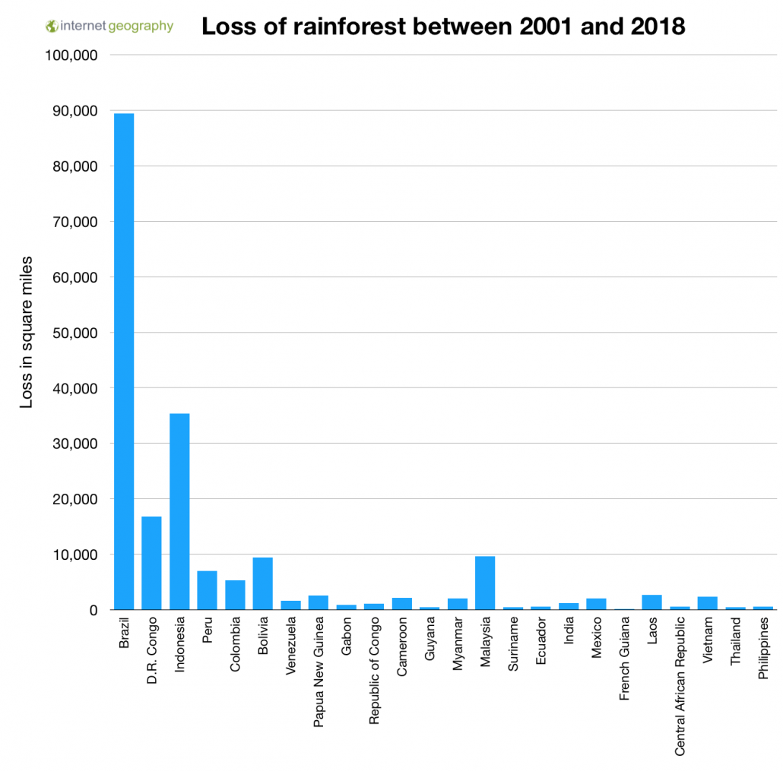
_______________________________________________________________________________________

_______________________________________________________________________________________

_______________________________________________________________________________________

_______________________________________________________________________________________

_______________________________________________________________________________________

_______________________________________________________________________________________

_______________________________________________________________________________________

_______________________________________________________________________________________

_______________________________________________________________________________________

_______________________________________________________________________________________

_______________________________________________________________________________________

_______________________________________________________________________________________

_______________________________________________________________________________________

_______________________________________________________________________________________

The graph below shows changes in the annual rate of rainforest deforestation between 2000 and 2010. Describe changes in the annual rate of deforestation between 2000 and 2010.
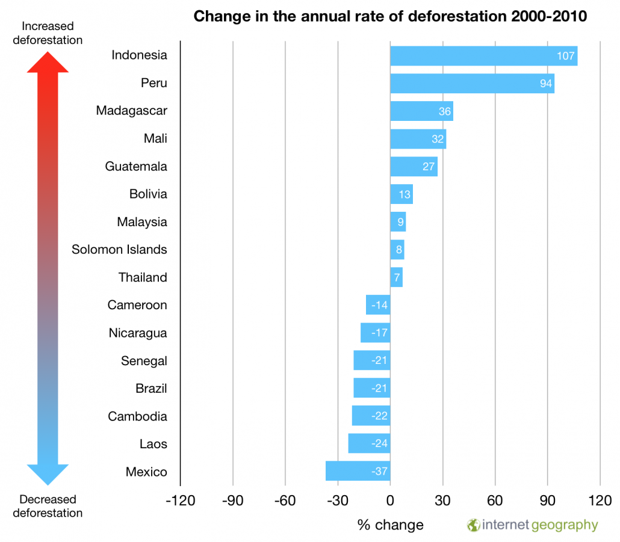
_______________________________________________________________________________________

_______________________________________________________________________________________

_______________________________________________________________________________________

_______________________________________________________________________________________

_______________________________________________________________________________________

_______________________________________________________________________________________

_______________________________________________________________________________________

_______________________________________________________________________________________

_______________________________________________________________________________________
Why do you think rates of rainforest deforestation are increasing in some areas and decreasing in others?

_______________________________________________________________________________________

_______________________________________________________________________________________

_______________________________________________________________________________________

_______________________________________________________________________________________

_______________________________________________________________________________________

_______________________________________________________________________________________

_______________________________________________________________________________________

_______________________________________________________________________________________

_______________________________________________________________________________________

Check your learning
Head over to www.internetgeography.net/wb8 and complete the quiz. Add your score for quiz 8 on the recording sheet.

Dual coding
Use dual coding to summarise what you have studied in this section. Take a look at https://www.internetgeography.net/dual-coding/

A case study of the causes and impacts of
deforestation

Case study: _________________________________________

Describe the location of the tropical rainforest case study you have identified above.

_______________________________________________________________________________________

_______________________________________________________________________________________

_______________________________________________________________________________________

_______________________________________________________________________________________

Produce a detailed spider diagram to describe the causes of deforestation in your case study location.
Causes of deforestation
Produce a detailed spider diagram to show the local impacts of deforestation in your case
study location.
National impacts of deforestation

Local impact of deforestation

Produce a detailed spider diagram to show the national impacts of deforestation in your case study location.
Produce a detailed spider diagram to show the global impacts of deforestation in your case study location.
Global impacts of rainforest deforestation

Check your learning
Head over to www.internetgeography.net/wb9 and complete the quiz. Add your score for quiz 9 on the recording sheet.

Dual coding
Use dual coding to summarise what you have studied in this section. Take a look at https://www.internetgeography.net/dual-coding/

The value of tropical rainforests
Why is it important to protect the tropical rainforest?

_______________________________________________________________________________________

_______________________________________________________________________________________

_______________________________________________________________________________________

_______________________________________________________________________________________

_______________________________________________________________________________________

_______________________________________________________________________________________

_______________________________________________________________________________________

_______________________________________________________________________________________

_______________________________________________________________________________________

Complete the table below to show the value of tropical rainforest to people and the environment.

Value to people | Value to the environment

Complete the table below to show how deforestation can have both economic gains and economic losses:

Economic gains for the country | Economic losses for the country

Check your learning
Head over to www.internetgeography.net/wb10 and complete the quiz. Add your score for quiz 10 on the recording sheet.

Dual coding
Use dual coding to summarise what you have studied in this section. Take a look at https://www.internetgeography.net/dual-coding/

Sustainable management of tropical rainforests

Complete the table below to explain international approaches to sustainable management
of the tropical rainforest.

Debt reduction programmes
International agreements
Other:

Complete the table below to explain national approaches to sustainable management of the tropical rainforest.

Education
Forest reserves
Monitoring

Complete the table below to explain local approaches to sustainable management of the tropical rainforest.

Afforestation
Shifting cultivation
Selective logging
Agroforestry

Why do tropical rainforests need to be managed? Your answer should outline their importance to people and the environment.

_______________________________________________________________________________________

_______________________________________________________________________________________

_______________________________________________________________________________________

_______________________________________________________________________________________

_______________________________________________________________________________________

_______________________________________________________________________________________

_______________________________________________________________________________________

_______________________________________________________________________________________

_______________________________________________________________________________________

_______________________________________________________________________________________

_______________________________________________________________________________________

_______________________________________________________________________________________

_______________________________________________________________________________________

_______________________________________________________________________________________

_______________________________________________________________________________________

_______________________________________________________________________________________

_______________________________________________________________________________________

_______________________________________________________________________________________

Check your learning
Head over to www.internetgeography.net/wb11 and complete the quiz. Add your score for quiz 11 on the recording sheet.

Dual coding
Use dual coding to summarise what you have studied in this section. Take a look at https://www.internetgeography.net/dual-coding/

Check your learning recording table

 | Attempt 1 | Attempt 2 | Attempt 3
Quiz 1  www.internetgeography.net/wb1/ | /13 | /13 | /13
Quiz 2  www.internetgeography.net/wb2/ | /10 | /10 | /10
Quiz 3  www.internetgeography.net/wb3/ | /10 | /10 | /10
Quiz 4  www.internetgeography.net/wb4/ | /10 | /10 | /10
Quiz 5  www.internetgeography.net/wb5/ | /10 | /10 | /10
Quiz 6  www.internetgeography.net/wb6/ | /10 | /10 | /10
Quiz 7  www.internetgeography.net/wb7/ | /10 | /10 | /10
Quiz 8  www.internetgeography.net/wb8/ | /5 | /5 | /5
Quiz 9  www.internetgeography.net/wb9/ | /11 | /11 | /11
Quiz 10  www.internetgeography.net/wb10/ | /10 | /10 | /10
Quiz 11  www.internetgeography.net/wb11/ | /8 | /8 | /8

