World Environment Day 2020:

World Environment Day 2020:

Pledge

Pledge

by ……………………………………….



I will…

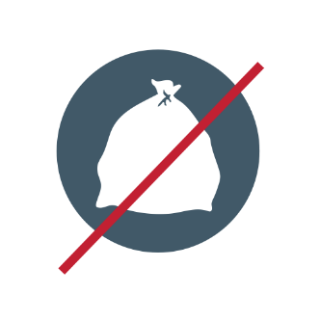

I will not…